“All Roads Lead to Rome”

Rome was famous for their system of roads. Rome became an empire because of their powerful soldiers and the genius of their generals. But Rome remained an empire because of its roads. Romans built over 53,000 miles of roads to connect every part of their empire. The roads were mostly built by the army and slaves. The roads were all done by hand and made out of stone. The roads were wide enough for large wagons to pass each other. The system of roads connected together every area of the empire. Roman emperors also used the road system to control their empire. For example, if there was a rebellion in one part of the empire, the emperor could send Roman armies from one part of the empire to another to maintain the peace. Roman emperors also used the road system to stay connected with the furthest territories of the empire by sending and receiving messages quickly over thousands of miles of roads. These roads weren’t built merely to accommodate armies and send messages, but they could when the need arose, but to speed the movements of tax collectors, administrators, and merchants, all the civilian travelers and traders who made the empire run smoothly. The Romans had a saying, “All roads lead to Rome”. A person could start traveling on a Roman road in Northwest Africa, travel around the entire Mediterranean Sea and end up in Rome without ever leaving a Roman Road. Some of these roads are still used today.
However, all Roman citizens were free to use the roads, there were some dangers to these roads. Travelers had to be aware of bandits, as people might simply “disappear” while riding on the Roman roads.
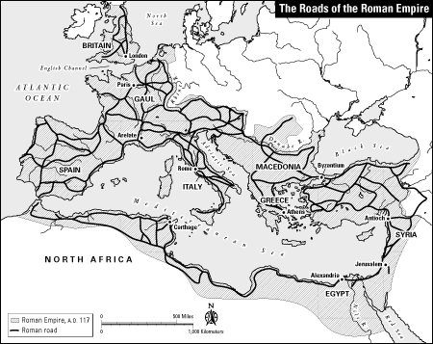

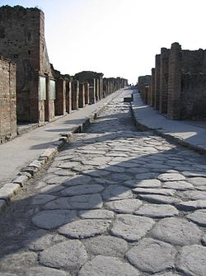

“All Roads lead to Rome”

DIRECTIONS: Use the graphic organizer to explain the pros (good things) and cons (bad things) about the roads in Rome.

ROMAN ROADS

List 4 PROS  (POSTIVE THINGS) | CONS  (NEGATIVE THINGS)

