Annotation Station
Symbols | Uses
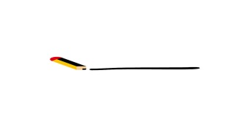 | important information  main ideas & key details
key words & new vocabulary
define in margins

something confusing or you have a follow up question
write your question in the margin and seek an answer
make a connection:
self, world, text, history, other parts of the text
explain the connection in the margin
when you agree with if you
when you disagree
explain your reasoning in the margin
REMEMBER | Write notes, ideas, summaries, questions, etc. in margins!  Interact with reading!

