The Bubonic Plague—the Black Death
#

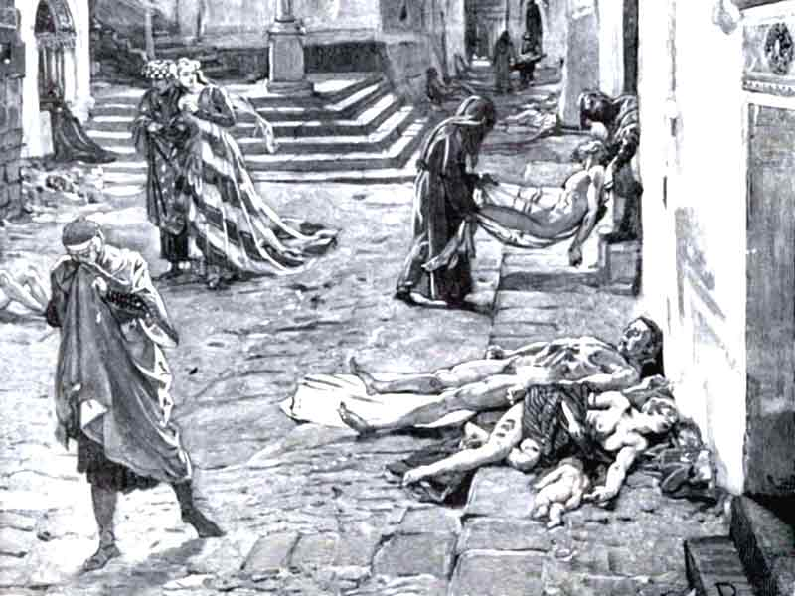I. Introduction
Although European society made many important advances after the Crusades, its progress had serious setbacks. The 14th century was a particularly difficult time for Europeans. The increased contact with other areas of the world did not only bring more than ideas and products to Mediterranean ports, but also disease.

DIRECTIONS: Read the following information about how the Black Death emerged in Europe in the 14th century. Highlight/underline important information that explains what caused the epidemic and how did it spread. Circle words you do not understand. Then fill in the accompanying template below.

A New Disease Arrives
In 1347, a disaster struck the European population. It began when a ship from Genoa in northern Italy docked in the Sicilian port city of Messina. The ship was returning from a trading post in the Black Sea port of Caffa. Many of its crew members and passengers had large black swellings in their armpits and groin. Sores called boils and dark bruises covered their bodies. Others, with more severe types of the illness, burned with fever, coughed and spat up blood. Within a few days, the stricken people died. As the ship lay at anchor, some black rats scurried off it and ran into the city. In this way, the bubonic plague, known as the Black Death, entered Europe.

About a year before the arrival of the plague ship, travelers had returned from Asia with frightening news. A devastating disease was spreading from China to Central Asia, India, Persia, Mesopotamia, Syria, Egypt, and Asia Minor. According to these travelers, the disease was wiping out the populations of entire countries. After hearing many of these reports, Pope Clement VI estimated the death toll of the disease in Asia to be about 23,840,000. Having no knowledge of the ways in which diseases can move from place to place, Europeans did not expect it to infect them. The people of Messina, therefore, did not prevent ships from the East from entering their harbor. Only when several citizens began to show symptoms like those of the dying passengers, did the city leaders force the plague ship back out to sea. Unfortunately, this measure was not in time to save Messina and the rest of Europe. The ships’ rats, which were infested with fleas that carried the deadly bacillus, had already made their nest in the city streets and European’s homes. Medieval towns provided perfect living conditions for these rats. During this time there were no sewer systems. People would throw their garbage and human waste out their windows and into the streets. Also there was no garbage pickup like modern cities, so garbage would pile up while the rats would feast on it and multiply. Soon other infected ships arrived in Venice, Genoa, and Marseilles. From these ports, the plague spread deeper and deeper inland infecting more people.

During the 14th century, Europe the Black Death arrived. This caused turmoil, suffering, and death to millions. There were a few reasons that caused the Black Death, which could have been prevented/could not have been prevented (circle one).
There were two major reasons that caused the Black Death and its spread. One reason that caused the Black Death was ___________________________________________________________
_________________________________________________________________________________________________. A second reasons for cause of the Black Death was _____________
_________________________________________________________________________
_________________________________________________________________________. The Black Death impacted Europe in a positive/negative way (circle one) because _____________
_________________________________________________________________________
_____________________________________________________. The Black Death could have been prevented/could not have been prevented (circle one) because ________________
___________________________________________________________________________________________________________________________. A solution to this problem could be _______________________________________________________________________
_______________________________________________________________________________.
EXCELLENT  - Argues a side accurately.  - Uses relevant information in the activity that demonstrates a clear and detailed understanding of the cause and spread of the Black Death.  - Product is creative, accurate, and complete. | GOOD  - Argues a side accurately.  - Uses relevant information in the activity that demonstrates a clear and somewhat detailed understanding of the cause and spread of the Black Death.  - Product is complete and creative. | SATISFACTORY  - Chooses to write a speech or create poster.  - Does not take a position or takes a position, but does not explain it clearly.  - Not enough details and information on the cause and spread of the Black Death.  - Product is complete. | UNSATISFACTORY  - Chooses to write a speech or create poster.  - Does not take a position or position does not accurately match speech/drawing.  - There are minimal details and information on the Great Migration.  - Product incomplete
NAME: ____________________________________________ BAND: ________
DIRECTIONS: Choose ONE of the activities on the Black Death below to complete.
ACTIVITY 1: Draw a warning sign/photo to make people aware to beware of the Black Death. Be sure to explain the causes of the Black Death and how they would be affected if they caught the disease.

EXPLANATION (4-5 SENTENENCES): ____ ____ ____ ____ ____
OR

ACTIVITY 2: Write a journal entry as if you were living in Medieval Europe and if the Black Death were to arrive in the city you lived in and a close family member was affected by the disease. Be sure to include the following in your entry:
- Reasons that caused the Black Death.
- How your close family member was affected by the plague and how you feel.
- How you would like society, government, and/or the Catholic Church to relieve the problems of the plague.
YOUR JOURNAL ENTRY SHOULD BE AT LEAST 10 SENTENCES.
EXCELLENT  - Chooses to create sign or write a journal entry.  - Uses relevant information in the activity that demonstrates a clear and detailed understanding of the Black Death.  - Product is creative, accurate, and complete. | GOOD  - Chooses to create sign or write a journal entry.  - Uses relevant information in the activity that demonstrates a clear and somewhat detailed understanding of the Black Death.  - Product is complete and creative. | SATISFACTORY  - Chooses to create sign or write a journal entry.  - Not enough details and information on the Black Death.  - Uses one key word and/or two key words, but does not display a clear understanding of the definition. | UNSATISFACTORY  - Chooses to create sign or write a journal entry.  - There are minimal details and information on the Black Death.  - Product incomplete or does not attempt to complete task.

