Bushido Code
#4
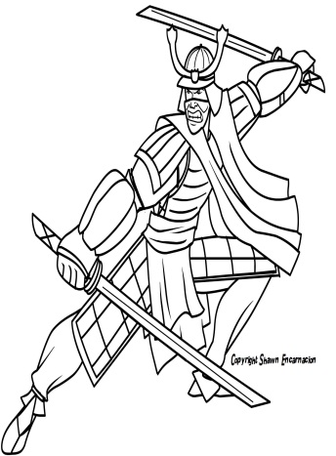
I. Introduction
The samurai had an unwritten code of behavior that later became known as bushido-the way of the warrior. The samurai code emphasized (stressed) loyalty to one’s overlord (master) and family values. It placed great value of courage, honor, self-discipline, and a sense of putting the needs of others above their own. The warrior was well disciplined and was prepared to die in battle. To the samurai capture or surrender was dishonorable.

DIRECTIONS: Read through the chart below about the role of a Japanese samurai compared to a European knight. Highlight/underline the similarities between the two and box the differences. Also, circle words/phrases you do not understand. Then, fill in the template below.

Japanese Samurai | European Knights
The role of the samurai was to fight for his lord in exchange for an allowance. Samurai entered into battle with iron and leather armor, swords, and bows and arrows. Samurai were required to show fairness and generosity to those weaker than himself. Samurai expected women to live up to the same values of honor and courage like samurai men. Samurai were expected to live by the code of honor called Bushido. The Code of Bushido values bravery and loyalty to their lord above all else. If a samurai is defeated or brings dishonor to the code, he will commit a ritual suicide known as seppuku. | The role of a knight was to fight for his lord in exchange for land. Knights entered into battle with chain mail or plate armor, broadsword, and lace. Knights were required to protect the weak and the poor. Knights viewed women as weak creatures to be idolized and defended. Knights were expected to live by the code of honor called Chivalry, which values bravery and loyalty to heavenly god, earthly lord (a noble), and chosen lady. If a knight dishonored the code by being a coward, he would have his armor striped off, his shield cracked and his sword broken over his head.

Both Japanese and Europeans had governments known as feudalism. In the both feudal systems, they had a certain groups that were required to protect others. In Japan, they were known as samurai. In Europe, they were referred to as knights. The samurai and knights had many similarities and some differences.
One similarity the Japanese Samurai and European Knights had were they both lived by codes of behavior. The samurai lived by a code called ______________________________, while the knights lived by the code called______________________. There are many similarities and differences between the codes of behavior of the Japanese Samurai and the European Knights. One similarity between them was ______________________________________________________________________________________________________________________. Another similarity was _____
_______________________________________________________________________________________. These warriors also shared a few differences as well. The first difference was ___________
______________________________________________________________________________________________________. Another difference was ________________________________
___________________________________________________________________________.
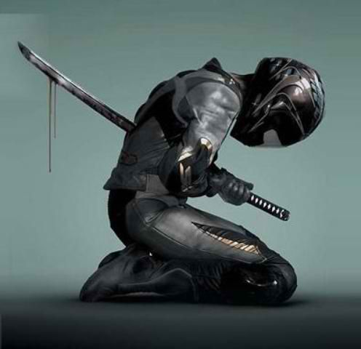
Seppuku
If the Samurai misses his objectives (goals) and continues to live, he must be seen as a coward. Rather than fall into enemy hands, a samurai, commonly committed suicide. The act of seppuku involved the act of stabbing a knife into the left side of the abdomen (stomach), then drawing the blade across to the right, and giving a final upward twist toward the chest.

You are going to watch a film clip that will show the act of seppuku being carried out by a samurai.

Regents Questions:

1. The code of Bushido of the Japanese samurai is most similar to the
1. belief in reincarnation and karma of Hindus
2. practice of chivalry by European knights
3. teachings of Judaism
4. theory of natural rights of the Enlightenment writers

2. Both European medieval knights and Japanese samurai warriors pledged oaths of
1. loyalty to their military leader
2. devotion to their nation-state
3. service to their church
4. allegiance to their families

