DIRECTIONS: The enduring issue your Ancient Rome project will cover is “How is power gained, consolidated, maintained, and lost?” After each Layer A activity, categorize each sheet into where it best fits in the chart below. Please check in with Mr. Smith & Mrs. Sarno-Ullo to ensure your answer is correct.

GAIN  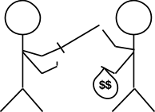  Gaining power is the process of getting it and expanding it. | CONSOLIDATE  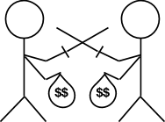  Consolidating power is the process of taking control from other people/places who also have power. | MAINTAIN  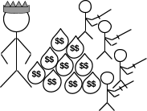  Maintaining power is the process of keeping power. | LOSE  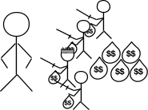  Losing power could be the result of one’s own actions or a power grab from another group or individual.
How did Ancient Rome gain power? | How did Ancient Rome consolidate power? | How did Ancient Rome maintain power? | How did Ancient Rome lose power?

