Christianity
I. Introduction
By 60 B.C.E. the land of Judah (Judea to the Romans) was under Roman control. The Jewish kings and Roman governors who ruled the province (territory) were unpopular with the people. Many Jews hoped that, miraculously, a king from the House of David would descend from heaven to replace the Roman rulers. Thousands of Jews eagerly awaited the arrival of their king. They called this future king the Messiah (the anointed, or enthroned one).Jesus, a Jew, was born in the city of Bethlehem in 3 B.C.E. He preached that people should love God and other men and women. Jesus, emphasized the spirit, not the letter, of the law. He said that God cared more for people than for laws. He embraced the uneducated and the poor, and he encouraged charitable acts. Material goods were unimportant. Since many of his followers believed that Jesus was the Messiah, he was called the Christ (the Greek word for Messiah is christos). His followers were called Christians.

II. The Message
Jesus’ teachings were firmly rooted in Jewish tradition. He believed in one God and accepted the Ten Commandments. Jesus emphasized God’s love and taught the need for justice, morality, and service to others. According to Jesus, a person’s major responsibilities were to “love the Lord your God with all your heart” and to “love your neighbor as yourself”. Jesus emphasized the importance of forgiveness. “Love your enemies,” he told his followers. “If anyone hits you on one cheek, let him hit the other one, too.” The Roman rulers looked upon Jesus as a revolutionary and a threat to their government.

Directions: Actively read the document below. Highlight/underline the PERSPECTIVES of the Roman, Gaius, versus Sulla, Christian. Compare the beliefs of Romans and Christians.

In our story, Gaius a young Roman, recalls the first time he encountered a group of Christians.

Sulla: Come Gaius, let us go to the Colosseum today. I want you to see how Rome deals with its most dangerous enemies.

Gaius: Who are these enemies of Rome?
Sulla: I’ll explain everything when we get there. Wait until you see the crowd gathered at the Colosseum. There must be tens of Thousands there already.
Gaius: Wow, they must be pretty dangerous all right!
Sulla: All right, we’re here.
Gaius: Ok, now who are these enemies of Rome?
Sulla: They call themselves Christians.
Gaius: Go on.
Sulla: The Christians teach that all men and women are brothers and sisters, and that we should strive for goodness rather than wealth and pleasure. They also believe that that there is eternal life after death, and true followers of their religion go to a place called heaven when they die.
Gaius: I know that wealth, power and pleasure are very important to us Romans, but what other reasons make them so dangerous to us?
Sulla: The Christians mock us. They do not accept our Roman gods, and they refuse to take part in our religious festivals. They speak out against war. The men even refuse to serve in the army.
Gaius: They will not serve in our army. Don’t they know what an honor it is to be a Roman soldier? How do they think we became the greatest and strongest empire the world has ever seen? We Romans were destined to conquer the world and have others serve us.
Sulla: I know, but worst of all, they are disloyal to Rome. They deny that our emperor is a god, and they refuse to worship him.
Gaius: Do they worship any gods?
Sulla: They are monotheistic, meaning they believe in just one God, whose name was Jesus. They say they he took human form during the reign of Augustus. He preached and worked miracles, such as healing the sick and providing food for the poor. The Roman leaders thought that Jesus was a troublemaker. They arrested him, put him on trial, and executed him by crucifixion.
Gaius: Didn’t his death prove to his followers that Jesus was just a human being?
Sulla: His followers believe that he rose from the dead and went back to heaven. They believe that his death has made it possible for all who believe in him to find eternal life in heaven after they have passed from this life.

At that moment, the mob gave a mighty roar. Men, women and children were led into the arena. They were all dressed in the skins of wild animals. The guards left the arena, and a sudden hush descended over the crowd.
Suddenly, gates were raised and wild dogs driven mad by hunger rushed into the arena. The dogs hesitated for a moment as they spied the waiting throng of Christians. In that moment the Christians joined hands and began to sing. The dogs now began to attack the people and tear them apart with their mighty jaws and sharp teeth.

Gaius thought to himself: Even if these people were enemies of Rome, they did not deserve to die this way. Look at the courage they are showing, even as they face a most horrible death. I cannot help but admire them for this. Where did they get such courage? Did they get it by believing that the god who had died for them was a god worth dying for? I bet this is not the last I will be hearing of these people called Christians.
ROMAN PERSPECTIVE | CHRISTIAN PERSPECTIVE

Name: __________________________________ Band: ______

Directions: Using EVIDENCE from the documents, answer the question below.

Comparison:
- Student will identify a similarity or a difference between the ideas presented in documents 1 and 2.
- Student will explain a similarly or a difference in the ideas presented in these documents. Student must use evidence from both documents 1 and 2 in their response.

Document 1: Christian martyrs thrown to the lions in the amphitheatre in ancient Rome.
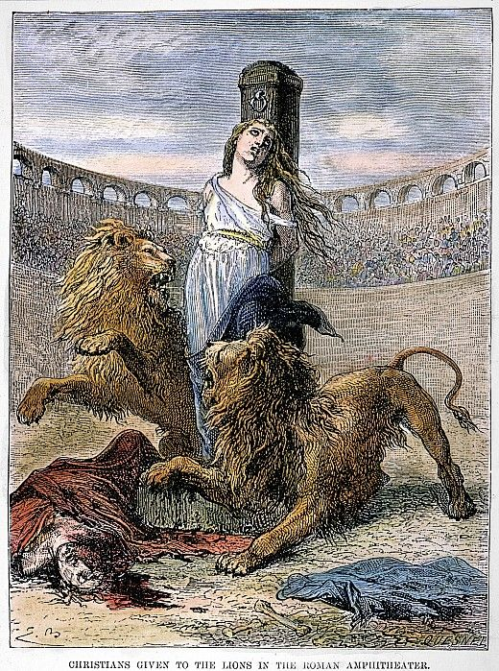
Document 2:
“But to you who are listening I say: Love your enemies, do good to those who hate you, bless those who curse you, pray for those who mistreat you. If someone slaps you on one cheek, turn to them the other also. If someone takes your coat, do not withhold your shirt from them. Give to everyone who asks you, and if anyone takes what belongs to you, do not demand it back.” –Luke 6: 27-30

1A. Identify a similarity or a difference regarding the ideas about the treatment of people in society as expressed in documents 1 and 2. .

SCORE OF 1: | SCORE OF 0:
Identified a similarity or a difference regarding the ideas about the treatment of people in society using both documents. | - Incorrect response (did not accurately identify a similarity or difference).  - No response.
1b. Explain a similarity or difference regarding ideas about the treatment of people in society as expressed in documents 1 and 2. Be sure to evidence from both documents 1 and 2 in your response.

SCORE OF 1: | SCORE OF 0:
Explains a similarity or a difference regarding the ideas about the treatment of people in society using both documents. | - Only identified and does not explain.  - Did not use evidence relate to information in both documents.  - Provided incorrect information.  - Did not answer the question (no response).

