NAME: ____________________________________________ BAND: _________

Semester 1 - ENDURING ISSUES ESSAY
- An enduring issue is a challenge or problem that a society has faced and debated or discussed across time. An enduring issue is one that many societies have attempted to address with varying degrees of success.

- To identify an Enduring Issue a student must analyze each of the documents, determine the issues in each document, and then group those issues under a common category that contains all of these other issues. This common category is the student’s Enduring Issue.

- The identified Enduring Issue must be an issue that has affected people or has been affected by people and has continued to be an issue across time or has changed over time.

- Defining the Enduring Issue will require information from the documents and the application of social studies knowledge.

- The identification of the Enduring Issue will be dependent on the documents provided, the context of those documents, and the perspective or lens the student uses to interpret those documents. This set of circumstances will affect how the Enduring Issue is defined.

Task: Extended Essay
An enduring issue is an issue that exists across time. It is one that many societies have attempted to address with varying degrees of success.

In your essay:
- Identify and define an enduring issue raised by this set of documents.
- Using your knowledge of Social Studies and evidence from the documents, argue why the issue you selected is significant and how it has endured across time.

Be sure to:
- Identify the issue based on a historically accurate interpretation of three documents.
- Define the issue using evidence from THREE documents.
- Argue that this is a significant issue that has endured by showing
  - How the issue has affected people or been affected by people
  - How the issue has continued to be an issue or changed over time
- Include OUTSIDE INFORMATION from your knowledge of social studies and evidence from the documents.

STEP 1: Actively read the document
- Highlight/underline important information in the document; annotate

STEP 2: Identify the enduring issue the document best is associated

POWER – unfair distribution of power (power isn’t equal amongst people in a society); relationship to ruler and those who are ruled are different
- Power has its pros and cons. In certain societies, some lack access to power, or there is unfair distribution of power; in addition, social classes can play a role in power as well as people’s relationship to rulers.

VIOLATION OF HUMAN RIGHTS/INEQUALITY- violation of basic rights and/or unfair treatment of people in a society
- Human rights are rights inherent to all human beings, whatever our nationality, place of residence, sex, national or ethnic origin, color, religion, language, or any other status. We are all equally entitled to our human rights without discrimination; however, human rights can be limited by things such as social hierarchies, governments, belief systems, etc.

STEP 3: QUICK OUTLINE using bullet point format

STEP 4: Write essay (EXAM TO BE DONE IN CLASS)

Document 1: Hammurabi’s Code
Hammurabi’s Code
(Vocabulary: irrigation- a way to water crops , shekels- money, currency in Sumer)
Family Laws
Law 129: If a married lady is caught [in adultery] with another man, they shall bind them and cast them into the water.
Law 195: If a son has struck his father, his hands shall be cut off.

Property Laws
Law 21: If a man has broken through the wall [to rob] a house, they shall put him to death and pierce him, or hang him in the hole in the wall, which he has made.
Laws 53, 54: If a man has opened his trench for irrigation and the waters have flooded his neighbor’s field, the man must restore the crop he has caused to be lost.
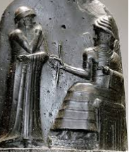
Personal Injury Laws
Law 196: If a man has knocked out the eye of a free man, his eye shall be knocked out.

Law 199: If he has knocked out the eye of a slave ... he shall pay half his value.

Law 209: If a man strikes the daughter of a free man and causes her to lose her baby, he shall pay 10 shekels of silver.

Source: Excerpt from Hammurabi’s Code: BCE 1754

1. The enduring issue this best associates with is
- POWER
- VIOLATION OF HUMAN RIGHTS/INEQUALITY

2. What information/quotes from the document show this E.I.?

3. What OUTSIDE INFORMATION (information that connects to the document) do you know about the Code of Hammurabi?

4. How did the Code of Hammurabi affect people, places, and societies (+/-)?

5. How has this change over time OR continued to be an issue?

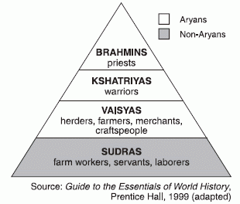
Document 2: Caste System
A caste is a social class in Hinduism that is determined by one’s actions in their previous life that one can only move out of through the process of reincarnation.

The four major castes in Hinduism are in the chart below. Not listed is a group called the Dalits, or “Untouchables.” Who are required to do disgraceful and “unclean work.”

The fourfold division of castes was created by me [Vishnu] according to the apportionment [distribution] of qualities and duties….The duties of Brâhmins, Kshatriyas, and Vaisyas, and of Sûdras, too...are distinguished according to the qualities born of nature. Tranquillity, restraint of the senses, penance, purity, forgiveness, straightforwardness, also knowledge, experience, and belief (in a future world), this is the natural duty of Brâhmins. Valour, glory, Courage, dexterity, not slinking away from battle, gifts, exercise of lordly power, this is the natural duty of Kshatriyas. Agriculture, tending cattle, trade, (this) is the natural duty of Vaisyas, And the natural duty of Sûdras, too, consists in service. (Every) man intent on his own respective duties obtains perfection. Listen, now, how one intent on one's own duty obtains perfection. Worshipping, by (the performance of) his own duty, him from whom all things proceed, and by whom all this is permeated, a man obtains perfection. One's duty, though defective, is better than another's duty well performed. Performing the duty prescribed by nature, one does not incur sin…. one should not abandon a natural duty though tainted with evil; for all actions are enveloped by evil, as fire by smoke.

Source: Kashinath Trimbak Telang, M. A., Trans. (1882). The Bhagavadgita. In F.M. Mueller (Ed.), The Sacred Books of the East (Vol.8)(pp. 43-46; 48-49; 51-52; 59; 126-128). Oxford: The Clarendon Press.Retrieved July 28, 2014, from http://www.sacred-texts.com/hin/sbe08/index.htm

1. The enduring issue this best associates with is
- POWER
- VIOLATION OF HUMAN RIGHTS/INEQUALITY

2. What information/quotes from the document show this E.I.?

3. What OUTSIDE INFORMATION (information that connects to the document) do you know about the caste system?

4. How did the caste system affect people, places, and societies (+/-)?

5. How has this change over time OR continued to be an issue?

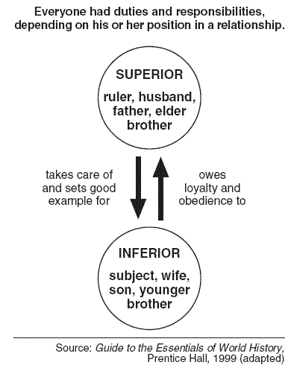
Document 3: Confucius

The Five Relationships
Confucius believed that there were five fundamental relationships in society:
- Ruler to Subject
- Father to Son
- Husband to Wife
- Older Brother to Younger Brother
- Friend to Friend

Each of these relationships showed who had more power over others. The only relationship that is equal is between friends.

1. The enduring issue this best associates with is
- POWER
- VIOLATION OF HUMAN RIGHTS/INEQUALITY

2. What information/quotes from the document show this E.I.?

3. What OUTSIDE INFORMATION (information that connects to the document) do you know about Confucianism?

4. How did Confucianism affect people, places, and societies (+/-)?

5. How has this change over time OR continued to be an issue?

OUTLINE
Name: __________________________________________ Band: _______
What enduring issue will you write about in your essay?
- POWER
- VIOLATION OF HUMAN RIGHTS/INEQUALITY

The three documents that I will use are document # ____, document # ____, and document # ____.

¶ | DETAILS
Parag  #1  INTRO | 1. General Statement:  2. Enduring issue & definition:  3. Thesis Statement/Claim-- Make a claim that argues why the enduring issue you chose is significant and list examples that will be discussed in the essay to show the issue has endured and is significant.  ___________________ (state enduring issue) is significant because ____________________  __________________________________________________________________________________________________________________________________________________________ as demonstrated by (list examples that will be discussed in the essay) _____________________________ _______________________________________(DOC 1), ________________________________  ________________________________________________________________________(DOC 2) _____________________________________________________________________(DOC 3).  *COMBINE STEPS 1, 2, AND 3 INTO PARAGRAPH FORM—GO IN NUMBER ORDER!*
Parag.#2  #3  #4 | For paragraph 2, 3, & 4, use the three documents that address a common enduring issue. Use the information provided on the document page. (Each document will be its own separate paragraph.)  TEAL:  1. (T) TOPIC SENTENCE that includes the enduring issue, the general idea of the document, and claim (positive/negative).  EX: The violation of human rights can been seen in the Code of Hammurabi, which had a negative impact on Mesopotamian society.  2. (E) Explain the document making connections to the enduring issue.  3. (E) Explain outside information making connections to the enduring issue.  4. (A) Analyze how the document affected people/societies  5. (E) Explain how this document changed over time OR continued to be an issue.  6. (L) Link to the next paragraph  Continue this process for the next two documents.
Parag  #5  CONCL | RESTATE THESIS STATEMENT:  SUM UP IDEAS (explain important points from each paragraph):  CLOSING SENTENCE:

