Geography of India
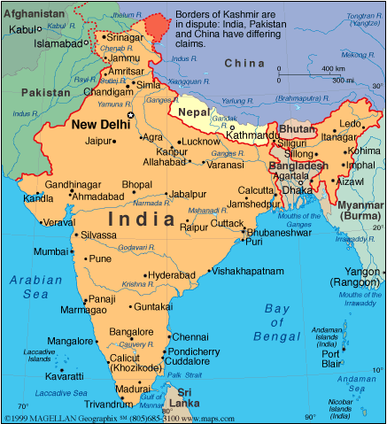
Introduction:
India is the world’s seventh largest country in size. It is approximately one third the size of the United States of America. India is located in Southeast Asia. India is often called a subcontinent, which means that it’s a part of the continent of Asia, but it’s so big that it has many differences in geography. India has a large population, diverse physical features, climates (weather), vegetation (trees, plants, etc), religions, and languages. In other words, there are as many differences in the country of India as there are in a huge continent.

Q. According to the reading above, why is India a “subcontinent?”
__________________________________________________________________________________________________________________________________________________

DIRECTIONS: With your group members, visit each station about the geography of India. Assess the GEOGRAPHIC CONTEXT of India affects the people who live there and evaluate whether the information provided is harmful or beneficial to the people that live there.

GEOGRAPHIC FEATURE/  WEATHER | BENEFICIAL  (good) | HARMFUL  (bad)
HIMALAYAS

DECCAN

GANGES RIVER

MONSOONS

NAME: _______________________________________ BAND: _______
INDIA’S GEOGRAPHY
DIRECTIONS: CHOOSE ONE OF THE FOLLOWING ACTIVITIES BELOW.

ACTIVITY 1-VISUAL: Create a visual that represents if you think India’s geography is more beneficial or harmful to its people. Then, explain you visual. BE SURE TO USE KEY WORDS LEARNED

EXPLANATION (4-5 SENTENENCES): ____ ____ ____ ____ ____ ____ ____ ____ ____ ____ ____

ACTIVITY 2-TEAL PARAGRAPH: Using TEAL strategies fill in the template below to answer the following question: How does the geographic context of India affect the people who live there?

The geographic context of India affect the people who live there in a positive/negative (circle one) way. One reason is (state the evidence) _____________________________________________________
____________________________________________________________________________________________________________________________. This shows that the geographic context affects the people of India and is a positive/negative (circle one) for them to live in because (analyze) ______________ _______________________________________________________________________________________________________________________________________________________________________________________________________________________________________________________________________________________________________________________________. A second reason the geographic context of India affect the people who live there in a positive/negative (circle one) way. One reason is (state the evidence) _________________________________________________
___________________________________________________________________________________________________________________________________________________________. This shows that the geographic context affects the people of India and is a positive / negative (circle one) for them to live in because (analyze) _______________________________________________________________
_______________________________________________________________________________________________________________________________________________________________________________________________________________________________________________________________________________________________________________. Overall, the geography of India is very diverse; however, the advantages outweigh the disadvantages /the disadvantages outweigh the advantages (circle one).
EXCELLENT (5)  - Chooses to create and advertisement or write argumentative statement.  - Uses relevant information in the activity that demonstrates a clear and detailed understanding of India’s geography.  - Product is creative, accurate, and complete. | GOOD (3-4)  - Chooses to create and advertisement or write argumentative statement.  - Uses relevant information in the activity that demonstrates a clear and somewhat detailed understanding of India’s geography.  - Product is complete and creative. | SATISFACTORY (1-3)  - Chooses to create and advertisement or write argumentative statement  - There are not enough details and information about India’s geography.  - Uses one key word and/or two key words, but does not display a clear understanding of the definition. | UNSATISFACTORY (0)  - Chooses to create and advertisement or write argumentative statement  - There are minimal details  and information about India’s geography.  - Product incomplete or does not attempt to complete task.

