Mandate of Heaven
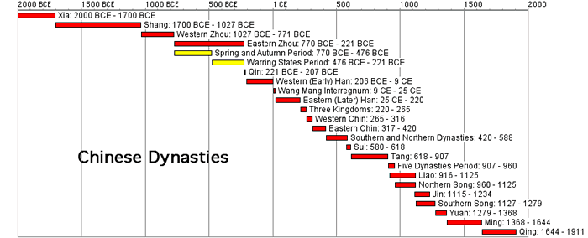
The civilization of Ancient China dates back thousands of years. Over this long period of time much of China was ruled by different dynasties or ruling families governed China. There were 24 dynasties, starting with the Shang dynasty and ending in 1912.

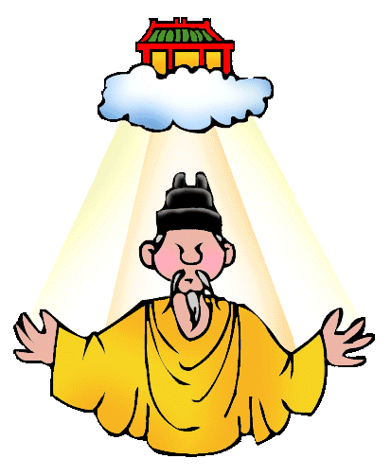
The Mandate of Heaven is what the Chinese people believed gave their rulers the right to be king or emperor. It meant that the gods had blessed that person with the right to rule. A ruler had to be a good and just (fair) ruler to keep the Mandate of Heaven. A wicked or foolish ruler could lose the Mandate of Heaven and lose the right to rule. Floods, famine (mass starvation), or other disasters were signs that a dynasty had lost the blessing of the gods. When a ruler or dynasty lost power, this meant that they must also have lost the Mandate of Heaven. Since dynasties rise and fall and are replaced by new ones, this is known as the dynastic cycle. The dynastic cycle always begins with a new dynasty that overthrows and old and aging dynasty that has lost the Mandate of Heaven. If a dynasty became weak or corrupt (bad), the Chinese believed that Heaven would withdraw (take away) it support of the dynasty and give the people the right to overthrow (mostly with violence) the old dynasty and replace it with a new one.

What is the purpose of the Mandate of Heaven? _____________________________________________________________________________________________________________________________________________________________________________________________________________________________________________________________________________________________________________________________________________________________________________

MANDATE OF HEAVEN—DYNASTIC CYCLE

ACTIVITY: Analyze the dynastic cycle flow chart below. Complete the chart by placing the correct information listed below in its appropriate spot. Use the information discussed today to guide you.

- Dynasty is overthrown through rebellion and bloodshed. New Dynasty starts.
- Disasters, such as floods, famines, peasant revolts, and invasions occur.
- After several generations, the new dynasty becomes old dynasty and becomes corrupt (bad), raises taxes, and power is weakened.
- New dynasty gains power restores peace and order and claims the Mandate of Heaven.

Strong new dynasty restores peace; builds roads, irrigation systems, repairs defensive walls
Old dynasty is seen as having lost the Mandate of Heaven; rebellion & violence against the old dynasty by the people is justified (allowed)

The Dynastic Cycle in China
The Role of the Mandate of Heaven

Present Day relationships between rulers and natural disasters

Trump's claim of success in Puerto Rico hurricane response derided (ridiculed/mocked)

Source: BBC News; September 12, 2018

DIRECTIONS: In 2017, Hurricane Maria (category 5) hit the United States’ territory of Puerto Rico. There have been debates regarding President’s Trump’s actions towards the aftermath of the hurricane and aid provided to help the country. Below are some statements made by various officials reported by the source: BBC News (https://www.bbc.com/news/world-us-canada-45492197). Actively read the citations from the article below, answer the questions that follow.

- The mayor of its capital (Puerto Rico) tweeted: "If he [Trump] thinks the death of 3,000 people is a success, God help us all."

- Puerto Rico only finished restoring full power last month, 11 months after the hurricane hit.

- The island's Governor Ricardo Rossello issued a statement on Tuesday night, describing Maria as "the worst natural disaster in our modern history. Our basic infrastructure was devastated, thousands of our people lost their lives and many others still struggle"

- “[Hurricane] Maria”, he said [President Trump], was the "hardest one we had by far because of the island nature", adding: "I actually think it was one of the best jobs that's ever been done with respect to what this is all about.”

- Democratic Senator Chuck Schumer said: "This is an offensive, hurtful and blatantly false comment from the president."

- "The job that Fema [the Federal Emergency Management Agency] and law enforcement and everybody did working along with the governor in Puerto Rico, I think was tremendous. I think that Puerto Rico was an incredible, unsung success."-President Trump

- Senator Bernie Sanders tweeted: "Nearly 3,000 people died. That is not a 'success'. That is a tragedy and a disgrace."

- New York Democratic primary winner Alexandria Ocasio-Cortez, said: "Some of my [Puerto Rico] family just got power a few weeks ago. People are developing respiratory issues partly due to airborne fungal spores from lack of proper cleanup. The admin's response to Puerto Rico has been a disaster."

- “Some Trump supporters on social media accepted there had been failures but said the president had done all he could and that it was Puerto Rican officials who were to blame.”
According to the quotes above, what is President Trump’s perspective on how he handled the aftermath of Hurricane Maria as a ruler? _________________________________________________________________
________________________________________________________________________________________________________________________________________________________________________________________________________________________________________________________________________________________________________________________________________________________________

Using the Mandate of Heaven dynastic cycle, where would President Trump believe he stands? Explain your evidence. ________________________________________________________________________________
________________________________________________________________________________________________________________________________________________________________________________________________________________________________________________________________________________________________________________________________________________________________

According to the quotes above, what are the perspectives of those under President Trumps’ rule on how he handled the aftermath of Hurricane Maria as a ruler? _____________________________________________
________________________________________________________________________________________________________________________________________________________________________________________________________________________________________________________________________
________________________________________________________________________________________________________________________________________________________________________________

Using the Mandate of Heaven dynastic cycle, where would people ruled by President Trump believe he stands? Explain your evidence. _____________________________________________________________________
________________________________________________________________________________________________________________________________________________________________________________________________________________________________________________________________________________________________________________________________________________________________

The enduring issue this best associates with is (check all that apply)

- CULTURAL DIFFUSION
- HUMAN RIGHTS
- IMPACT OF ENVIRONMENT ON HUMANS
- POWER
- SCARCITY
- TECHNOLOGY

