Martin Luther & the Protestant Reformation

I. Introduction
During the 1300-1500’s, the abuses of the Catholic Church drew great criticism (disapproval) from a many people in Europe. Monarchs began to challenge the church’s power, merchants were angry with the high church taxes, and common people were disgusted with church corruption and hypocrisy. Unlike in the Middle Ages, people after the Renaissance were no longer afraid to question the Catholic Church. During the 1500’s, Martin Luther, a German reformer (a person who wants to change society for the better) confronted the Catholic Church about how it was corrupt, changing the course of history for the church in Europe. This turning point was known as the Protestant Reformation.

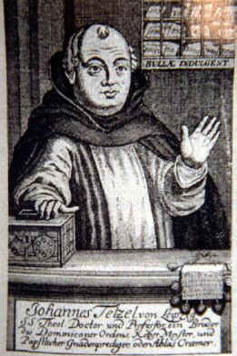DIRECTIONS: Read and evaluate the actions of both Johann Tetzel and Martin Luther. Make sure to use active reading skills (highlight/underline important words/phrases, circle words you do not understand). Then fill in the templates below.

II. Johann Tetzel’s Speech
In 1517, a German priest named Johann Tetzel sold indulgences to Germans. This is because RCC leaders wanted to rebuild the Cathedral of St. Peter’s Basilica in Rome. Tetzel offered indulgences any Christian who gave money to rebuilding the Church. Tetzel claimed that if Christians bought indulgences, they would not only enter into heaven, but also their dead relatives would as well. Below, is his Tetzel’s speech to Christians in Germany:

Dear Germans,
...I offer to you these letters of indulgence that you can use anytime in your life. With these letters, you can get full forgiveness for your sins and the sins of your dead loved ones, thus releasing their souls from the horrors of Purgatory!” And remember: “As soon as the coins in the money box rings, the souls out of Purgatory spring.”
Johann Tetzel was a German priest that was corrupt. He sold letters of indulgences to Christians because he and other Roman Catholic leaders wanted to ________________________________________________. According to the document, Johann Tetzel says, “As soon as the coins in the money box rings, the souls out of Purgatory spring”. This quote shows that Johann Tetzel’s actions were inappropriate because _______________
_______________________________________________________________________________________________________________________________________________________________.
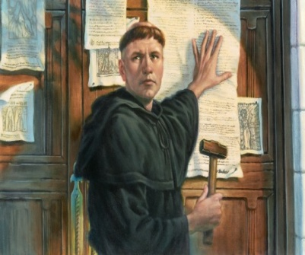
III. Martin Luther
Martin Luther was a German monk and professor. He did not like the corruption of the Catholic Church. Johann Tetzel’s action of selling indulgences for the Church’s benefit, made him angry. As a result, Martin Luther wrote 95 Theses (Arguments) criticizing the Catholic Church and religious figures like Johann Tetzel. Martin Luther posted his 95 Theses on the door of Wittenberg’s All Saints Church in Germany. This would be a turning point in history called the Protestant Reformation.

Some of Luther’s Arguments against the RCC:
# 2 – Paying for forgiveness is not the same as asking for forgiveness.
# 5 – The Pope doesn’t have the power to free a man from asking God for forgiveness.
# 43 – Christians should learn that giving to the poor is better than buying your way into Heaven.
# 50 – The poor should not have to pay for building St. Peter’s Basilica when they don’t have money for food or clothes.
# 86 – The Pope and his family are rich. Why doesn’t the Pope build St. Peter’s Basilica with his own money instead of taking money from the poor?

Martin Luther was a German monk who believed that the Roman Catholic Church was corrupt. As a result, Martin Luther posted 95 Theses, which were ________________________________________________. One of his arguments were (choose an argument above) ______________________________________
_______________________________________________________________________. Luther was justified (right)/not justified (not right) in posting his 95 Theses because _________________________
_______________________________________________________________________________________________________________________________________________________________.
IV. Effects of Martin Luther’s 95 Theses
In 1519, Martin Luther was excommunicated (thrown out) from the RCC by the Pope. In 1521, Luther met a group of Catholic officials and government leaders in a German city called Worms. This was known as Diet of Worms. These officials gave Luther a chance to recant (take back) his beliefs. He refused to take back what he said unless they could prove him wrong by the Bible or by reason. Because Luther did not recant his 95 Theses, the RCC said that Martin Luther was a heretic (someone whose beliefs go against the Catholic Church) and declared an outlaw. It was a crime for anyone to give Luther food or shelter. However, many people in Germany believed Martin Luther was a hero and accepted his teachings and did not follow the Pope’s teachings anymore. Instead, they followed Luther’s teachings, such as having faith would bring salvation (save someone from sin/evil) rather than doing good deeds to be saved. Followers of Martin Luther became known as Lutherans.

Three effects of Martin Luther posting his 95 Theses were (effect 1) ___________________________
_______________________________________________________________________________,
(effect 2) ________________________________________________________________________
_______________________________________________________________________________, (effect 3) ________________________________________________________________________
_______________________________________________________________________________.

How did the 95 Theses impact the following..
GROUP/PERSON | +/- | EXPLAIN
The RCC

Martin Luther

Followers of the RCC

