Printing Press Spreads Renaissance Ideas

DIRECTIONS: Read about the invention, the printing press. Highlight/underline important ideas/phrases and circle things you do not understand. Then answer the Regents questions below.
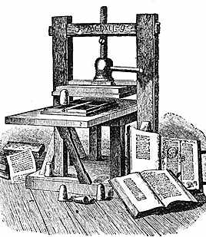
Two inventions greatly helped the spread of ideas during the Renaissance. In the mid 1400’s, Johannes Gutenberg, a German printer, invented movable metal type and the printing press. Before the 1400’s, books had to be copied by hand—a time consuming method. Consequently, books were rare, owned and read only by scholars and the wealthy. Guttenberg’s invention of movable type changed all that. People could buy books and expand their knowledge and questioned traditional ideas.

The printing press had a revolutionary impact on European society. It enabled (allowed) a printer to produce hundreds of copies, all exactly alike, of a single work. For the first time, books were cheap enough that many people could buy them. This was because the printing press could produce (make) copies of books quickly; therefore, making it cheaper for people to buy because there were a lot more copies than before. Printing spread quickly to other cities in Europe. By 1500, presses in about 250 cities had printed between 9 to 10 million books. The development of the printing press promoted a communications revolution. Information once available to a small percentage of people could now spread to vast numbers.

New ideas spread more quickly than ever before. At first, printers produced many religious works. Soon they began to provide books on other subjects such as travel guides and medical manuals. The availability of books encouraged people to learn to read and so caused a rise in literacy (more people could read and write). Readers gained access to a broad range of knowledge, from medicine and law to mining. The printing press would eventually even contribute to people questioning the Roman Catholic Church.

1. Which advancement in technology revolutionized the way ideas were spread throughout western Europe in the 15th century?
1. development of the astrolabe
2. introduction of the telegraph
3. improvements to the printing press
4. creation of the telescope

2. In western Europe, a long-term effect of the invention of Gutenberg's printing press was that the
1. monarchies were restored to absolute power
2. feudal system declined
3. literacy rate increased
4. development of new ideas was discouraged

3. A direct impact that the printing press had on 16th-century Europe was that it encouraged the
1. spread of ideas
2. beginnings of communism
3. establishment of democracy
4. development of industrialization

If you wanted to protest against something today, what medium would you use to communicate your cause? Why?
What was the impact of the printing press?

Ask students to consider how computers are related to the printing press.
Ask students to suppose that there are no printing presses. All books have to be carefully and slowly copied by hand and there are no newspapers or lmagazines. Have students think about how life would be different. Would information be harder to get? Would the levels of education and literacy among people be different?

