Martin Luther & the Protestant Reformation

Historic Context/Circumstances:
During the 1300-1500’s, the abuses of the Catholic Church drew great criticism (disapproval) from a many people in Europe. Monarchs began to challenge the church’s power, merchants were angry with the high church taxes, and common people were disgusted with church corruption and hypocrisy. Unlike in the Middle Ages, people after the Renaissance were no longer afraid to question the Catholic Church. During the 1500’s, Martin Luther, a German reformer (a person who wants to change society for the better) confronted the Catholic Church about how it was corrupt, changing the course of history for the church in Europe. This turning point was known as the Protestant Reformation.

DIRECTIONS: Actively read the documents below. Answer the questions that follow.

DOC 1: Johann Tetzel
In 1517, a German priest named Johann Tetzel sold indulgences to Germans. This is because RCC leaders wanted to rebuild the Cathedral of St. Peter’s Basilica in Rome. Tetzel offered indulgences to any Christian who gave money to rebuilding the Church.

In Heaven, there is a treasure chest filled with merit (reward). Merit from Christ Jesus, the Virgin Mary, and the Saints. Who, through their holy lives have merit to spare for us poor sinners in need. Tonight, that treasury is open to you…Because for a few coins you can rescue your deceased parents, grandparents, aunts, uncles, and siblings from their punishment and pain. “For when a coin in the coffer (money chest) rings the soul in purgatory springs”

1. Who is the intended audience of Tetzel’s speech? _________________________________________________________
__________________________________________________________________________________________________

2. Explain Tetzel’s purpose (to inform, persuade, entertain) for giving his speech on indulgences. __________________________________________________________________________________________________
____________________________________________________________________________________________________________________________________________________________________________________________________

3. Provide EVIDENCE/REASONS from the document that support Tetzel’s purpose. _______________________________
______________________________________________________________________________________________________________________________________________________________________________________________________________________________________________________________________________________________________

DOC 2: Martin Luther’s Ninety-five Theses
Martin Luther was a German monk and professor. He did not like the corruption of the Catholic Church. Johann Tetzel’s action of selling indulgences for the Church’s benefit, made him angry. As a result, Martin Luther wrote 95 Theses (Arguments) criticizing the Catholic Church and religious figures like Johann Tetzel. Martin Luther posted his 95 Theses on the door of Wittenberg’s All Saints Church in Germany. This would be a turning point in history called the Protestant Reformation.

This is an excerpt from the Ninety-five Theses.
Disputation [argument] of Doctor Martin Luther on the Power and Efficacy [effectiveness] of Indulgences, October 31, 1517

. . .21. Therefore those preachers of indulgences are in error (wrong), who say that by the pope’s indulgences a man is freed from every penalty (sin/wrong doing), and saved; …

27. They preach man [human doctrine] who say that so soon as the penny jingles into the money-box, the soul flies out [of purgatory]. …

36. Every truly repentant Christian (who seeks forgiveness for their sins) has a right to full remission of penalty and guilt, even without letters of pardon.

37. Every true Christian, whether living or dead, has part in all the blessings of Christ and the Church; and this is granted him by God, even without letters of pardon. . . .

Source: Martin Luther, Works of Martin Luther with Introductions and Notes, Volume I, A.J. Holman Company, 1915 (adapted)

1. Who is the intended audience of Martin Luther’s Ninety-five Theses? _________________________________________
__________________________________________________________________________________________________

2. Explain Luther’s purpose (to inform, persuade, entertain) for writing the Ninety-Five Theses. ____________________
____________________________________________________________________________________________________________________________________________________________________________________________________

3. Provide EVIDENCE/REASONS from the document that support Martin Luther’s Ninety-five Theses purpose. __________________________________________________________________________________________________
______________________________________________________________________________________________________________________________________________________________________________________________________________________________________________________________________________________________________
DOC 3: Diet of Worms
In 1519, Martin Luther was excommunicated (thrown out) from the RCC by the Pope. In 1521, Luther met a group of Catholic officials and government leaders in a German city called Worms. This was known as Diet of Worms. These officials gave Luther a chance to recant (take back) his beliefs.

“Unless I am convinced by Scripture and plain reason . . . my conscience is captive to the Word of God. I cannot and I will not recant anything, for to go against conscience is neither right nor safe. Here I stand, I cannot do otherwise."- Martin Luther, Diet of Worms (1517)

1. Who is the intended audience of Martin Luther’s speech at the Diet of Worms? ________________________________
__________________________________________________________________________________________________

2. Explain Luther’s purpose (to inform, persuade, entertain) for giving his speech. ________________________________
____________________________________________________________________________________________________________________________________________________________________________________________________

3. Provide EVIDENCE/REASONS from the document that support Martin Luther’s purpose. __________________________________________________________________________________________________
___________________________________________________________________________________________________________________________________________________________________________________________________
Name: ____________________________________ Band: __________

Protestant Reformation Homework

Directions: Actively read the document below. Then answer then identify and explain the cause and effect relation associated with the events/ideas in document 1 and 2.

Document 1: Document 2:
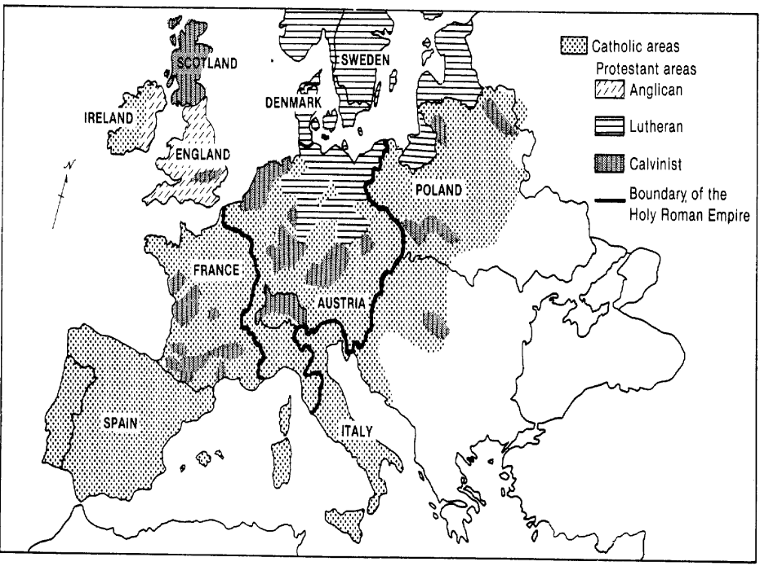
Martin Luther’s Ninety-Five Theses

2. An indulgence is not the same as praying for forgiveness, which the believer performs the ritual of confessing and feeling sorry for his sins with the help of a priest.

21. Priests who support indulgences and say that buying a certificate from the Pope or his representatives frees a man from punishments in the afterlife, are wrong.

22. Christians should be taught that he who gives money to a poor man, and good deeds is better than using the money to buy an indulgence

23. By buying an indulgence the man does not become better, only freer of punishment in the eyes of the Church, not in the eyes of God. It is belief, faith, and goodness that saves us.

24. Christians should be taught that if the Pope knew of the money his indulgences have taken from poor people, he would prefer that St. Peter’s Cathedral be burned to ashes rather than have it built with the flesh, bones, and skin of his people.

Source: Martin Luther’s 95 Theses

Cause: refers to something that contributes to the occurrence of an event, the rise of an idea, or the bringing about of a development.

Effect: refers to what happens as a consequence (result, impact, outcome) of an event, an idea, or a development.

Identify and explain a cause-and-effect relationship associated with these events of ideas in documents 1 and 2. Be sure to use evidence from both documents 1 and 2 in your response.
___ ___ ___ ___ ___ ___ ___
___ ___ ___ ___
___
___
___
___
SCORE OF 1: | SCORE OF 0:
- Identified a cause-effect relationship using both documents.  - Explains a cause-effect relationship using both documents. | - Only identified and does not explain a cause-effect relationship.  - Did not use evidence relate to information in both documents.  - Provided incorrect information.  - Did not answer the question (no response).

