Renaissance Men & Renaissance Women
DIRECTIONS: Read about “ideal”, or perfect, men and women during the Renaissance. As you read, highlight/underline important information that men and women were expected to do in order to be considered a “Renaissance man” or “Renaissance women”. Then fill in the Venn diagram comparing and contrasting what was expected of each and the characteristics they should embody.

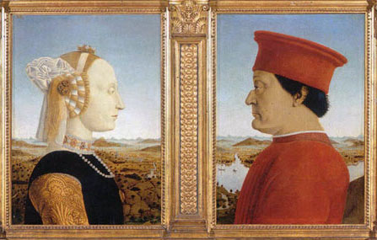
For Renaissance thinkers, the “ideal” individual (perfect person) strived to master almost every art. Those who excelled in many fields were admiringly known as “universal men”. Later ages called such people “Renaissance men”. A book called The Courtier by Baldassare Castiglione became widely popular because it told young people how to become a successful person whom everyone would admire. Castiglione believe that a man should be well educated in the Greek and Latin classics, as well as charming, polite, and witty (humor). A typical Renaissance man should also be able to dance, write poetry, sing, and play music. In addition, he should be physically graceful and strong, a skilled rider, wrestler, and swordsman.

Renaissance men tried to live up to this ideal. In his autobiography, Leon Battista Alberti boasted of his many skills. Here, in the third perso, is Alberti’s description of his accomplishments and interests:

He played ball, hurled (threw) the javelin (spear), ran, leaped, wrestled, and above all, delighted in climbing steep mountain. As a youth, he excelled in warlike games. With his feet together, he could leap over the shoulders of men standing by…He delighted in the organ and was considered an expert among the leading musicians.

In addition, Alberti designed and built several churches and made a few scientific studies. Alberti was the perfect example of his times of what it was to be a Renaissance man.

Upper class women of the Renaissance were as well educated as the men. According to The Courtier the ideal women were expected to know the Greek and Latin classics, to write well, to pain, to make music, to dance, and to be charming. Yet they were not expected to seek fame as men did. Women were expected to inspire poetry and art, but rarely to create it, meaning they may be an example for men to write about them in poetry and art. The most honored woman of the Renaissance in northern Italy was probably Isabellad’Este. Her art collection was famous throughout Europe. She brought many of the greatest Renaissance artists, including Leonardo da Vinci, to her city of Mantua. She was also skilled in politics. Isabella and a few other women of her time exercised real political power. For the most part, women were expected to create a charming home, but not to take part in public life. Although upper class women of the Renaissance were far better educated than the women of the Middle Ages, most Renaissance women had less political, economic, and social influence than medieval women.

