Name: ________________________________________ Band: ______
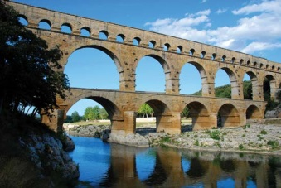
Roman Aqueducts

DIRECTIONS: Watch the videos on Roman aqueducts and modern day aqueducts. Evaluate their impact on societies and how it changed over time.

The Roman aqueduct was a channel used to transport fresh water to highly populated areas. Aqueducts were amazing achievements of engineering given the time period. Though earlier civilizations in Egypt and India also built aqueducts, the Romans improved on the structure and built an extensive and complex network across their territories.

- Read questions 1 & 2.
- Go to YOUTUBE.com
- Watch the Roman aqueduct video: https://www.youtube.com/watch?v=AMEy2R9Fp9U
- Take notes to help you answer the questions below
Notes:

After watching the Roman aqueducts video, answer the following questions:
- What was the purpose of the Roman aqueduct?
___________________________________________________________________________________________________________________________________________________________________________________________________________________________________________________________________________________________________________________________________________________________________________________________________________________________________________________________________________________________________________________________________________________________

- How did the aqueduct ensure the survival of the Roman Empire?
______________________________________________________________________________________________________________________________________________________________________________________________________________________________________________________________________________________________________________________________________________________________________________________________________________________________________________________________________________
- Read question 3.
- Go to YOUTUBE.com
- Watch the modern day aqueduct video: http://historicalmasterpieces.weebly.com/the-importance-of-roman-aqueducts.html
- Take notes to help you answer the questions below:
Notes:

After watching the Roman aqueducts video, answer the following questions:

- After watching the modern day aqueduct video (Colorado), how have aqueducts changed over time (structurally & purpose)?
___________________________________________________________________________________________________________________________________________________________________________________________________________________________________________________________________________________________________________________________________________________________________________________________________________________________________________________________________________________________________________________________________________________________

The enduring issue this best associates with is (check all that apply):
- CULTURAL DIFFUSION
- HUMAN RIGHTS
- IMPACT OF ENVIRONMENT ON HUMANS
- POWER
- TECHNOLOGY
- SCARCITY

