Changing Views of the Universe
Until well into the 1500’s, most Europeans saw little difference between science and magic. The spirit of the Renaissance encouraged curiosity, investigation, discovery, and the practical application of the knowledge of nature to everyday life. Some people felt freer to question old ideas and beliefs. They were moving willing to use new approaches to answering questions about the natural world. This historical change became to be known as the Scientific Revolution.

Despite the opposition of the religious authorities, by the early 1600’s, a new approach to science had emerged. Unlike earlier approaches, it did not rely on the Bible as a source to answer questions and problems. It depended, instead upon, observation and experimentation to explain problems or questions about the natural world. The new approach to science required scientists to collect and accurately measure data. To explain the data, scientists used reasoning to propose a logical hypothesis, or possible explanation. They then tested the hypothesis with further observation or experimentation. After reaching a conclusion, scientists repeated their work at least once-—and usually many times to confirm their findings. This step by step process of discovery became known as the scientific method.

DIRECTIONS: After reading the above information, place six of the seven steps of the scientific method in the correct order on the diagram below. Use the pictures and the reading above to help you. The first step is given to you in the diagram.
*YOU HAVE 3 TRIES TO GET IT RIGHT BEFORE POINTS GET DEDUCTED.*
- Experiment to test the hypothesis
- Form a hypothesis or educated guess
- Draw conclusions
- Repeat the steps
- Record and analyze the data
- Gather information on the problem
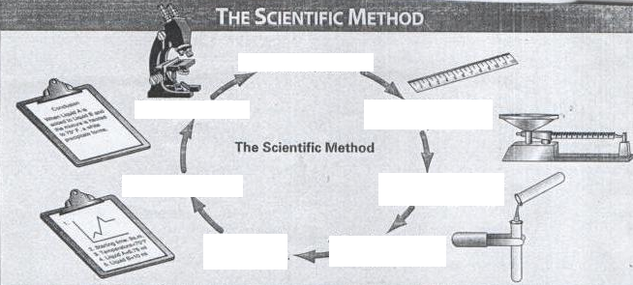
2.
1. State the problem
7.
6.
5.
4.
3.

After you CORRECTLY PUT THE STEPS IN THE PROPER ORDER ANSWER THE FOLLOWING QUESTION:
1. State the problem
2.
3.
3.
5.
4.

Why do you think step 7 is important?

How does the Scientific Revolution reflect the spirit/ideas of the Renaissance?

