The Neolithic Revolution
#6
#6

I. Introduction
The invention of tools, mastery of fire, and the development of language are some of the most impressive achievements in human history. Scientists believe these occurred during the prehistoric period known as the Stone Age. The Old Stone Age or Paleolithic Age lasted from 2.5 million to 8000 B.C.E The New Stone Age or Neolithic Age began in 8000 B.C.E and lasted to about 3000 B.C.E.

II. Paleolithic vs. Neolithic Living
DIRECTIONS: Using the documents below, analyze and compare and contrast the Paleolithic Age and Neolithic Age. Then using the evidence, evaluate which is more advanced and explain.

Document 1: Dwellings

Paleolithic Age vs. Neolithic Age
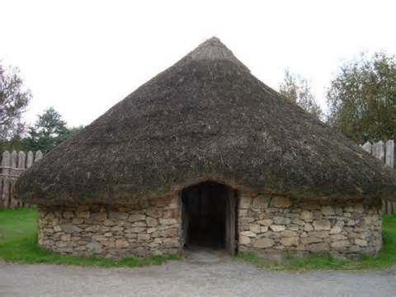
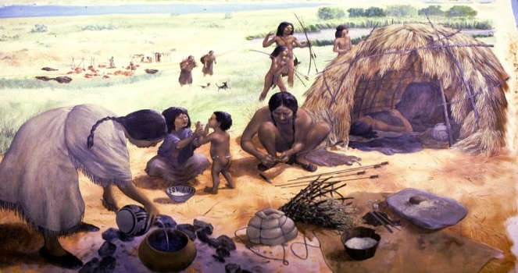

According to the documents, the difference in the Paleolithic dwelling compared to the Neolithic dwelling is that in the Paleolithic dwelling, it is ____________________________________________________________
_______________________________________________________________________________, while the Neolithic dwelling is ___________________________________________________________
_______________________________________________________________________________.
The evidence from the document proves that the Paleolithic Age/Neolithic Age (circle one) is more advanced because __________________________________________________________________________
_______________________________________________________________________________
_______________________________________________________________________________.
Document 2: Tools
Paleolithic Age vs. Neolithic Age
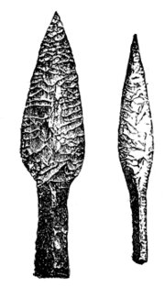
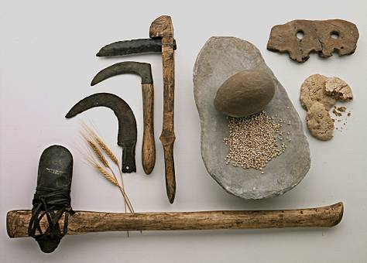

According to the documents, the difference in the Paleolithic tools compared to the Neolithic tools is that in the

the Paleolithic tools, they are ____________________________________________________________
_______________________________________________________________________________, while the Neolithic tools are ___________________________________________________________
_______________________________________________________________________________.
The evidence from the document proves that the Paleolithic Age/Neolithic Age (circle one) is more advanced because __________________________________________________________________________
_______________________________________________________________________________.
Document 3: From Food Gathering To Food Producing
. . . Paleolithic men could not control their food supply. So long as they relied on foraging (scavenging), hunting, fishing, and trapping, they were dependent on the natural food supply in a given area to keep from starving. But while Paleolithic men continued their food-gathering pattern of existence in Europe, Africa, and Australia, groups of people in the Near East began to cultivate edible plants and to breed animals. Often described as the “first economic revolution” in the history of man, this momentous change from a food-gathering to a food-producing economy initiated the Neolithic Age. Paleolithic man was a hunter; Neolithic man became a farmer and herdsman.

According to the documents, the difference in the Paleolithic compared to the Neolithic way of life of getting food resources is that in the Paleolithic people get their food by ________________________________________
_______________________________________________________________________________, while the Neolithic people get their food by __________________________________________________
_______________________________________________________________________________.
The evidence from the document proves that the Paleolithic Age/Neolithic Age (circle one) is more advanced because __________________________________________________________________________
_______________________________________________________________________________
_______________________________________________________________________________.
III. Cause & Effects of the Neolithic Revolution
DIRECTIONS: Actively read the story. Highlight/underline important things that describe the Paleolithic Age and the Neolithic Age. Then fill out the writing template by identifying the differences between the Ages and identifying the turning point associated with the ideas found in the document and explain why it is a turning point.

One day in the Paleolithic Age…
Today, we were out hunting for many hours in search of food. We are nomads, which mean we travel from place to place in search of food. We do not have a permanent home. We stay in a particular area for a short time and when there are no more animals left to hunt, or the weather is bad, we move to another place. Living in the Paleolithic Age is very hard.

But the very next day...
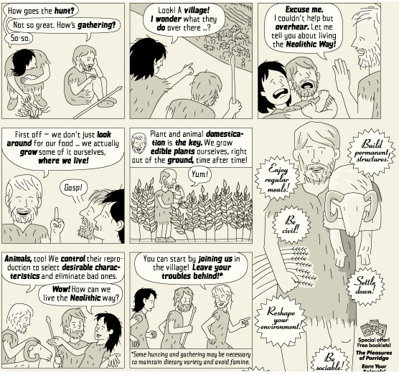

Throughout history, the way people lived has changed over time. From 2.5 million to 8000 B.C.E., people live in the time period known as the Old Stone Age, or also known as the Paleolithic Age/Neolithic Age (circle one). People in this period were known as ________________________. These were people who _____________
____________________________________. Their homes were permanent/not permanent (circle one). The way they got their food was by ___________________________________. After the Paleolithic Age/Neolithic Age (circle one), came the New Stone Age, known as Paleolithic Age/Neolithic Age (circle one). This was different than the Old Stone Age. Their homes were permanent/not permanent (circle one). People in this era got their food by _____________________. They did not hunt their animals. Instead, they ____________________ their animals. The (state the turning point) ___________________________ was a complete change in people’s lifestyle because humans ______________________________________
_________________________________________________________, ______________________
_______________________________________________________________________________,
and _____________________________________________________________________________.
3  - Selects the correct answer to the differences between the Ages using the document.  - Identifies the turning point associated with the event in the document  - Details are clear and accurate that explains why it is a turning point. | 2  - Selects the correct differences between the Ages using the document.  - Identifies the turning point associated with the event in the document.  - Details are clear, but may have 1 minor inaccuracy that explains why it is a turning point. | 1  - Explains the differences between the Ages using the document, but has 1 inaccuracy.  - Identifies the turning point associated with the event in the document.  - Details are unclear and/or inaccurate that explains why it is a turning point.

Directions: Examine the flowchart below. Using the text, images, and transitions below, write a series of sentences that explain how humans transitioned from the Paleolithic Era to developing the first civilizations.
Paleolithic Age Hunters and  Gatherers |  | Neolithic Revolution  Agriculture and Domestication |  | Food Surpluses  Extra Food |  | Population Increase  Population grows |  | Growth of Civilizations  and Cities
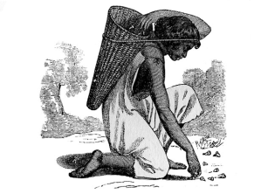 |  | 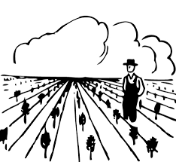 |  | 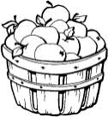

Transitions (You may use any of these transitions. You do not need to use all of them)
as a result | because | so | therefore | then, | initially, | next, | finally | eventually

In the space below, write a series of sentences that explain how humans transitioned from the Paleolithic Era to developing the first civilizations.

