**The Plow**

If you are going to plant [seeds](http://quatr.us/biology/plants/reproduction/seeds.htm), like [wheat](http://quatr.us/food/wheat.htm) seeds for example, and harvest them, then you are going to have to plow. Plowing is the hardest work of farming. Basically you have to make zillions of holes in the ground to put the seeds in, and you have to loosen up the soil around those seeds so that [water](http://quatr.us/environment) will get to them, and so that they will be able to grow. One way of doing this is with just any strong stick, with a point on one end: you stick it in the ground and wiggle it around, and then drop a seed in, and you cover it loosely with dirt, then you do it again, and again, and again, all day long. These are called digging sticks.

But it's faster to use a plow. The simplest kind of plow is a digging stick with a handle on it crossways - a scratch plow or *ard*. You push it along through the dirt, so it makes a groove, and then somebody else goes along behind you dropping the seeds in here and there, and using her foot to cover up the seeds again loosely. You can make the plow go a little better by hardening the wooden point in the [fire](http://quatr.us/africa/science/fire.htm), or by adding a [stone](http://quatr.us/environment/obsidian.htm), [bronze](http://quatr.us/arts/bronze.htm), or [iron](http://quatr.us/science/mining/iron.htm) point to the stick, to act as a wedge.

Now, you can make a plow go faster, by adding leather straps or ropes to the front of it, and fastening them to a [donkey](http://quatr.us/economy/donkeys.htm) or an [ox](http://quatr.us/economy/cattle.htm), or two donkeys or two [oxen](http://quatr.us/economy/cattle.htm), or even four sometimes. Now you push the plow while the animal pulls it. In heavier dirt, more like [clay](http://quatr.us/arts/clay.htm), which is common in river valleys like [Mesopotamia](http://quatr.us/westasia/history/sumerians.htm), it may be impossible to plow without animals.

**The Development of the plow through the ages**

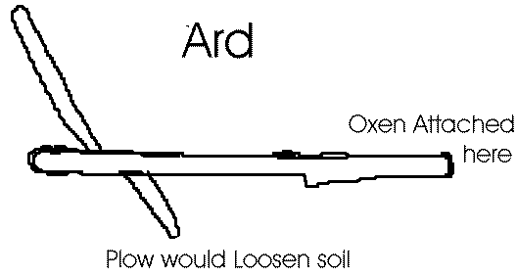

**Ancient Plow**

**[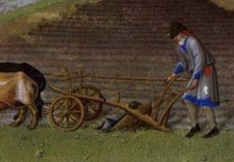](http://quatr.us/medieval/art/)**

**Plow of the Middles Ages**

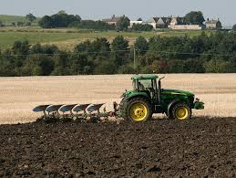

**Modern Day plow**