Trans-Sahra Trade Routes

I. Historic Context
. . The aridity [dryness] of the North African steppe turns to desolation [isolation] in the Sahara, the most extensive desert in the world. In popular imagination the Sahara is seen as a wilderness of sand dunes; yet it is a region of most varied landscapes, ranging from the great massifs [highlands] of Ahaggar and Tibesti with their extraordinary rock formations and their lofty volcanic peaks to vast stretches of gravelly plains or broad belts of constantly shifting dunes. The desert is not completely waterless––in certain parts, particularly on the northern fringes, excellent supplies of subterranean [underground] water support the rich culture of the oases—nor is it completely bereft of [without] vegetation. Men have thus found it possible to gain a livelihood in the Sahara whether as cultivators in the oases or pastoralists [herders] in other areas. . Source: Robin Hallett, Africa to 1875: A Modern History, The University of Michigan Press, 1970
According to Robin Hallet, how did the geographic context of Northern Africa affect its development? _______
________________________________________________________________________________________________________________________________________________________________________________________________________________________________________________________________________________________________________________________________________________________________

II. Trans-Sahara Trade Route
As the Sahara dried out due to desertification (fertile land becomes desert), some Neolithic people migrated southward into the savanna, an area of grasslands that was good for farming. By 100 A.C. E., settled agricultural villages were expanding. This expansion from farming villages to towns was due, in part, to the development of trade. Farming villages began to produce a surplus, which is making more food than they needed. They began to trade their surplus food for products from other villages. Gradually, a trade system linked the savanna (grassland area of Africa) to the rain forests in the south. Even though the Sahara was a large barrier, this did not prevent the trade of goods across the Sahara to civilizations along the Mediterranean, Europe, and in Southwest Asia. A series of trade routes that crossed the Sahara desert that connected West Africa with Mediterranean coast was called the Trans-Sahara Trade Route. Soon strong monarchs (kings & queens) arose, gained control of the most trade routes, and built powerful kingdoms. Three powerful kingdoms rose at different time periods in the West Africa. The first was called Ghana, followed by Mali, and then Songhai.

Directions: Actively read and analyze the documents about the Trans-Sahara Trade Route. You should annotate any social, political, and/or economic impact the gold-salt trade had on the three African kingdoms. Then, check which applies and explain.

Document 1: Gold & Salt Trade
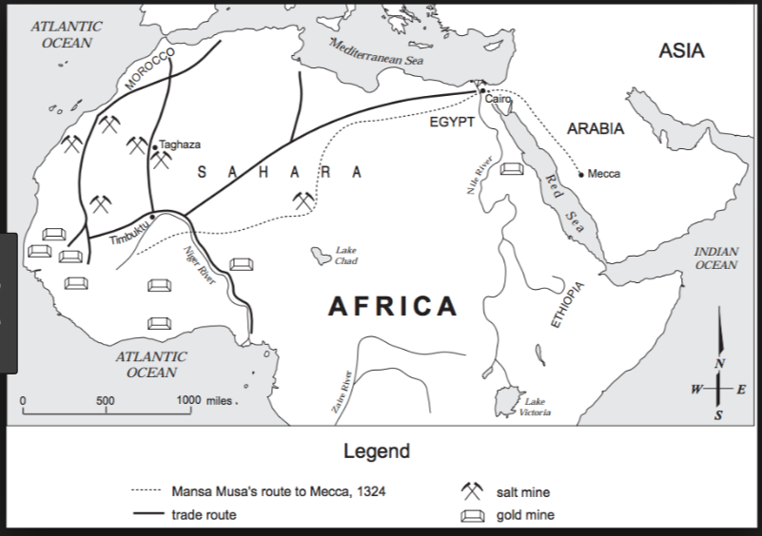

All this trade led to the founding cities. Most of these cities were especially concerned with the trade across the Sahara. They began as small trading settlements, but grew bigger as more traders came and went, and became centres for craftsmen who worked in leather, wood, ivory, and metals. City governments became necessary, as well as men trained to be put in charge of keeping accounts, of maintaining law and order, of ensuring the safety of citizens. Then the rulers of these cities began to extend their power to ever wider regions of neighbouring countryside. Gradually the cities grew into states, and the states into empires.…
Source: Basil Davidson, A History of West Africa to the Nineteenth Century, Anchor Books (adapted)

Explain the impact the gold-salt trade had on the development of West Africa.
________________________________________________________________________________________
________________________________________________________________________________________________________________________________________________________________________________________________________________________________________________________________________________________________________________________________________________________________
________________________________________________________________________________________________________________________________________________________________________________

Document 2: Timbuktu
…One of the chief trade centers for salt in the ancient world was the fabled city of Timbuktu. Located on the southern edge of the Sahara Desert, the city thrived on profits from the salt trade.…The salt trade made the city prosperous; in Africa, salt ranked with gold and slaves in value. For merchants to risk camels over hundreds of miles of burning sand, the profits must have been enormous. Nor did the city squander [waste] its wealth. Timbuktu’s salt trade supported schools and libraries; merchants lived in fine houses; the king paid handsome salaries to judges, doctors, and clerics—all from profits on the three-hundred-pound salt cargo that each camel carried.…
Source: Robert Kraske, Crystals of Life: The Story of Salt, Doubleday & Company

Explain the impact the city of Timbuktu had on the development of West Africa.
________________________________________________________________________________________________________________________________________________________________________________________________________________________________________________
________________________________________________________________________________________________________________________________________________________________
Document 3: Spread of Islam
. . . Merchants were carriers of Islam rather than agents of Islamization. They opened routes and exposed isolated societies to external (outside) influences, but they were not themselves engaged in the propagation [spread] of Islam, which was the work of religious leaders. The leaders became integrated into African societies by playing religious, social, and political roles similar to those of traditional priests. Like traditional priests, Muslim men of religion were peacemakers, who pleaded for those who broke the king’s laws. Mosques, like traditional shrines, were considered sanctuaries. Immunity (protection) of life and property was extended to men of religion only as long as they kept out of politics and posed no threat to the existing sociopolitical order. . . .
Source: John L. Esposito, ed., The Oxford History of Islam, Oxford University Press from the NYS Global History and Geography Regents Examination, August 2010.

Explain the impact Islam had on the development of West Africa.
________________________________________________________________________________
________________________________________________________________________________________________________________________________________________________________________________________________________________________________________________________________________________________________________________________________
________________________________________________________________________________
________________________________________________________________________________
HOMEWORK: Actively read the stimuli questions below; then choose the best answer.
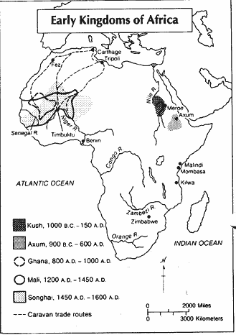
1. Which conclusion regarding early African trade is supported by the information provided by this map?
- The kingdom of Zimbabwe grew rich from trade with Egypt.
- The kingdoms of western Africa traded with the city states of eastern Africa.
- The Congo and Zambezi Rivers played an important role in Africa's early trade.
- The west African kingdoms had trading contacts with the cities of the Mediterranean.

2. “. . . The King is a declared enemy of the Jews. He will not allow any to live in the city. If he hears it said that a Berber merchant frequents them or does business with them, he confiscates his goods. There are in Timbuktu numerous judges, teachers, and priests, all properly appointed by the king. He greatly honors learning. Many hand-written books imported from Barbary are also sold. There is more profit made from this commerce than from all other merchandise. . . .”
— Leo Africanus, The Description of Africa, 1526

This passage suggests Timbuktu was a city that
- participated frequently in war
- emphasized literacy and trade
- protected the human rights of all citizens
- selected political leaders through democratic elections

