**DIRECTIONS: Using the Venn Diagram below, outline the similarities and differences between what a “Renaissance man” and “Renaissance women” should embody (characteristics, what should they do, how should they act, etc.). Remember, where the two circles overlap is where you put the things that are the same. The outside, where the two circles do not meet, are the differences.**

**Similarities**

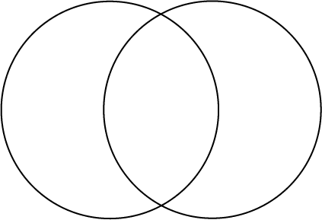

**“Renaissance Women”**

**“Renaissance Man”**