The Roman Military—Waging War and Keeping the Peace

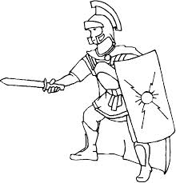
Without their huge, well-trained army, the Romans could not have conquered or controlled the vast territory that became the Roman Empire. The Roman army attracted hundreds of thousands of men. Many poor men joined the army because of the opportunities available. In the army soldiers received pay, food, a place to live, and the chance to learn a trade. Advancement was possible and when they returned, soldiers might be granted land or money. Life as a soldier was not easy. Training began when boys were about 16 and enlistment (when they joined) was for 20 to 25 years. Soldiers were not allowed to marry. They might be stationed far from home for long periods of time. There was also the definite possibility of being killed in battle. The Roman army was made up of thousands of foot soldiers called legionaries. About 5,000 soldiers made up each legion. They trained hard and discipline was strict. In addition to the foot soldiers, men in the cavalry were soldiers who rode horses. They were more highly paid, but had to provide their own horses and equipment. Cavalry soldiers patrolled the borders, scouted ahead during campaigns (battles), and guarded the army’s flank (the rear of a charging army). Soldiers wore iron helmets and body armor made of hinged metal plates or chain mail. They carried wooden shields covered with leather for protection. Their main weapons were short swords about 20 inches long, daggers and spears. When the soldiers were not conquering new territory, their job was to build roads, guard the frontiers, and put down uprisings.

ADVANTAGES | DISADVANTAGES

Write a TEAL paragraph answering the following question:
Do the disadvantages outweigh the advantages of joining the Roman army or do the advantages outweigh the disadvantages of joining the Roman army?

