What led to the Renaissance?

DIRECTIONS: Actively read the information below, then list and explain three causes of the Renaissance.

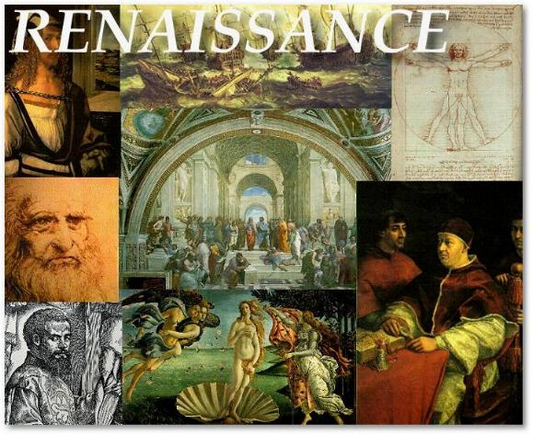
The Black Death epidemic change Europe dramatically. The rapid spread of disease killed 1/3 of the population. In Europe, the plague brought terror and confusion, as people had no way to stop the disease. The late Medieval Ages brought spiritual crisis, scandal, and division to the Roman Catholic Church. Many priests and monks died during the plague and their replacement faced challenging questions from survivors of the Black Death who asked, “Why did God spare some and kill others?”

The Roman Catholic Church, which controlled all the spiritual and secular life of people during the Medieval Ages, could not provide answers as to why the Black Death killed so many people. Also, kings and other leaders could not protect people against the Black Death. Many witnessed their close friends, family, and neighbors die painful deaths. As a result, people in Europe began to question their leaders. Because the church and feudal leaders could not provide the answers, the church and leaders were no longer looked up to. Those who survived wanted to celebrate life and the human spirit. They began to question institutions like the church, which had been unable to relieve the suffering brought by the plague. Some people questioned the Church which taught Christians to endure (tolerate, experience) suffering while they would be rewarded with a place in heaven for their suffering. People began looking for their own answers to questions, such as “Why God had allowed the plague?” or “Why God made Europe become such a chaotic place in the world”? Thinkers and educated elitists (rich) began to search for answers for their own thinking that was outside of approved church doctrine (guidelines/rules). The inability of the church to control entire education, thinking, and published works began to weaken the power and control the Church had over European society.

Another reason that contributed to the Renaissance was the decline of feudalism, which was the basis of life in Medieval Times. The expansion of trade and of the food supply encouraged the growth of towns. Towns contributed to the decline of the feudal system. Many serfs fled from the manors with the hope of hiding in a crowded town. After remaining in the town for a year and a day, serfs could legally claim their freedom and their lord could not force them to return to the manor. Serfs could now find jobs and earn salaries. Towns also brought the rise of a new social class—the middle class. The middle class was made up of merchants and their families. The life of people in the middle class was very different from that of the Church and nobles. Their world was the market (place to buy goods) rather than the Church or the manor. Members of the middle class owed nothing to a lord. Their wealth came from trade and not the feudal lord or the blessing of the Church. This gave a serious set back to Feudalism and manorial life.
The Crusades (holy wars between the Christians and Muslims) fought between 11th and 14th century was another factor that resulted in the Renaissance. In the beginning, the Crusades had strengthened the power of the pope. It was the Pope who had inspired the crusading armies and acted as their spiritual leader. Later, Popes, however, called for crusades against heretics (non believers) and rulers who resisted the pope’s commands. Many Christians came to believe that the Pope was using religious beliefs just to boost the Church’s political power. As these criticisms grew, the power and prestige (status) of the Pope and the Church fell. The Crusades also brought Christians in contact with the Muslim world which they never knew existed. Soon, a few curious Europeans had left to explore far off places such as India and China. They brought Europe into a wider world from which it had been cut off since the fall of Rome. In the 1400’s a desire to trade directly with India and China would lead Europeans to a new age called the Renaissance.

In Europe, people began to reject the values of society in the Medieval Ages and a new period began. This period was called the Renaissance, meaning “rebirth.” This time in Europe was the “rebirth” of learning and rediscovery of old ideas of the Greeks and Romans which were left behind or forgotten in the Medieval Ages. The Renaissance was a time when Europeans began to question old values and explore the world around them. It was an age of adventure and curiosity. The Renaissance produced new attitudes towards culture and learning. Unlike medieval scholars, who were more likely to focus on life after death, Renaissance thinkers explored the richness and variety of human experience in the here and now (present time). The Renaissance was a reentrance into the secular world instead of the religion. People began to inquire (ask questions) and become self-reliant. The Renaissance also emphasized individual achievement—The Renaissance ideal was the person with talent in many fields.
The Renaissance
DEFINITIONS  Define the following key words: | The Renaissance:  Black Death:  Feudalism:  Crusades:
HISTORICAL CIRCUMSTANCE:  LIST and EXPLAIN the causes of the Renaissance (bullet point format). | Cause 1: _________________________________________  Explanation:  Cause 2: _________________________________________  Explanation:  Cause 3: _________________________________________  Explanation:

