Africa

I. Geographic Context
Africa has been known as the “Dark Continent”, a land of mystery and the unknown. It has been isolated for many years. This is because of Africa’s geography. The only thing that was known about Africa was the Sahara Desert, the world’s largest desert in North Africa. The Sahara Desert is larger than the whole United States. It extends from the Red Sea in the east to the Atlantic Ocean in the west. The desert is made up mostly of rock than sand. Because the Sahara Desert is so large, it has been an obstacle (blockage) to travel between North Africa and Central Africa. As a result, it has limited cultural diffusion (the exchange of ideas) between the heartland of Africa and the Mediterranean coastlands. Another factor has also caused Africa to be isolated was its unbroken and irregular coastline in sub-Sahara Africa (below the Sahara Desert). Due to an irregular coastline, there are few natural harbors for ships to anchor in for trading and exploration. It is also difficult for ships to sail northward along the west coast because the winds and ocean currents are always from the northeast. Because of Africa’s complex geography, there are many different African groups. They organize themselves to meet their political, economic, and social needs. In the varied regions of Africa, climate and topography (landforms) influence how each community developed and lived.

How did the geographic context of Africa impact the development of African civilizations?________________
________________________________________________________________________________________________________________________________________________________________________________________________________________________________________________________________________________________________________________________________________________________________________________________________________________________________________________________________________________________________________________________________________________

II. Trans-Sahara Trade Route
As the Sahara dried out due to desertification (fertile land becomes desert), some Neolithic people migrated southward into the savanna, an area of grasslands that was good for farming. By 100 A.C. E., settled agricultural villages were expanding. This expansion from farming villages to towns was due, in part, to the development of trade. Farming villages began to produce a surplus, which is making more food than they needed. They began to trade their surplus food for products from other villages. Gradually, a trade system linked the savanna (grassland area of Africa) to the rain forests in the south. Even though the Sahara was a large barrier, this did not prevent the trade of goods across the Sahara to civilizations along the Mediterranean, Europe, and in Southwest Asia. A series of trade routes that crossed the Sahara desert that connected West Africa with Mediterranean coast was called the Trans-Sahara Trade Route. Soon strong monarchs (kings & queens) arose, gained control of the most trade routes, and built powerful kingdoms. Three powerful kingdoms rose at different time periods in the West Africa. The first was called Ghana, followed by Mali, and then Songhai.

Directions: Actively read and analyze the documents about the Trans-Sahara Trade Route. You should annotate any social, political, and/or economic impact the gold-salt trade had on the three African kingdoms. Then, check which applies and explain.

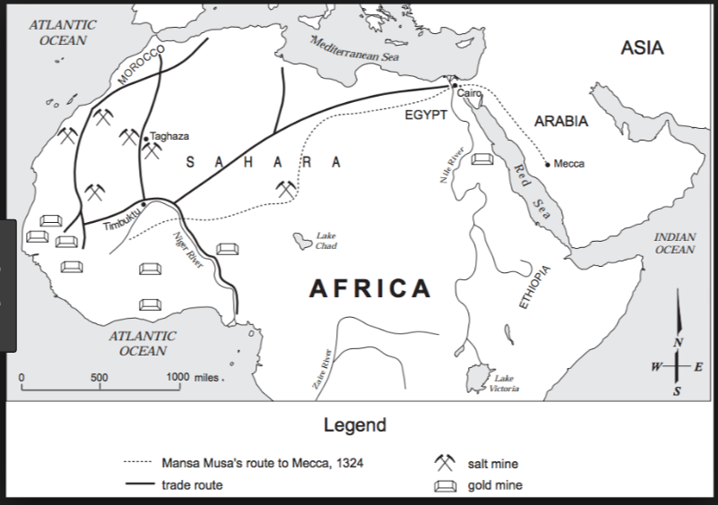
Document 1:
All this trade led to the founding cities. Most of these cities were especially concerned with the trade across the Sahara. They began as small trading settlements, but grew bigger as more traders came and went, and became centres for craftsmen who worked in leather, wood, ivory, and metals. City governments became necessary, as well as men trained to be put in charge of keeping accounts, of maintaining law and order, of ensuring the safety of citizens. Then the rulers of these cities began to extend their power to ever wider regions of neighbouring countryside. Gradually the cities grew into states, and the states into empires.…
Source: Basil Davidson, A History of West Africa to the Nineteenth Century, Anchor Books (adapted)

The impacts presented in this document are (Check all that apply)…
- Social
- Economic
- Political

The gold-salt trade had a positive/negative (CIRCLE ONE) impact on the development of West Africa because (explain the document in YOUR OWN WORDS) ____________________________________________________________
_______________________________________________________________________________________________________________________________________________________________________________________________________________________________________________________________________________________________________. This was good/bad for society because (ANALYZE) ___________________
________________________________________________________________________________________
________________________________________________________________________________________________________________________________________________________________________________________________________________________________________________________________________________________________________________________________________________________________
Document 2:
…One of the chief trade centers for salt in the ancient world was the fabled city of Timbuktu. Located on the southern edge of the Sahara Desert, the city thrived on profits from the salt trade.…The salt trade made the city prosperous; in Africa, salt ranked with gold and slaves in value. For merchants to risk camels over hundreds of miles of burning sand, the profits must have been enormous. Nor did the city squander [waste] its wealth. Timbuktu’s salt trade supported schools and libraries; merchants lived in fine houses; the king paid handsome salaries to judges, doctors, and clerics—all from profits on the three-hundred-pound salt cargo that each camel carried.…
Source: Robert Kraske, Crystals of Life: The Story of Salt, Doubleday & Company

The impacts presented in this document are (Check all that apply)…
- Social
- Economic
- Political

The gold-salt trade had a positive/negative (CIRCLE ONE) impact on the development of West Africa because (explain the document in YOUR OWN WORDS) ____________________________________________________________
________________________________________________________________________________________________________________________________________________________________________________________________________________________________________________________________________________________________________________________________________________________________. This was good/bad for society because (ANALYZE) ___________________________________________________
________________________________________________________________________________________
________________________________________________________________________________________________________________________________________________________________________________________________________________________________________________________________________________________________________________________________________________________________________________________________________________________________________________________.

Document 3:
. . . Merchants were carriers of Islam rather than agents of Islamization. They opened routes and exposed isolated societies to external (outside) influences, but they were not themselves engaged in the propagation [spread] of Islam, which was the work of religious leaders. The leaders became integrated into African societies by playing religious, social, and political roles similar to those of traditional priests. Like traditional priests, Muslim men of religion were peacemakers, who pleaded for those who broke the king’s laws. Mosques, like traditional shrines, were considered sanctuaries. Immunity (protection) of life and property was extended to men of religion only as long as they kept out of politics and posed no threat to the existing sociopolitical order. . . .
Source: John L. Esposito, ed., The Oxford History of Islam, Oxford University Press from the NYS Global History and Geography Regents Examination, August 2010.

The impacts presented in this document are (Check all that apply)…
- Social
- Economic
- Political

The gold-salt trade had a positive/negative (CIRCLE ONE) impact on the development of West Africa because (explain the document in YOUR OWN WORDS) ____________________________________________________________
________________________________________________________________________________________________________________________________________________________________________________________________________________________________________________________________________________________________________________________________________________________________. This was good/bad for society because (ANALYZE) ___________________________________________________
________________________________________________________________________________________
________________________________________________________________________________________________________________________________________________________________________________________________________________________________________________________________________________________________________________________________________________________________________________________________________________________________________________________.

