River Valleys
I. Introduction
Civilization resulted from the development of agriculture, the increase in population that agriculture brought about and the need to solve problems presented by the environment. The first civilizations began along river valleys because people could more easily grow food there.

II. Activity: MAP SKILLS
Directions: Analyze and read the map below. Answer the question that follows.
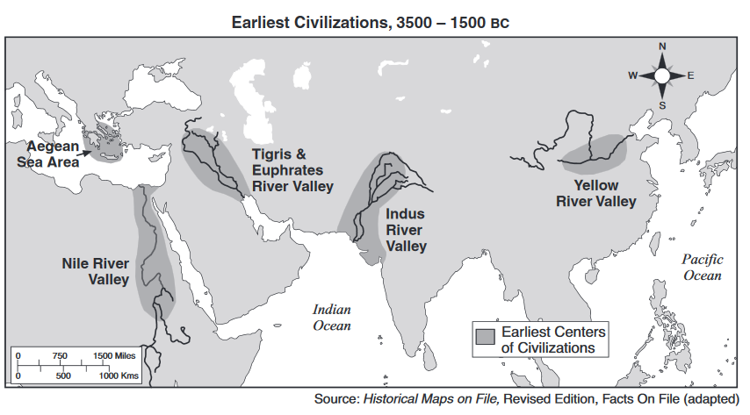

1. Based on this map, identify one geographic feature that influenced the location of early centers of civilization? _______________________________________________________________________
________________________________________________________________________________.
Turn and talk to your partner, discuss the advantages and disadvantages of settling by a river valley. Be ready to share your answers.

III. Geographic context
Geography is the science of place and space. Geography asks where things are located on the surface of the earth, why they are located where they are, how places differ from one another, and how people interact with the environment. The geographic context means how does the geography of a specific area, place, region (in this case river valleys) impacts how people live.

DIRECTIONS: Actively read the documents below about the geographic context of river valleys. List the advantages and disadvantages of settling near a river valley.

Document 1: Greetings, Oh Nile,…who comes in peace to give Egypt life; hidden god who guides the darkness,…irrigator of the meadows…to give all animals life; you feed the earth;…friend of bread and fruitfulness, benefactor of the grain.-Hymn to the Nile

Document 2: One such civilization was the Harappan civilization that developed in the Indus River Valley thousands of years ago. It was not until the 1920s that the world learned of the existence of this civilization. In 1922, a team of archaeologists uncovered one of the cities from the civilization. A vast region including present-day Pakistan and northern India made up the territory controlled by the Harappan civilization. Rich farmlands provided food for the people in over a hundred cities and towns. Goods were transported to and from the farms by means of a series of canals. Life was good in this civilization. The people had mastered reading, writing, and arithmetic. People in the cities enjoyed such modern conveniences as indoor plumbing, sewage systems, and heated public baths. -World History, Glencoe

Document 3: The early Chinese first settled along the Huang River-also called the Yellow River-about 5000 B.C. Hundreds of years later, farming villages were built there. By about 3000 B.C. Chinese farmers were growing grain in the valley’s rich soil. They were also raising cattle and sheep. Like the Egyptians along the NileRiver, the people in the Huang valley learned how to build dikes to control floods. They also built ditches and canals to irrigate their fields. The HuangRiver was not as regular as the Nile in ancient Egypt. Some years the Huang did not flood. In other years the Huang’s flood broke through the dikes along its banks and destroyed crops as well as whole villages. For this reason the Chinese named the Huang the River of Sorrows. -Exploring World History. Globe Book Company
+ | 11a. List three ADVANTAGES of settling near a river valley. | - | 11b. List three DISADVANTAGES of settling near a river valley.
+ |  | -
+ |  | -
+ |  | -

IV. Adapting to the geography of river valleys

When humans adapt to or modify their environment, they change their behavior and change the world around them to meet their needs. All civilizations need access to water. However, in some places there are not reliable water supplies. To meet the needs for reliable water access, early civilizations made modifications to their environment. The Neolithic Revolution was a major turning point in human history around 10,000 BCE. This was the point when humans began to grow crops and domesticate certain animals. People abandoned hunting and gathering and permanent settlements were established. Even though rivers provided the means for early civilizations to survive and grow, there was a major problem that the environment presented to early humans. Not every person could live on or near the river. There were parts of the cities that were a few miles away from the river that made access to water unreliable. Mostly all the river valleys developed in very dry and desert like areas. Rainfall was also not reliable and some areas could go with little rainfall for many months

DIRECTIONS: With a partner, you will be assigned ONE document. While actively reading, identify how the river valley civilization adapted and modify their environment to meet the need of the region they lived and how it impacted their way of life. Answer the questions for the document you have been assigned.
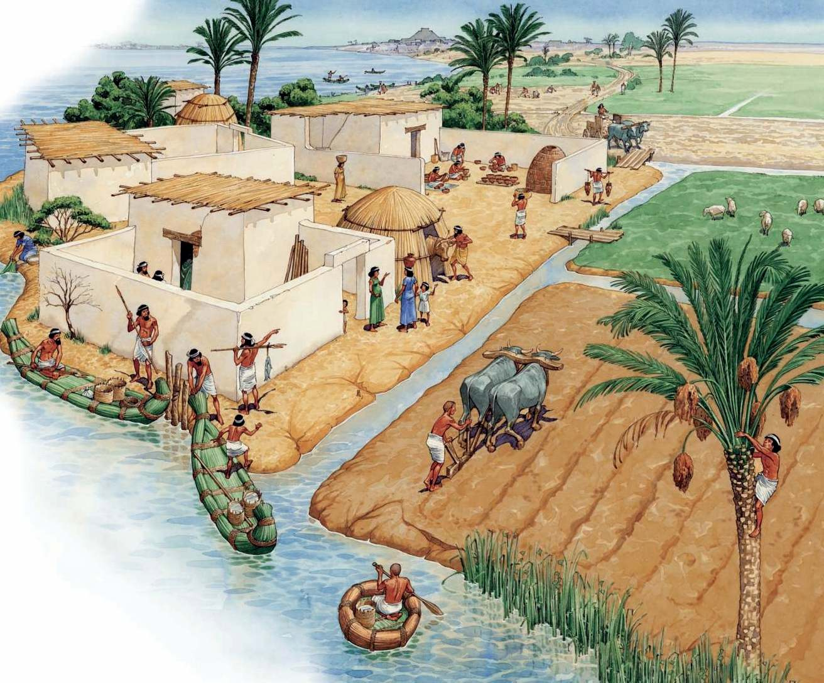
DOCUMENT 1: The first successful efforts to control the flow of water were made in Mesopotamia and Egypt, where the remains of the prehistoric irrigation works still exist. In ancient Egypt, the construction of canals was a major endeavor of the pharaohs and their servants, beginning in Scorpio’s time. One of the first duties of provincial (local) governors was the digging and repair of canals, which were used to flood large tracts of land while the Nile was flowing high. The land was checker boarded with small basins, defined by a system of dikes. Problems regarding the uncertainty of the flow of the Nile were recognized. During very high flows, the dikes were washed away and villages flooded, drowning thousands. During low flows, the land did notreceive water, and no crops could grow. In many places where fields were too high to receive water from the canals, water was drawn from the canals or the Nile directly by a swape or a shaduf. These consisted of a bucket on the end of a cord that hung from the long end of a pivoted boom, counterweighted at the short end. The building of canals continued in Egypt throughout the centuries...

1. How did the ancient river valley of Egypt adapt to their environment? _______________________________
________________________________________________________________________________________________________________________________________________________________________________________________________________________________________________________________________.

2. Based on this document, state two problems ancient Egyptians faced as a result of the uncertain flow of the Nile. ____________________________________________________________________________________
________________________________________________________________________________________________________________________________________________________________________________________________________________________________________________________________________.
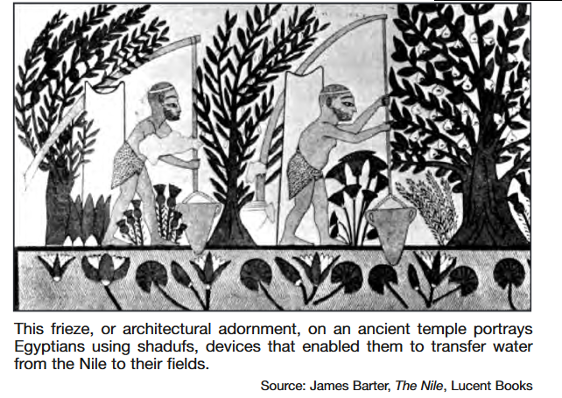
DOCUMENT 2: In the Ptolemaic period, Greek temple records presented each region as an economic unit, and referred to the name of the canal which irrigates the region, the cultivated region which is located on the river’s banks and is directly irrigated with its water, and the lands located on the region’s border that could be reclaimed. The beds irrigation system allowed cultivating one winter crop; while in summer, the only lands that could be cultivated were the high lands away from the flood. Thus, when the Egyptians invented tools to lift water, such as the shaduf, they were able to cultivate two crops per year, which was considered a great advance in the field of irrigation. The shaduf was invented in the Amarna period and is a simple tool which needs two to four men to operate. The shaduf consists of a long, suspended pole weighted at one end and a bucket tied at the other end. It can lift about 100 cubic meters (100,000 liters) in 12 hours, which is enough for irrigating a little over a third of an acre.

1. How did the ancient river valley of Egypt adapt to their environment? _______________________________
________________________________________________________________________________________________________________________________________________________________________________________________________________________________________________________________________.

2. Based on these documents, what was one effect the invention of the shaduf had on the Egyptians? ________
________________________________________________________________________________________________________________________________________________________________________________.
*HOMEWORK*: Answer the following question in 10 or more sentences: How does the geographic context of river valleys affect the lives of those who live there?

Be sure to include:
- Evidence- describe the geography of a river valleys
- Analysis – provide examples of how the geography affects those who live there (ex: positive ways and/or negative ways).

