The Aztecs

I. Historic Context
The Aztecs were the rulers of what is now Mexico between about 1300 and 1500 A.D. According to Aztec legend, at the beginning of the 12th century until the 13th century, the Aztec peoples came south to the Valley of Mexico in search of a place to live. Their capital was at Tenochtitlan (Ten-oc-tit-lan). Soon, the Aztecs created one of the strongest countries in the Americas. Some of their cities at that time were as large as any in Europe. Aztec peoples practiced a religion that was important for every part of their lives. To honor their gods, they built great temples, huge sculptures, and held ceremonies that included bloody human sacrifices. In 1521, the Spaniards destroyed and took over the Aztec empire. The Aztecs are a very important part of Mexican culture.

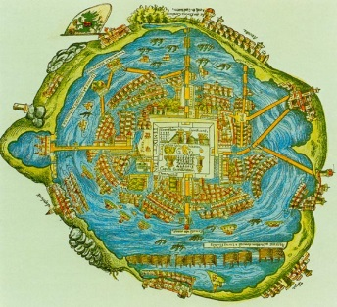
II. Geographic Context of the Middle America
The Americas are made up of two continents, North America and South America. Within these two geographic regions is a cultural region that historians call Middle America. Middle America includes Mexico and Central America (Latin America) was home to several early civilizations. The Aztecs were mainly located (at least in the earlier days when they were building their capital) in Tenochtitlan, their capital. Tenochtitlan was located in an island on Lake Texcoco in the Valley of Mexico (which is part of Mexico City). Tenochtitlan was built on a series of islets (islands) there, and the city plan was based on a symmetrical layout that was divided into four city sections which were called campans, which were also divided into 20 districts called calpullis, meaning "big house". The climate there was mainly mild or temperate, so they mostly made clothes that were the best for warmer days and not as much for freezing climates (as they had a warm longish summer and short, slightly rainy, winters). The climate also affected how successfully they farmed. Since they were very agriculturally successful, and it probably gave them more suitable "good days" to do stuff in and get more work done. But not only did the climate affect them, but the geographical setting too. They were fairly geographically isolated because, after all, they were on an island in the middle of a lake, but their special farming method (called chinampas, meaning "floating gardens") separated them from other civilizations as well. Since the major landforms around them were mainly marshes (swampland) and the lake, it was pretty hard to build everything as the larger ones would always sink a little below surface on the soft ground despite the many precautions they made, like large wooden stakes were planted into the ground for secure foundations and the Aztecs used Tezontli stone to construct the buildings on such unstable ground. However, the Aztecs would simply rebuild the building over the old core (so many super old Aztec structures have many layers of building history to them!). The lake, however, gave them more resources. The Aztecs used bows and spears to kill fish and frogs, meaning that they were most likely extremely accurate with those weapons, and they used to lake to make canals for the chinampas. Unfortunately, after the Spanish took over, most of the Lake Texcoco drained in the Spanish's efforts to control the flooding of it.

How did the geographic context of the Middle America impact the development of Aztec civilization? ________
________________________________________________________________________________________________________________________________________________________________________________________________________________________________________________________________________________________________________________________________________________________________________________________________________________________________________________________________________________________________________________________________________________
________________________________________________________________________________________________________________________________________________________________________________
DIRECTIONS: Actively read (highlight/underline important information and circle words you do not understand) the various ways Aztecs adapted to their environment as well as other achievements.

Tenochtitlan
“The city has many squares where markets are held and trading is carried on. There is one square… where there are daily more than 60,000 souls, buying and selling, and where are found all kinds of merchandise produced in these countries, including food products, jewels of gold and silver, lead, brass, copper, zinc, bones, shells, and feathers.” (Source: Hernán Cortés on seeing Tenochtitlan, 1519)

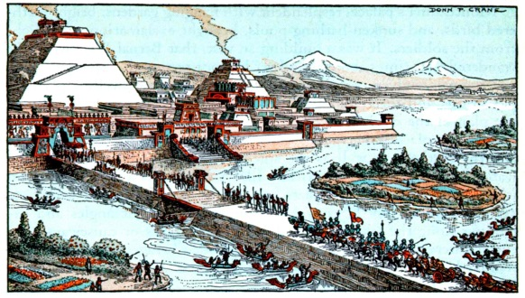

Causeways
The capital city (Tenochtitlan), which may have had a population as high as 200,000 to 300,000 in the early sixteenth century, was a superb example of planned growth. By building out into the lake, the Aztecs consolidated and enlarged the original two islands which in turn were linked to the mainland by three large causeways. Fresh water was brought to the city from the mainland by aqueduct. (Source: Jeremy A. Sabloff, The Cities of Ancient Mexico: Reconstructing a Lost World, Thames and Hudson, January 2014 Global Regents examination)

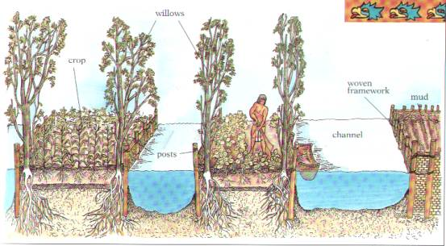
Chinampas
… Chinampas added both living and agricultural space to the island. Houses could be built on chinampas after they were firmly in place, and the plots were used to grow a great variety of products, from maize and beans to tomatoes and flowers. The Mexica [Aztec] built chinampas all around Tenochtitlan, like their neighbors in the freshwater lakes to the south. They were, however, constantly faced with the danger of flooding, which brought salty water across the chinampas and ruined the land and crops. Lake Texcoco accumulated minerals from the river water running into it, which caused the water to be brackish [mix of fresh and salt water]. In the mid-15th century, this problem was solved; a dike was built, separating the western section of the lake where Tenochtitlan was located and protecting the city from salty water and some flooding. (Source: Frances F. Berdan, The Aztecs, Chelsea House Publishers, January 2014 Global Regents examination)

Human Sacrifice
The prisoners taken at Teuclepec were brought out. Motecuhzoma and Chihuacoatl began to sacrifice them, slicing open their chests and extracting their hearts. First, they raised the hearts to the sun, then they threw them into the shrine before the gods to receive rain, sun, and other blessings from the gods to make life possible. This sacrifice began at midday and ended at nightfall. Aztec practice as the intentional manipulation and expansion of a widespread phenomenon that had long existed among many American peoples. In other words, the Aztec rulers, priests, and nobility used war and human sacrifice for political purposes to terrorize their neighbors and subdue (control/dominate) the lower classes. (Source: Peter N. Stearns et al., World Civilizations: The Global Experience, AP Edition, New York: Addison-Wesley Educational Publishers, Inc., Longman, 2003)

Name: ___________________________________ Band: ______________

Impact of Environment on Humans (Aztec Civilization)

Due to the geographic context of Middle America (specifically Mexico) Aztecs had to adapt to their environment. Using the Enduring Issue – impact of environment on humans- fill in the template below explaining how this environment impacted Aztec civilization. Use the documents from today as well as your knowledge of Social Studies.
Impact of Environment on Humans: impact of natural physical barriers, impact of access to seas, impact of natural resources, impact of access to fertile soil, impact of physical geography, impact of natural disasters, impact of flooding, impact of earthquake destruction, impact of destruction by tsunamis, impact of efforts to mitigate (lessen/ease) natural disasters.

An enduring issue is an issue that exists across time. It is one that many societies have attempted to address with varying degrees of success. One enduring issue is impact of environment on humans, which means (USE AN APPROPRIATE DEFINITION THAT RELATES TO MIDDLE AMERICA) ___________________________
____________________________________________________________________________________________________. This enduring issue has been seen in Middle America’s geography. One example of the enduring issue of impact of environment on humans can be seen in Middle America’s geography is (sentence explanation) _____________________________________________________________________
_______________________________________________________________________________________________________________________________________________________________________________________________________________________________________________________________________________________________________________________________________________________________________________________________________________.
This enduring issue of impact of environment on humans impacted Aztec civilization in a positive/negative way because _______________________________________________________________________
_______________________________________________________________________________________________________________________________________________________________________________________________________________________________________________________________________________________________________________________________________________________________________________________________________________________________________________________________________________________________.
A second example of the enduring issue of impact of environment on humans can be seen in Middle America’s geography is (sentence explanation) ____________________________________________________
_______________________________________________________________________________________________________________________________________________________________________________________________________________________________________________________________________________________________________________________________________________________________________________________________________________________________________________________________________________________________.
This enduring issue of impact of environment on humans impacted Aztec civilization in a positive/negative way because __________________________________________________________________________
_______________________________________________________________________________________________________________________________________________________________________________________________________________________________________________________________________________________________________________________________________________________________________________________________________________________________________________________________________________________________.

Excellent (4.5-5)  - Clearly identifies and accurately defines an enduring issue.  - Develops a thoughtful and in-depth argument about it impacts people or how they have been affected.  - Is more analytical or descriptive | GOOD (3.5-4)  - Identifies and  - accurately defines an enduring issue.  - Develops a thoughtful argument in some depth about how the E.I. affected people.  - Provides some analysis. | SATISFACTORY (3-1)  - Identifies and accurately defines an enduring issue; may include minor inaccuracies or identifies, but does not define an enduring issue.  - Argument is not clearly explained on in depth about how the E.I. affected people.  - Lacks analysis; provides only description. | UNSATISFACTORY (0)  - Fails to develop the task or may only refer to the issue in a general way; OR includes no relevant facts, examples, or details; OR includes only evidence copies from the documents; OR includes only entire documents copied; OR is illegible; OR is a blank paper.

