Bushido Code
I. Introduction
Bushido, “The Way of the Warrior” means in a common understanding of the word the samurai code. However, the term encompasses much more than a samurai warrior’s list of rules and codes he obeys. The key here is “the way” – and in this case it is also a way of life practiced by a noble warrior. Bushido is a set of principles that a warrior should pursue in his life in order to be capable to fight without losing his humanity, as well as be capable to lead and command without losing contact with important basic values.

II. Bushido Code

The business of the samurai consists in reflecting on his own station (place) in life, in discharging (honoring) loyal service to his master if he has one, in deepening his fidelity (faithfulness) in association with friends, and with the due consideration of his own position in devoting himself to duty above all. - Yamaga Soko (1622-1685)

The actual code was passed on verbally to each generation of samurai, but over time, seven chief virtues emerged, and became the written form of Bushido. These are:
- Rectitude (Integrity) - To do the right thing by yourself. A Samurai must be smart in making choices and always chose what is good for the clan. He will make the right choice even if left alone. Practice Gi in everything you do.

- Courage - To show courage every moment of living, in danger or not.

- Benevolence - To show everyone kindness and show compassion for all regardless.

- Respect - more than just being kind, it’s about caring about others, and some say it borders an almost love-like feeling.

- Honesty - Be true by the actions you show, and by the words you speak. Follow the laws of the universe and you will become an honest person.

- Loyalty - To be loyal. To be trustful, loyal, and show these unconditionally to others.
- …and above all: Honour- The Samurai lived and died by their honor, with haragiri (seppuku) being the final way of preserving lost honor.
Code of Chivalry of Knights:

Thou shalt believe that the Church teaches, and shalt observe all of its directions.

Thou shalt defend the Church

Thou shalt respect all weaknesses, and shalt constitute (establish) thyself the defender of them.

Thou shalt love the country in which thou wast [was] born.

Thou shalt not recoil (be fearful) before thine enemy.

Thou shalt make war against the Infidel (a non-believer or someone who has a different religion) without cessation, and without mercy. (Show no mercy to the infidel a person who does not believe in religion or who adheres to a religion other than one's own. Do not hesitate to make war with them).

Thou shalt perform scrupulously (carefully) thy feudal duties, if they be not contrary (different) to the laws of God.

Thou shalt never lie, and shall remain faithful to thy pledged word.

Thou shalt be generous, and give largess (generosity) to everyone.

Thou shalt be everywhere and always the champion of the Right and the Good against Injustice and Evil.

Source: http://www.the-dogs-of-war.com/Crusades1.jpg

According to the documents above, identify and explain a similarity and/or difference regarding the codes of conduct for a Japanese samurai versus a medieval knight.

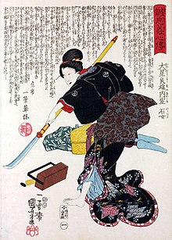
II. Women: Medieval Europe vs. Japanese Feudalism
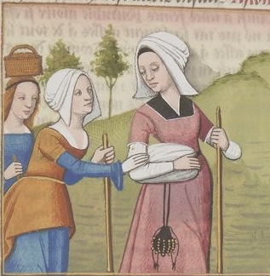

According to the documents above, identify and explain a similarity and/or difference regarding women’s role in medieval society vs. Japanese society under the feudal system.

Seppuku
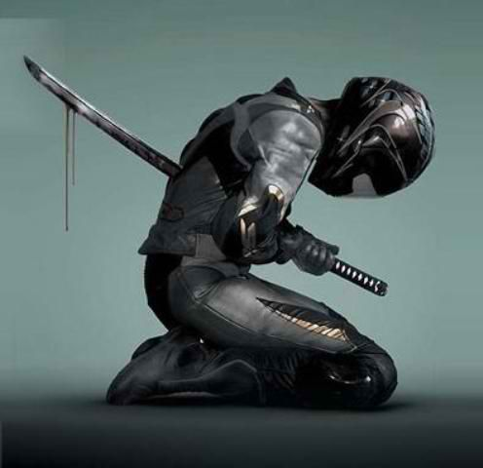
“The way of the warrior (bushido) is to find a way to die. If a choice is given between life and death, the samurai must choose death. There is no more meaning beyond this. Make up your mind and follow the course. Someone may say, ‘You die in vain if you do not accomplish what you set out to do.’

“If the samurai misses his objectives (purpose and goal) and continues to live, he must be seen as a coward. If he misses his objectives and chooses death … this must be a noble act. It is of utmost importance for bushido. Day and night, if you make an effort to think of death and at a moment’s notice, you and the bushido will become one. In this way throughout your life you can perform your duties for your master…” - Hagakure by Yamato Tsunetomo, 1716

According to the documents, was the purpose of the samurai in feudal Japan?

HOMEWORK:
Using the video clip and document below, how has the role of a samurai changed over time? (8 sentence minimum)

. . As the object of modernisation was to obtain equal treatment by the West many of the cultural innovations, besides being more than outward forms to the Japanese themselves, had an important psychological influence on Western diplomats and politicians. Under the [Tokugawa] shogun, members of the first Japanese delegation to the United States in 1860 wore traditional samurai dress with shaved pate [top of the head] and long side hair tied in a bun and carried swords. Under the [new Meiji] emperor, Western-style haircuts were a major symbol of Westernisation. Soldiers and civilian functionaries [officials] wore Western-style uniforms, and politicians often adopted Western clothes and even full beards. In 1872 Western dress was prescribed for all court and official ceremonies. Meat eating, previously frowned on because of Buddhist attitudes, was encouraged, and the beef dish of sukiyaki was developed at this time. Western art and architecture were adopted, producing an array of official portraits of leading statesmen as well as an incongruous [incompatible] Victorian veneer [appearance] in the commercial and government districts of the cities and some rather depressing interiors in the mansions of the wealthy. . . .
Source: Richard Perren, “On the Turn–Japan, 1900,” History Today, June 1992

4.5-5 | 3.5-4 | 1.5-3 | 1 | 0/redo/incomplete
Evidence and examples presented pertain to task in great detail; Incorporates substantial evidence about the change over time. More analytical than descriptive. | Evidence and examples are presented and pertain to task and support position; Incorporates relevant evidence about the change over time with facts; more descriptive than analytical. | Evidence and examples are presented; Incorporates some evidence about the change over time with limited facts. | Evidence and examples are not present to support position and/or evidence does not support the position taken or there is very little evidence with details; Incorporates little or disconnected evidence about the change over time. | Evidence is not present or address the change over time OR evidence is present, but does not address the task.

