Name: ________________________________________ Band: _____

The RCC—Controversy over Renaissance Art

DIRECTIONS: Actively read about the Church’s reaction to Renaissance art. Label where you see the following enduring issues this best associates with is (check all that apply):

- CHANGE (CH)
- CONFLICT (CON)
- POWER (P)
- TECHNOLOGY (T)

Then answer the question that follows.

Historic Context
Heavily influenced by the “rebirth” of interest in the art and culture of the classical civilizations of the Greeks and Romans, during this time, artist continued the trends of the earlier period without fundamental (important) changes, but using classical clothing and architectural settings which were after all appropriate for New Testament scenes. However, a clear loss or religious intensity (passion) is apparent in many early Renaissance religious paintings. The famous frescoes in the Tornabuoni Chapel by Domenico Ghirlandaio (1485-90) seem more interested in the detailed depiction of scenes of bourgeois (rich) city life than their actual religious subjects. Another example, the Life of the Virgin and that of John the Baptist by Benozzo Gozzoli (1459-61) is more a celebration of Medici (high) status than of the arrival of the Magi (the three wise men). The situation was further exacerbated (made worse) during the era of the High Renaissance painting, as humanism (characteristically expressed in the male and female nude) became an important feature of Renaissance aesthetics (appreciation of beauty); as demonstrated in the marble statue of David by Michelangelo. All of these examples come from Florence, the heart of the Early Renaissance, and the place where the charismatic Italian preacher Savonarola launched his attack on the worldliness of the life and art of the citizens. Like Savonarola this non-traditional approach to art did not go down well with the Roman Catholic Church. Savonarola launched his attack on the worldliness of the life and art of the citizens, ending in his famous Bonfire of the Vanities in 1497. A bonfire of the vanities is a burning of objects condemned by religious leaders as sinful acts. Savonarola collected and publicly burned thousands of objects such as cosmetics, art, mirrors, fine dresses, playing cards, books that deemed to be immoral, secular songs and even musical instruments books. The focus of this destruction was on objects that might tempt one to sin.

What were the historical circumstances that led to the Bonfire of the Vanities? _________________________
________________________________________________________________________________________________________________________________________________________________________________________________________________________________________________________________________________________________________________________________________________________________
________________________________________________________________________________________
One of Savonarola’s sermons in 1496 before leaving for Rome:

Look at the customs of Florence: how the Florentine women marry off their girls (pay them to model for paintings), put them on show (in paintings) and outfit them so that they look like nymphs, and the first thing they do is take them to Santa Liperata (church). These are your idols (that you worship), which you have put in my temple. The images of your gods are the images and similitudes (likenesses) of the figures you have painted in the churches, and the young men of Florence go around saying about this one or that “this one (woman looks like ) is the Virgin Mary:, this other (man looks like ) is Saint John”, because the figures you have made in the churches are in the likeness (resemble) of one or another woman(look like every day ordinary people), which is very badly done and in great disrespect for what is Gods’…Do you think the Virgin Mary went clothed in the manner that you paint her? I tell you that she went dressed as a poor woman, simply and covered so that you could hardly see her face…You make the Virgin Mary appear dressed like a whore. Now the divine cult is ruined, and people care only about the honor done for themselves.

What is Savonarola’s perspective on most Renaissance art and artist? ________________________________
________________________________________________________________________________________________________________________________________________________________________________________________________________________________________________________________________________________________________________________________________________________________
________________________________________________________________________________________

Catholic Church’s perspective about Modern Art today
From the very beginnings of the modern art movement, the Church has been skeptical (doubtful/untrusting) of it, but has accepted that art which is connected to truth, beauty and goodness.

Pope Pius XII discusses “modern art” in his encyclical Mediator Dei in 1947:
“Recent works of art which lend themselves to the materials of modern composition should not be universally despised (hated) and rejected through prejudice. Modern art should be given free scope (choice) in the due and reverent (respectful) service of the church and the sacred rites, provided that they preserve a correct balance between styles tending neither to extreme realism nor to excessive “symbolism” (imagery) and that the needs of the Christian community are taken into consideration rather than the particular taste or talent of the individual artist… We cannot help deploring (criticizing) and condemning (juding) those works of art, recently introduced by some artist, which seem to be a distortion (lie) and perversion (insult) of true art and which at times openly shock Christian taste, modesty and devotion, and shamefully offend the true religious sense. These must be entirely excluded and banished from our churches, like anything else that is not in keeping with the sanctity (holiness) of the place.

What is Pope Pius XII perspective on modern art in 1947? __________________________________________
________________________________________________________________________________________________________________________________________________________________________________________________________________________________________________________________________________________________________________________________________________________________
________________________________________________________________________________________

Continue on the back

Excerpts from speech made at the Gospel Coalition National Conference April 4th 2017
We must allow art to be art. Sometimes Christians make the mistake of thinking that for art to be valuable it must share the gospel or try to point people to Jesus. Such an approach usually makes for bad evangelism and bad art. Art is valuable because it can be beautiful and full of truth. We should not expect art to communicate in the same way that discourse does.
The Gospel Coalition

What was the Gospel Coalition’s perspective on Modern art today? __________________________________
________________________________________________________________________________________________________________________________________________________________________________________________________________________________________________________________________________________________________________________________________________________________
________________________________________________________________________________________

Has the church changed over time its position towards modern art since the Renaissance? Explain your answer. ________________________________________________________________________________________
________________________________________________________________________________________________________________________________________________________________________________________________________________________________________________________________________________________________________________________________________________________________
________________________________________________________________________________________

DIRECTIONS: Analyze the art works below. Then, according to Savonarola, what would his perspectives be on these art works.
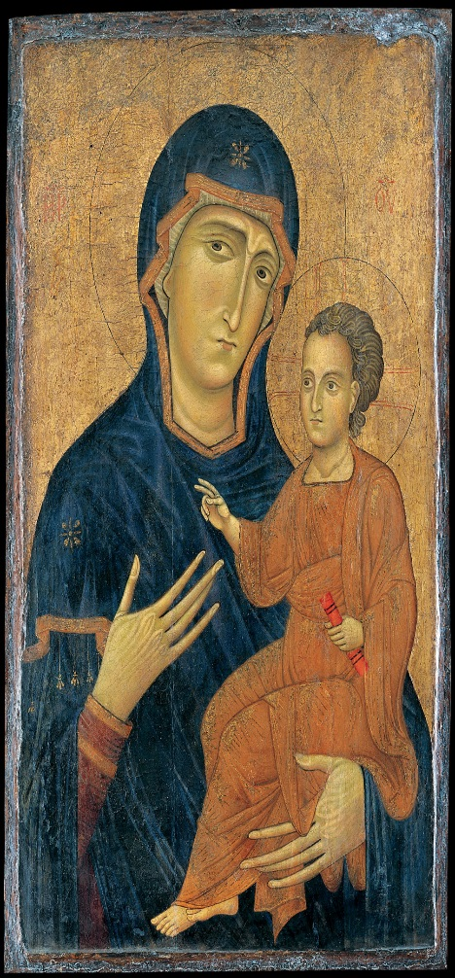
Modonna by Berlinghiero 1230 Niccolini-Cowper Modonna by Rapheal 1508
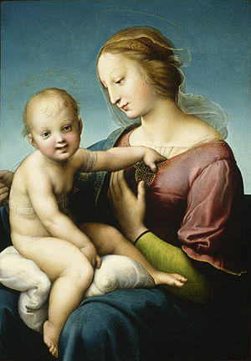

Perspective on Modonna by Berlinghiero 1230 | Perspective on Niccolini-Cowper Modonna by Rapheal 1508

The enduring issue this best associates with is (check all that apply):

- CHANGE
- CONFLICT
- POWER
- TECHNOLOGY

