NAME: ______________________________________________ BAND: ______

The Colosseum

DIRECTIONS: Actively read/annotate information regarding the construction of the Colosseum. Be sure to label enduring issues. Then answer the tasks that follow.

Historic Context
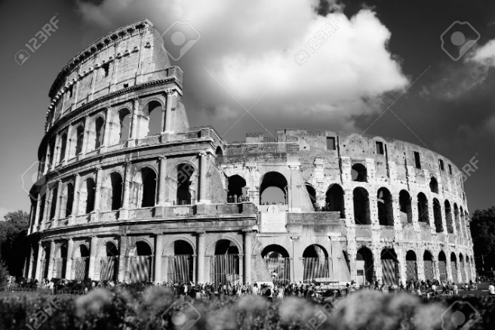
The Colosseum or Flavian Amphitheatre is a large ellipsoid arena built in the first century CE under the Roman emperors of the Flavian dynasty: Vespasian (69-79 CE), Titus (79-81 CE) and Domitian (81-96 CE). The arena was used to host spectacular public entertainment events such as gladiator fights, wild animal hunts and public executions from 80 CE to 404 CE.

Purpose & Construction
The construction of the Colosseum was begun in 72 CE in the reign of Vespasian on the site that was once the lake and gardens of Emperor Nero’s Golden House. This was drained and as a precaution against potential earthquake damage concrete foundations six meters deep were put down. The building was part of a wider construction program begun by Emperor Vespasian in order to restore Rome to its former glory prior to the turmoil and chaos of the recent civil war. As Vespasian claimed on his coins with the inscription Roma resurgens, the new buildings --the Temple of Peace, Sanctuary of Claudius and the Colosseum-- would show the world that ‘resurgent’ Rome was still very much the center of the ancient world.

The Flavian Amphitheatre opened for business in 80 CE in the reign of Titus, Vespasian’s eldest son, with a one hundred day gladiator spectacular and was finally completed in the reign of the other son, Domitian. The finished building was like nothing seen before and situated between the wide valley joining the Esquiline, Palatine and Caelian hills, it dominated the city. The biggest building of its kind, it had the following features:

- four stories.
- a height of 45 metres high (150 feet).
- a width of 189 x 156 metres.
- an oval arena measuring 87.5 m by 54.8 m.
- a roofed awning of canvas.
- capacity for 50,000 spectators.

The theatre was principally built from locally mined limestone with internal linking lateral walls of brick, concrete and volcanic stone. Vaults were built of lighter pumice stone. The sheer size of the theatre was the possible origin of the popular name of Colosseo, however, a more likely origin may have been as a reference to the colossal gilded bronze statue of Nero which was converted to resemble the sun-god and which stood outside the theatre until the 4th century CE.

Architecture
The theatre was spectacular even from the outside with monumental open arcades on each of the first three floors presenting statue-filled arches. The first floor carried Doric columns, the second Ionic and the third level Corinthian. The top floor had Corinthian pilasters and small rectangular windows. There were no less than eighty entrances, seventy-six of these were numbered and tickets were sold for each. Two entrances were used for the gladiators, one of which was known as the Porta Libitina (the Roman goddess of death) and was the door through which the dead were removed from the arena. The other door was the Porta Sanivivaria through which victors and those allowed to survive the contests left the arena. The final two doors were reserved exclusively for the Emperor’s use.

Inside, the theatre must have been even more impressive when the three tiers of seats were filled with all sections of the populace. Encircling the arena was a wide marble terrace protected by a wall within which were the prestigious ring-side seats or boxes from where the Emperor and other dignitaries would watch the events. Beyond this area, marble seats were divided into zones: those for richer private citizens, middle-class citizens, slaves and foreigners and finally wooden seats and standing room in the flat-roofed colonnade on the top tier reserved for women and the poor. On top of this roof platform sailors were employed to manage the large awning which protected the spectators from rain or provided shade on hot days. The different levels of seats were accessed via broad staircases with each landing and seat being numbered. The total capacity for the Colosseum was approximately 45,000 seated and 5,000 standing spectators. One of the oldest depictions of the Colosseum appeared on the coins of Titus and shows three tiers, statues in the upper external arches and the large column fountain - the Meta Sudans - which stood nearby.

Video: The Colosseum: Watch the clip from “Gladiator” of fighting in Colosseum—https://www.youtube.com/watch?v=uQQZR-Skftk. Then, using the reading above and the clip, answer the questions.

- What was the purpose of the Roman Colosseum?
______________________________________________________________________________________________________________________________________________________________________________________________________________________________________________________________________________________________________________________________________________________________________________________________________________________________________________________________________________________________________________________________

- How did the coliseum contribute to maintaining power?
______________________________________________________________________________________________________________________________________________________________________________________________________________________________________________________________________________________________________________________________________________________________________________________________________________________________________________________________________________________________________________________________

The enduring issue this best associates with is (check all that apply):

- CULTURAL DIFFUSION
- HUMAN RIGHTS
- IMPACT OF ENVIRONMENT ON HUMANS
- POWER
- TECHNOLOGY
- SCARCITY

