**Commercial Revolution**

**I. Introduction**

In the 1500s, countries were looking for new ways to travel and trade. This led them to explore territories that had never been explored before by Europeans. Economic expansion increased. People looked for new ways to make money and to increase the amount of wealth in order to become more powerful. With more trade and travel, the world became more connected and a new period called the **Commercial Revolution** began. The Commercial Revolution was a period of increased trade, travel and business around the world. With the Commercial Revolution, came business practices that we are familiar with today, such as banking, insurance and investing*.*

**DIRECTIONS: Actively read about the different methods of doing business and trade that emerged during Commercial Revolution. Evaluate how this impacted people’s way of life.**

|  |  |
| --- | --- |
| **CHANGES DUE TO INCREASE OF TRADE & BUSINESS** | **How did this new business practice impact society, people, & places?** |
| **Mercantilism:**  The catalyst for this expansion was Europe's discovery and **colonization** of the Americas. Monarchs from various countries, such as Spain and Britain, enjoyed the benefits of the Commercial Revolution. A new economic policy known as **mercantilism** aimed at strengthening their national economies (becoming wealthy) as well as being more powerful. In order to become powerful, a country needs money. To become wealthy, a country must take over **colonies**. This country that controls the colonies is known as the **mother country**. The colonies, the land controlled by the mother country, must give **raw materials** (natural resources), such as lumber, sugar, iron, rubber, fur, cotton to the mother country at a lower price because they are not available. The mother country then uses the raw materials to make goods, also known as a **manufactured product** (products made by machines). The manufactured products are then sold back to the colonies they control for a higher price. The colonies must only buy from the mother country and cannot trade with anyone else.    **Mother Country**  **Country**  ***Example:***  *Britain (Europe) is the mother country of American colonies. The American colonies in North America must sell their cotton (raw material) at a low price to Britain because Britain controls them. Britain then uses the cotton to make shirts (manufactured product). Britain then sells the shirts back to the American colonies at a higher price. The American colonies can only buy shirts from Britain because Britain controls them. The American colonies are NOT ALLOWED to trade with any other country and they are also NOT ALLOWED to make their own manufactured products (make their own shirts).* |  |
| **Capitalism:**  One important effect of the Commercial Revolution was the invention of **capitalism**. Capitalism is an economic system that allows people to have the right to make lots of money and they can keep the profits (money they make) from their businesses. The government does not have the right to tell the business owner what they could do, for example, the government cannot tell the business what to make, what price to sell their product for, or control trade. Instead, there is **free trade**. Capitalism can be risky because **entrepreneurs** (people who use their money to invest in their business and hope they make money) can either do really well (make money) or they can fail and make people lose money. Entrepreneurs make money by creating products that are demanded (what people WANT) by the people. As business grew in power, guilds lost power. |  |
| **Joint Stock Company:**  When one person does not have enough money for their business, they look to other people to get money. These people put all their money to create a business. As a result, all the people who gave money are owners of the business (not just one person). All the partners must share the profits (money) and be part making decisions on how to run the business. |  |

**Name: ______________________________________ Band: ______**

**THE COMMERCIAL REVOLUTION**

**DIRECTIONS: Identify and explain a *cause-and effect* relationship associated with the events, ideas, or historical developments. Be sure to use evidence from both documents in your response.**

**Document 1: Document 2:**

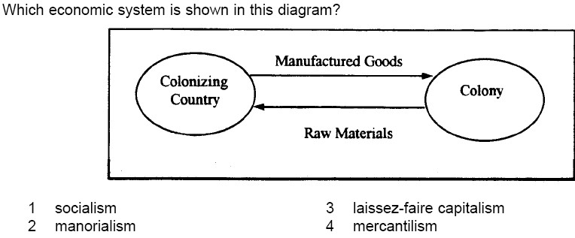

**Cause:** refers to something that contributes to the occurrence of an event, the rise of an idea, or the bringing about of a development.

**Effect:** refers to what happens as a consequence (result, impact, outcome) of an event, an idea, or a development.

**Identify and explain a cause-and-effect relationship associated with these events of ideas in documents 1 and 2. Be sure to use evidence from both documents 1 and 2 in your response.**

___ ___ ___ ___ ___ ___ ___ ___ ___ ___ ___

|  |  |
| --- | --- |
| **SCORE OF 1:** | **SCORE OF 0:** |
| * Identified a cause-effect relationship using both documents. * Explains a cause-effect relationship using both documents. | * Only identified and does not explain a cause-effect relationship. * Did not use evidence relate to information in both documents. * Provided incorrect information. * Did not answer the question (no response). |