Confucianism
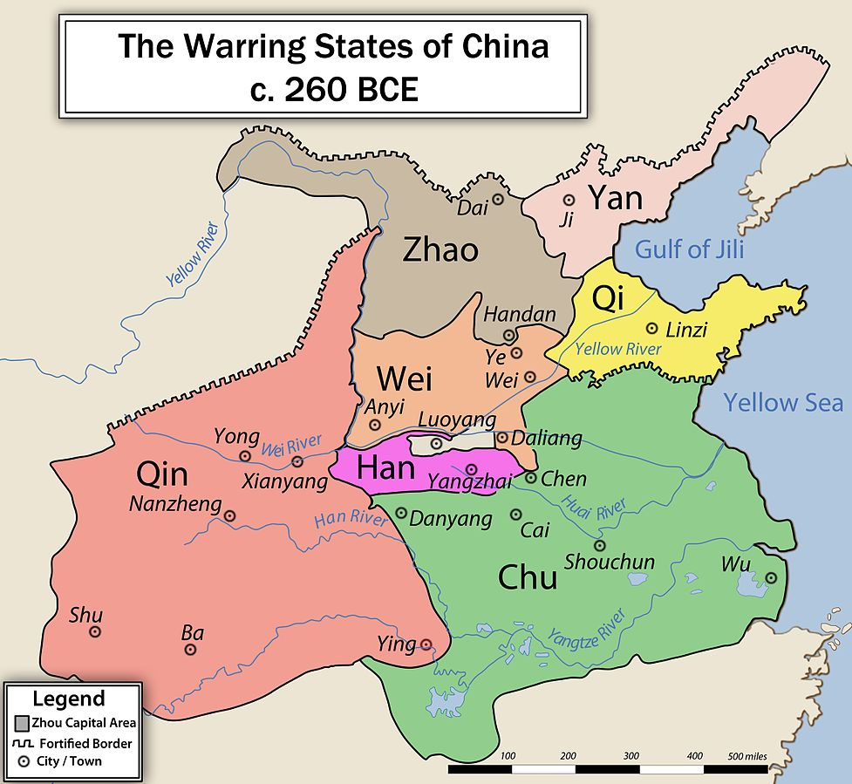
I. Introduction
Confucius lived from 551- 479 BCE (2,500 years ago) as part of a powerful family near Beijing (the capital of China). When he was growing up, China's Zhou Dynasty was gradually splitting up and China was in chaos. Different states were competing with each other for power. Confucius saw morality (ethics/standards/principles) deteriorating and the aristocracy [wealthy people] turning their back on the traditions the Zhou Dynasty. There were no good leaders around to keep order and calmness in China.

Confucius viewed the Zhou as a kind of Golden Age. Confucius felt he had a mission to return China to its former glory, to return to the way of the Dao, China’s traditional culture of self-cultivation and an emphasis on the way of virtue. Confucius became interested in government and started to think about how to create a peaceful society, with a good leader, where everyone got along. He started giving advice to the princes and other leaders in China on how to keep a peaceful society. His beliefs, Confucianism, were written down in a book called The Analects.

- What were the historical circumstances surrounding ancient China (260 B.C.E – 551 B.C.E)? ___________
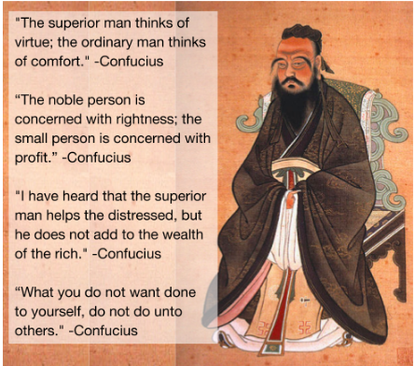
____________________________________________________________________________________________________________________________________________________________________________________________________________________________________________________________________________________________________________________________________________________________________________________________________________________________________________________________________________________
II. What is Confucianism?
Confucians (followers of Confucius) believe that they should strive for peace and harmony with others in society. Confucius was not as interested in the big mysteries of existence such as the origin or the universe, God, or the afterlife. According to Confucianism, peace, harmony, and social order can be achieved through the proper behavior of each family member and society.

DIRECTIONS: Actively read/Annotate (highlight/underline important words/phrases, circle words you do not understand) about the beliefs of Confucianism. Evaluate the impact Confucius’ ideas and teachings has on Chinese civilization.

BELIEFS
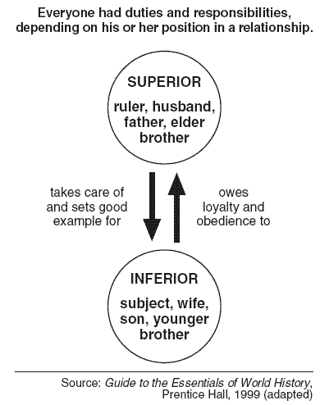
The Five Relationships
Confucius taught that harmony resulted when people accepted their place in society. He stressed five key relationships:
- “Fathers, show love to your sons. Sons, show respect in return.”
- “Older brothers, look after your younger brothers. Younger brothers, be kind to your older brothers and always thank them for taking care of you.”
- “Husbands, treat your wives with respect. Wives, listen to your husbands and do everything they say.”
- “Rulers, you be good and kind towards your people. People who are ruled, you must be loyal to your ruler.”
- “Friends should be kind to one another.”

Filial Piety
Confucius put filial piety, which means respect for parents, above all other duties. It involves many different things including taking care of the parents, burying them properly after death, bringing honor to the family, and having a male heir to carry on the family name.

“When your father is alive observe his intentions. When he is deceased, model yourself on the memory of his behavior. If in three years after his death you have not deviated (moved away) from your father's ways, then you may be considered a filial child.”-Confucius
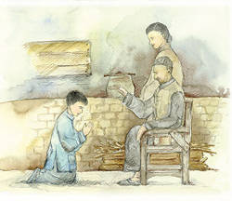
Golden Rule
His student asked Confucius, “Confucius, can you give me one rule that will help me live through life?” Confucius said, “What you do not want done to yourself, do not do unto others.”

Government
Confucius believed a ruler had the responsibility to provide a good government, and in return, the people would be respectful and loyal subjects. He felt the best rulers were ones who led by good example and that rulers should take the advice from wise and educated men.

Confucius said to be a powerful ruler: “If you try to be good, your people would also be good.” Confucius said, “In a good country, there must be three things: enough food, enough military equipment and people’s faith in their ruler". His student asked “If we couldn’t help it and one of these had to go, which would you get rid of first?” Confucius replied, “The military equipment.” His students asked again, “If we couldn’t help it and one of these had to go, which one would you get rid of first?” Confucius replied, “Get rid of the food. It will hurt the people not to have food, but it will kill them if they don’t have faith in their ruler.”

Name: ______________________________________________ Band:_________
An enduring issue is an issue that exists across time. It is one that many societies have attempted to address with varying degrees of success.

DIRECTIONS: Write an enduring issue response in which you use evidence, examples, and analysis. To write a well-developed response, please do the following:

- Identify and define an enduring issue about Confucianism (PICK ONE OF THE OPTIONS BELOW)
The enduring issues that are present in Confucianism are:
- POWER - unfair distribution of power (power isn’t equal); relationship to ruler and those who are ruled
- BELIEF SYSTEMS – our ideas and beliefs shape the way we looks at the world. Ideas and beliefs can come from one’s conclusions from observation, religion, parents, books, or friends.

- Explain how the issue has affected people.

An enduring issue is an issue that exists across time. It is one that many societies have attempted to address with varying degrees of success. One enduring issue is power/belief systems (choose one), which means (provide a definition) ______________________________________________________________
________________________________________________________________________________
_______________________________________________________________________________. This enduring issue has been seen in China during the development of the philosophy Confucianism. One example of the enduring issue of power/belief systems (choose one) can be seen in Confucianism because (explain the historical circumstances taking place during this time period—background) __________________
_______________________________________________________________________________________________________________________________________________________________________________________________________________________________________________________________________________________________________________________________________________________________________________________________________________________________________________________________________________________________. As a result, power/belief systems began to shape the society of China. For example, the Confucianism
(provide examples and evidence about Confucianism that relate to the EI chosen; 7 sentence minimum) _______________________________________________________________________
________________________________________________________________________________
_______________________________________________________________________________________________________________________________________________________________________________________________________________________________________________________________________________________________________________________________________________________________________________________________________________________________________________________________________________________________________________________________________________________________________________________________________________________________________________________________________________________________________________________________________________.
This enduring issue of power/belief systems (choose one), affected Chinese society in a positive/negative (choose one) way because (explain why the evidence you described above impacts people in a good/bad way) ____________________________________________________________________
________________________________________________________________________________________________________________________________________________________________________________________________________________________________________________________________________________________________________________________________
EXCELLENT (4.5-5)  - Clearly identifies and accurately defines an enduring issue.  - Develops a thoughtful and in-depth argument about it impacts people or how they have been affected.  - Explained how it continued to be an issue or change over time clearly and in depth.  - Is more analytical or descriptive | GOOD (3.5-4)  - Identifies and accurately  defines an enduring issue.  - Develops a thoughtful argument in some depth about how the E.I. affected people.  - Explained how it continued to be an issue or change over time with details.  - Provides some analysis. | SATISFACTORY (1.5-3)  - Identifies and accurately defines an enduring issue; may include minor inaccuracies or identifies, but does not define an enduring issue.  - Argument is not clearly explained on in depth about how the E.I. affected people.  - Explained how it continued to be an issue or change over time, but lacks clarity or depth.  - Lacks analysis; provides only description. | UNSATISFACTORY (0-1)  - Fails to develop the task or may only refer to the issue in a general way; OR includes no relevant facts, examples, or details; OR includes only evidence copies from the documents; OR includes only entire documents copied; OR is illegible; OR is a blank paper.
________________________________________________________________________________

