DOCUMENT 1: The Council of Trent

In 1545, the leaders of the Catholic Church gathered in the Northern Italian city of Trent for an emergency conference. Their aim was to reclaim the moral high ground, and the superiority of the Holy Mother Church, in the wake of the Protestant challenge. The stakes were high. They were playing for the survival of the Roman Catholic Church.

After 20-years of debate, the Council of Trent established the basis for a Catholic counter-attack. Decrees (rulings) were issued covering every aspect of Church authority, from the holding of multiple offices, to the chastity of priests, and monastic reform. Ignatius Loyola was charged with forming the Jesuits, a band of militant missionaries whose task was to reconvert the converted.

Decrees of the Council of Trent

1. Only the Catholic Church can interpret the Bible. Its decisions on what the Scriptures mean or teach are final.
2. No one who is alive can know before he dies if he will be saved.
3. Clerics (priests) must wear dress that properly reflects their order and place in society. If anyone says they may marry he shall be cursed.
4. The church has the absolute right to issue indulgences. If anyone asserts that indulgences are useless they shall be cursed. The unauthorized selling of indulgences is banned.
5. The Clergy must be content with modest furniture and a frugal (inexpensive) table. In the lives of all Clergy there should be nothing that does not show simplicity.
6. The Pope is the leader of the Catholic Church on Earth and all acts of the Church must be approved by him.

DOCUMENT 2: The Index

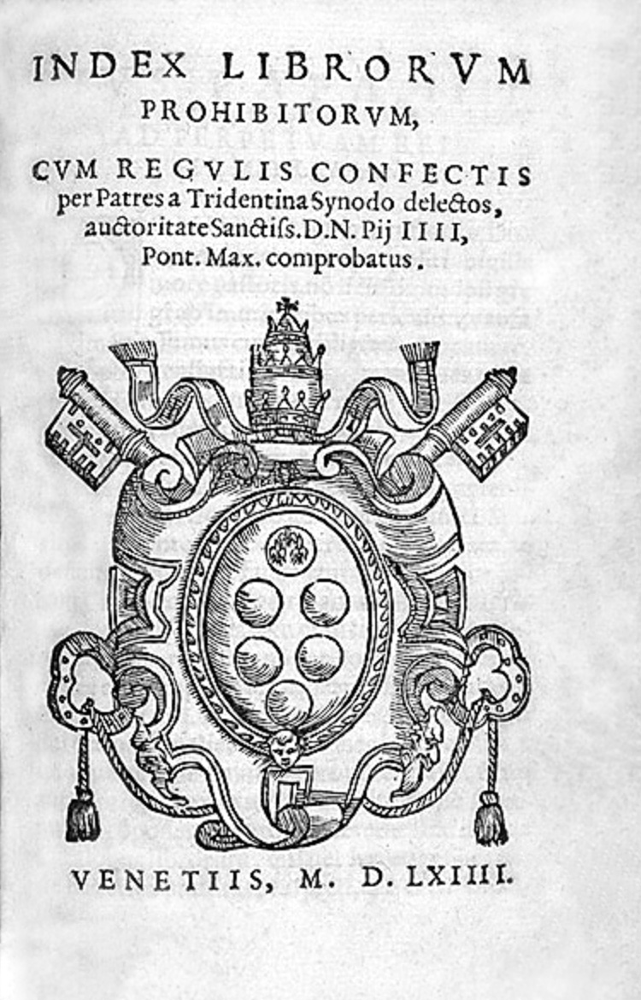
The “Index of Forbidden Books” was published, naming and shaming 583 heretical (sacrilegious/disrespectful against the Church) texts, including most translations of the Bible and the works of Erasmus, Calvin and Luther (leaders who wanted reform of the RCC). Some notable authors on the Index include novelist Gustave Flaubert (Madame Bovary), historian Edward Gibbon (The History of the Decline and Fall of the Roman Empire), political intriguer and legendary lothario Casanova (his memoirs), and revolutionary astronomer Galileo (Dialogue on the Great World Systems was banned in 1634 and then removed from the Index in 1822). Catholic bishops throughout Europe were ordered to gather up the offensive books and burn them in great bonfires. In Venice alone, 10,000 books were burned in one day. This censorship (restriction) of books by the Index continued into the twentieth century (1900s).

DOCUMENT 3: The Inquisition

To stop the spread of Protestantism, the Catholic Church set up courts called the Inquisition. The Inquisition had begun in the year 1217 and was used to find and punish heretics, or people whose beliefs differed from those of the church. These courts used investigators, trials, prisons, and torture to change people’s mind who thought about going or speaking against the Catholic Church. Those found guilty were either tortured or killed. The Pope was determined to get rid of heresy no matter what it took. It is reported that he once said, “Even if my own father were a heretic, I would gather the wood to burn him”.
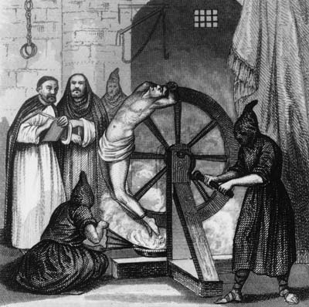
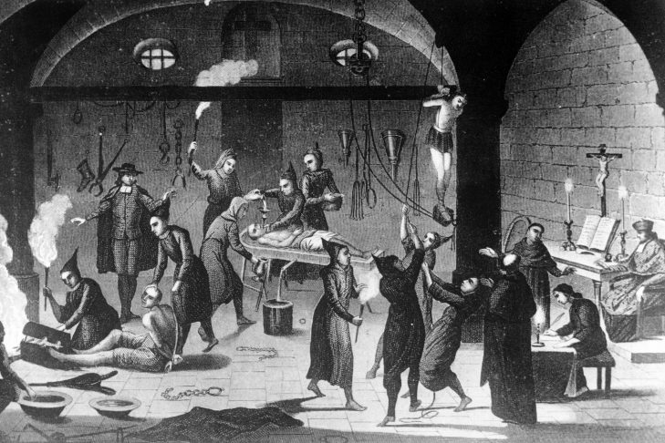

DOCUMENT 4: Jesuits

Some Catholics believed that it was important that Catholics reformed (changed) the church and not Protestants. These groups began their own groups to improve the things that were wrong with the church. The most powerful and important of these reforming groups was the Society of Jesus. Its priests, known as Jesuits, were dedicated to converting (changing) unbelievers to Christianity, stopping the spread of Protestantism and helping the sick and the poor. The Jesuits were like soldiers without guns. Their weapons were the cross and the Bible. Jesuits were intelligent, zealous (eager) men who were very successful in slowing the spread of Protestantism because of their dedication (loyalty) to education, missionary (spreading religion) work, and helping the poor. Education was of utmost importance to the Jesuits, and in Rome Ignatius founded the Roman College (later called the Gregorian University) and the Germanicum, a school for German priests. The Jesuits also ran several charitable organizations, such as one for former prostitutes and one for converted Jews. In addition, they devoted themselves to care for the young, sick, prisoners, and soldiers.
The Jesuits had three main goals:
- Create schools throughout all of Europe
- Convert non-Christians to Catholicism in Europe and abroad (The New World)
- Stop the spread of Protestantism

