Enlightenment Thinkers

I. Historic Context
The Age of Enlightenment occurred in the 1600s and 1700s when new thinkers came about. These thinkers tried to change society using reasoning. Enlightenment thinkers challenged ideas and had a major impact on culture, politics, and government in the Western world. Many Enlightenment thinkers tried to explain the purpose of government and describe the best form of government. Two Enlightenment thinkers were Thomas Hobbes and John Locke. Hobbes and Locke had different ideas about human nature and how the government should be run.

DIRECTIONS: Actively read through the ideas of Thomas Hobbes and John Locke. Identify & compare their perspectives on human nature and government.

Enlightenment Thinker: | 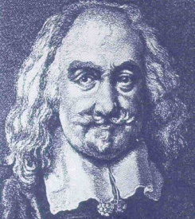  Thomas Hobbes | 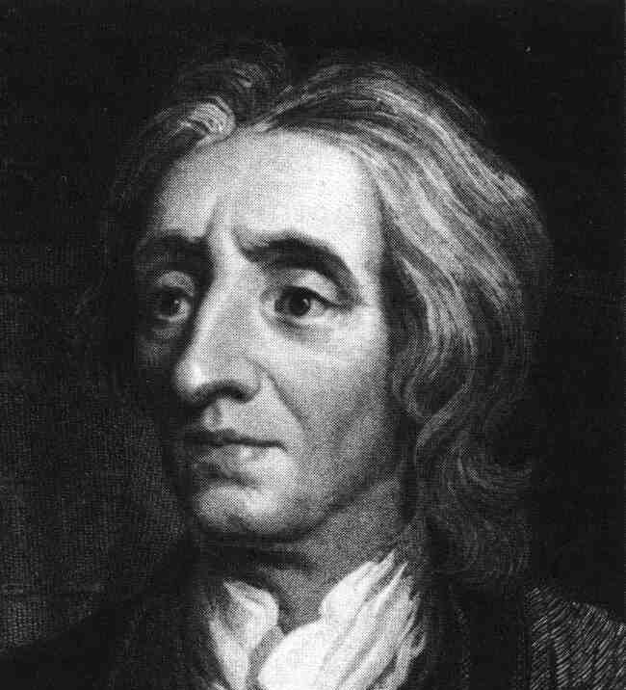  John Locke
Book: | Leviathan | Two Treatises on Government
Human Nature: | “So that in the nature of man,  we find three principal causes of quarrel (argument/problems):  First—Competition, which make men use violence to want to invade for gain and become masters of other men, their wives, children, and their cattle.  Secondly—Dissidence (disagreements), which make men to use violence to want to defend themselves and feel safe.  Thirdly—Glory, which make men use violence over trifles (small things) like words, a smile, a different opinion and any other sign of undervalue that speak against them or their relatives.” | “Men being, as has been said, by nature, all free, equal and independent, no one can be put out of this estate (land), and subjected to the political power of another, without his own consent (permission).”
What are Hobbes & Locke’s PERSPECITVE on humans?
Government: | “The only way to build a common power is to entrust [trust] the power and strength to one man, or Assembly that would reduce all their wills [wants], by majority rule in a single will. That is to say, appoint [put into power] a man or a meeting [assembly of people], to assume the personality of the people and that everyone admits and recognizes as the author of anything done or would have done so, as to those things which concern the Peace and Security Policy, who has assumed their personality, and each, therefore, submit [list and follow] to his will and the will to trial and trial of this man or this meeting. The multitude, and united in one person is well known Republic. This is the generation of that great Leviathan.” | “The state of nature has a law of nature to govern it, which obliges [pleases] every one: and reason, which is that law, teaches all mankind, who will but consult [check] it, that being all equal and independent, no one ought to harm another in his life, health, liberty, or possessions… (and) when his own preservation [protection] comes not in competition, ought he, as much as he can, to preserve the rest of mankind, and may not, unless it be to do justice on an offender, take away, or impair[damage] the life, or what tends to the preservation of the life, the liberty, health, limb, or goods of another.”
What are Hobbes & Locke’s PERSPECTIVE on government?

What would Locke and Hobbes think of us today?
DIRECTIONS: Look at the different modern issues below. With a partner, decide how Hobbes and Locke would answer the question. EXPLAIN you answer using facts you learned about the two thinkers.
Issue | Hobbes | Locke
- Should the government censor (cut out) music lyrics on the CD’s we listen to?

- Should the police use any means necessary to prevent crime?
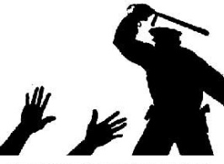
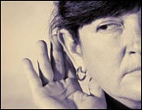
- Should the government listen to our phone calls and email in order to prevent terrorism?

