Name: ________________________________________ Band: _____

Life in Renaissance Florence

DIRECTIONS: Actively read about how the city-state Florence and why it was important to the Renaissance. Label where you see the following enduring issues this best associates with is (check all that apply):
- CHANGE (CH)
- CONFLICT (CON)
- POWER (P)
- TECHNOLOGY (T)
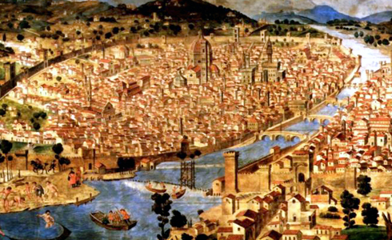
Then answer the question that follows.

For over two centuries, from the early 1300’s to the early 1500’s the city states of Italy had led the rest of Europe into the Renaissance, by creating new forms and styles of painting, sculpture, architecture, and decorative arts.

How did Italy come to be such a leader and source of change in Europe by the 14th century? Unlike the kingdoms of most of Europe, Italy was divided into many small city-states. Unlike most European countries, Each Italian city-state was not controlled by nobles that owned land instead they were controlled by powerful families and dominated by a wealthy and powerful merchant (business) class. These merchant families exerted both political and economic leadership. They stressed education and individual achievement which was the main point of the Italian Renaissance.

One leading city-states was Florence, located along the Arno River in northern Italy, was a center for European banking and manufacturing. Great textile mills were located in Florence. Nearly one out of every three Florentines was involved in the woolen industry—from raising sheep to selling cloth to foreign buyers. During the Renaissance, Florence represented the soul of the period, rising to fame as a source of great art produced largely under the patronage or financial support of one ruling family: The Medici family. Members of this important Italian family greatly influenced the Renaissance in Italy and France from the 1400’s to the 1700’s.
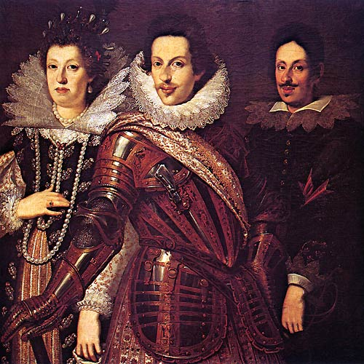
The Medici were patrons (supported the arts) of Florence with money and influence. Through them, Florence became the creative center of the Renaissance. They also gave support to the new liberal (open-minded) education of the period. Experts estimate that the Medici family spent hundreds of millions of dollars on the arts and sciences during a 50 year period. The Medici family ordered the building of the first public library in Europe since the days of the Roman Empire. They also supported the arts. The artists supported by the Medici family were Renaissance painters, sculptors, and architects, such as Donatello, Filippino Lippi, Botticelli, Davinci and Michelangelo. All of these artists produced great works of art under the generous patronage of the Medici family. The Medici family’s great wealth and influence transformed (changed) Florence. Perhaps more than any other city, it came to symbolize the energy and brilliance of the Italian Renaissance. Like the ancient Greek city of Athens, it produced a dazzling number of gifted poets, artists, architects, scholars, and scientists in a relatively short span of time.

Define the following words:

City-state:

Patrons of the arts:

How did Florence encourage the growth of the Renaissance? ____ _____ ____ _____ ____ _____ ____ _____ ____ _____ ____ _____ ____ _____ ____ _____ ____ _____ ____ _____ ____ _____ ____ _____ ____ _____ ____ _____ ____
_____ ____

The enduring issue this best associates with is (check all that apply):

- CHANGE
- CONFLICT
- POWER
- TECHNOLOGY

