A Scientist Challenges the Church

DIRECTIONS: Below you will read about Galileo Galilei and the trial he faced. As you read, highlight/underline important information, as well as circle things you do not understand. Then answer the questions below.
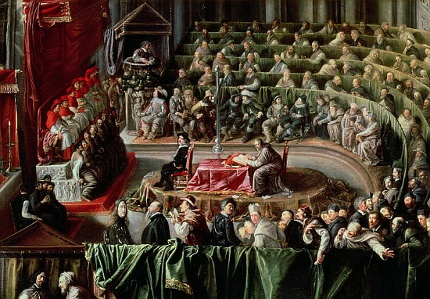
During the European Middle Ages, people had been taught that life on earth was not as important as life after death. By the 1300s and 1400s, however, this outlook was changing. Many people were living better. They were looking forward to a good life on earth rather than later. In the 1500s and 1600s, daring scientists had new ideas about how to study and understand the world. They challenged what the ancient writers and the Catholic Church had said about the workings of the universe. These scientists looked around them. They observed nature, saw how people lived, and learned that the earth moved around the sun. They asked questions and searched for answers. Sometimes they found the answers. If they did not they kept searching. One of these searchers for truth was Galileo Galilei, who made several important discoveries.

In the selection that follows, Galileo is about to appear before the Inquisition (judicial system of the Roman Catholic Church) to explain his discoveries. This court seeks to uphold the teachings of the Catholic Church.
Rome 1633

To think that I have come to this! If I do not admit that I am wrong. I will be executed! I will be remembered for all time as a heretic (a person who does not agree with the churches’ teachings), who denied the truth of the teachings of the Church. Yet, I, Galileo Galilei, have always been faithful to my Church and to the discoveries of science. Now I am told that I cannot believe in both science and God.

The Church says that the earth is the center of the universe. I know better. I have read and tested the theories of Copernicus. A hundred years ago, he proved by mathematics that the earth moves around the sun. I made my own telescope because I wanted to test his ideas. People asked how the astronomy of the Bible could be wrong. It was an insane idea to think that the teachings of the Church have been false for so many centuries. But my eyes did not betray me. Copernicus was right. The earth is not the center of the universe. How excited I was when I saw the rings of Saturn, the moons of Jupiter, and the countless stars of the Milky Way. These were my eyes, my telescope, making my discoveries!

We know the things we can see and prove. Is there any other possibility? There cannot be. Perhaps I was wrong to think that I could know more than the great scholars of my Church. If it is true that we are made in God’s image, then we must be at the center of the universe. Are there not mysteries and spirits that we cannot understand? Only God knows all. The leaders of his Church can explain the meaning of life to us. That is what I am supposed to believe. But in my heart of hearts I know that there is much to be discovered and explored. No one, not even the holy Church, knows that answers to all the mysteries!

If we are to find the answer to the riddle of the universe, we must never stop looking. We must experiment and experience as much as we can. Blind faith is not my way of life. I cannot accept whatever I am told simply because it has been said by the Church.

Enough of these wandering thoughts! I must make up my mind. I know that I can faith in my God and still search for answers. The Church fathers do not agree. They say I must give up my search for learning, destroy my book, agree that the sun moves around the earth. They want me to stop my experiments and accept the ways of God and of the Church. I don’t want to accept blindly, but if I am to see another sunrise I must give in. I must pretend to believe. I wonder, is it better to live a lie than to die and face the unknown?

Postscript:
To save his life, Galileo told the judges of the Inquisition that the earth was the center of the universe. However as he left the courtroom, he whispered, “all the same, the earth does move.” Galileo was placed under arrest at his home in Arcetri, near the city of Florence, and remained there until his death in 1642.

Q1. How did the beliefs of the Roman Catholic Church differ from that of scientist, Galileo?

Q2. Is it possible for science and religion to coexist (live together)?

Possible Activities
- Imagine that you are Galileo. You are accused of heresy by the Church. Would you act in the same way that Galileo did? Explain your answer. Are there people today who like Galileo are placed on trial for their ideas? Explain.
- Make a drawing of Galileo sitting in his prison cell. What is he thinking? Make up a title for your drawing.
- Imagine that you are a lawyer. Would you rather defend or prosecute Galileo? Prepare your case.

