Name: ______________________________________________________ Band: ______
Geography of Greece

DIRECTIONS: Actively read/annotate about the geographic context of Greece. LABEL WHERE YOU SEE ANY ENDURING ISSUES. Then complete the task that follows.
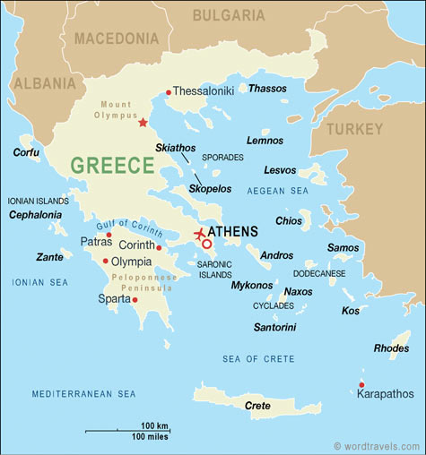
Greece is in southeastern Europe and part of the Balkan Peninsula, which extends southward into the eastern Mediterranean Sea. Mountains divide the peninsula into isolated valleys. Beyond the rugged coast, hundreds of rocky islands spread towards the island, which makes Greece an archipelago, which means that it is a group of islands. The Greeks who farmed the valleys or settled on the scattered islands did not create a large empire, but instead they built polis, also known as small city-states cut off from one another by mountains or water. A city-state is a region of land that’s controlled by a powerful city. Even though Greek city states shared the same religion and language, they all had different cultures, governments, and social structures, which led to frequent wars. Two such city states were called Athens and Sparta. The barriers of city-states caused Greece to lack cultural diffusion and unity.

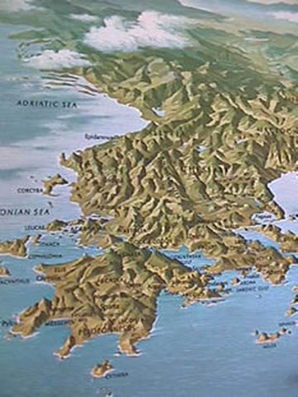
Mountains divided Greeks. As a result, the seas were a vital link to the world outside. With hundreds of bays, the Greek coastline provided safe harbors for ships. The Greeks became skilled sailors, carrying cargoes of olive oil, wine, and marble around the eastern Mediterranean. They returned not only with grains and metals but also with ideas, which they adapted for their own needs (cultural diffusion). One benefit of Greece’s trade with other nations is that they encountered the Phoenician alphabet, which the Greeks expanded and adapted resulting in the Greek alphabet becoming the basis of all western alphabets and languages.

By 750 B.C.E., rapid population growth was forcing many Greeks to leave their own overcrowded areas. With fertile land limited due to the mountains making up 80% of the land and limited natural resources, the Greeks expanded overseas. Gradually, a scattering of Greek colonies took root all around the Mediterranean from Spain to Egypt. Wherever they traveled, Greek settlers and traders carried their ideas and culture.

Name: _____________________________________________ Band: __________

How does the geographic context of the Greece affect the empire’s development?
Ancient Greece is on the continent of ________________________________________. The geographic feature of Greece is a ________________________________, which means (describe Greece’s geographic feature) ___________________________________________________
Greece’s geographic context affected the empire’s development positively/negatively (circle appropriate answer) because (EXPLAIN AT LEAST 2 REASONS AND WHY THEY ARE POSITIVE OR NEGATIVE TO THE EMPIRE’S DEVELOPMENT) ____________________________________________________________________________
________________________________________________________________________________________________________________________________________________________________________________________________________________________________________________________________________________________________________________________________________________________________________________________________________________________________________________________________________________________________________________________________________________________________________________________________________________________________________________________________________________________________________________________________________________________________________________________________________________________________________________________________________________________________________________________________________________________________________________________________________________________________________________________________________________________________________________________________________________________________________________________________________________________________________________________________________________________________________________________________________________________________________________________________________________
________________________________________________________________________________________________________________________________________________________________

The enduring issue this best associates with is (check all that apply)
- CULTURAL DIFFUSION
- HUMAN RIGHTS (inequality/equality)
- IMPACT OF ENVIRONMENT ON HUMANS
- POWER
- SCARCITY
- TECHNOLOGY

Name: _____________________________________________ Band: __________

Using the reading above, how does the geographic context of Greece affect its development?
In your response, be sure to provide the following:
- Topic sentence in the form of a thesis/claim
- Evidence—a minimum of 2 pieces of evidence describing the geography of Greece
- Analysis that connects to your claim and evidence (positive/negative impact)

_______________________________________________________________________________________________________________________________________________________________________________________________________________________________________________________________
_______________________________________________________________________________________________________________________________________________________________________________________________________________________________________________________________
_______________________________________________________________________________________________________________________________________________________________________________________________________________________________________________________________
_______________________________________________________________________________________________________________________________________________________________________________________________________________________________________________________________
__________________________________________________________________________________________________________________________________________________________________________
__________________________________________________________________________________________________________________________________________________________________________
_____________________________________________________________________________________

_______________________________________________________________________________________________________________________________________________________________________________________________________________________________________________________________
_______________________________________________________________________________________________________________________________________________________________________________________________________________________________________________________________
_______________________________________________________________________________________________________________________________________________________________________________________________________________________________________________________________

The enduring issue this best associates with is (check all that apply)
- CULTURAL DIFFUSION
- HUMAN RIGHTS
- IMPACT OF ENVIRONMENT ON HUMANS
- POWER
- TECHNOLOGY
- SCARCITY

