Geography of India
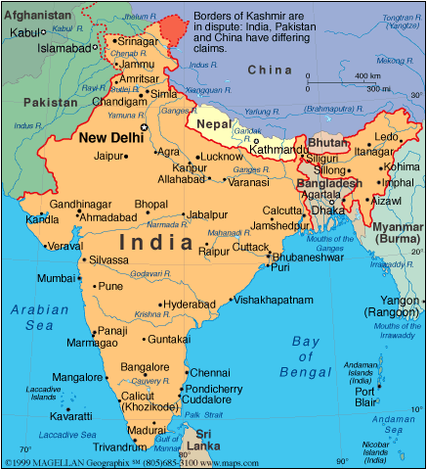
Introduction:
India is the world’s seventh largest country in size. It is approximately one third the size of the United States of America. India is located in Southeast Asia. India is often called a subcontinent, which means that it’s a part of the continent of Asia, but it’s so big that it has many differences in geography. India has a large population, diverse physical features, climates (weather), vegetation (trees, plants, etc), religions, and languages. In other words, there are as many differences in the country of India as there are in a huge continent.

Q. According to the reading above, why is India a “subcontinent?”
__________________________________________________________________________________________________________________________________________________

DIRECTIONS: With your group members, visit each station about the geography of India. Assess the GEOGRAPHIC CONTEXT of India affects the people who live there and evaluate whether the information provided is harmful or beneficial to the people that live there.

GEOGRAPHIC FEATURE/  WEATHER | BENEFICIAL  (good) | HARMFUL  (bad)
HIMALAYAS

DECCAN

GANGES RIVER

MONSOONS

NAME: _______________________________________ BAND: _______
INDIA’S GEOGRAPHY

DIRECTIONS: Using TEAL strategies fill in the template below to answer the following question: How does the geographic context of India affect the lives of people who live there?

The geographic context of India affect the people who live there in a positive/negative (circle one) way. One reason is (state the evidence—explain one geographic feature/climate of India) ___________________ ________________________________________________________________________________________________________________________________________________________________
_______________________________________________________________________________________________________________________________________________________________________________________________________________________________________________. This shows that the geographic context affects the people of India and is a positive/negative (circle one) for them to live in because (analyze—explain why the geographic feature/climate you described above is good or bad) ________________________________________________________________________________________________________________________________________________________________ _________________________________________________________________________________________________________________________________________________________________________________________________________________________________________________________________________________________________________________________________________________________. A second reason the geographic context of India affect the people who live there in a positive/negative (circle one) way is (state the evidence—explain another geographic feature/climate of India) __________________________________________________________________________
________________________________________________________________________________
___________________________________________________________________________________________________________________________________________________________. This shows that the geographic context affects the people of India and is a positive / negative (circle one) for them to live in because (analyze—explain why the geographic feature/climate you described above is good or bad) ________________________________________________________________________________________________________________________________________________________________________________________________________________________________________________
_______________________________________________________________________________________________________________________________________________________________________________________________________________________________________________________________________________________________________________________________.
Overall, the geography of India impacts its people is a good/bad (circle one) way.

SCORE:

EXCELLENT (5)  - There is a clear claim that shows clear connection to the evidence and analysis; the claim is carried throughout the entire writing task.  - Uses relevant information in the activity that demonstrates a clear and detailed understanding of India’s geography.  - Develops a thoughtful and in-depth argument about how the geography of India impacts people or how they have been affected.  - Is more analytical than descriptive. | GOOD (3.5-4.5)  - There is a claim that connects to the evidence presented.  - Chooses to create and advertisement or write argumentative statement.  - Uses relevant information in the activity that demonstrates a clear and somewhat detailed understanding of India’s geography.  - Provides some analysis; is more descriptive than analytical. | SATISFACTORY (2-3)  - There is a claim; the claim is connected to limited evidence or needs more details.  - There is limited details and information about India’s geography.  - Argument is not clearly explained in depth/lacks analysis/limited connections to the evidence. | UNSATISFACTORY (0-1)  - A claim is presented; however, there is limited connections evidence in the writing task.  - There are minimal details  and information about India’s geography.  - Limited or no analysis/ analysis does not show clear connections to the evidence.  - Fails to develop the task OR includes limited facts and details

