Name: ________________________________________ Band: _______

Geography of Rome—Expansion from a Republic into an Empire

DIRECTIONS: Actively read about the geographic context of the Roman Empire. Then, fill out the template that follows.
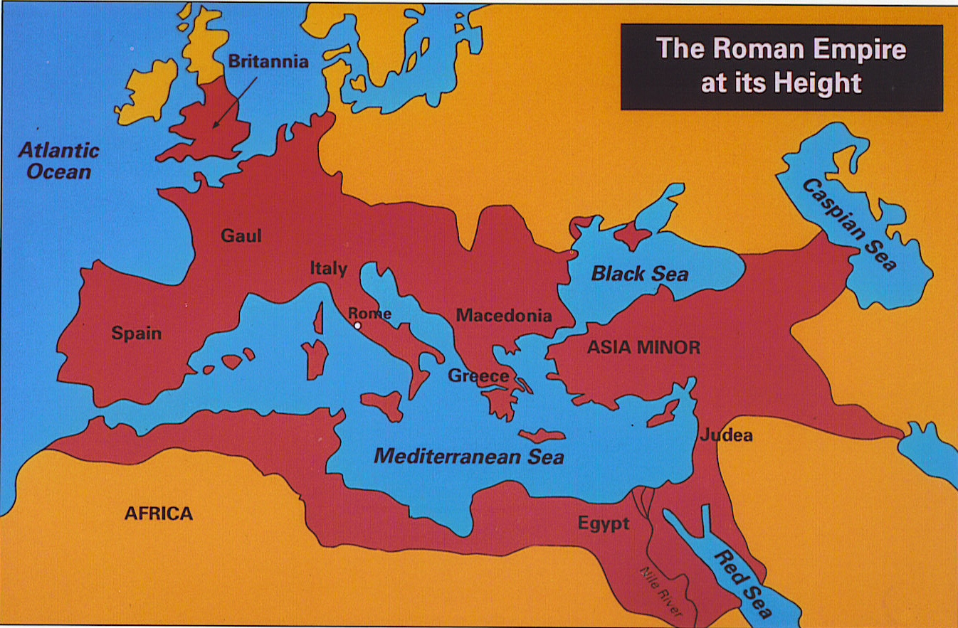
Rome began as a small city-state in Italy but ended up ruling the entire Mediterranean world. The story of the Romans and how they built a world empire starts with the land where they live.
Italy is a peninsula, which is land surrounded by three sides of water. The peninsula is centrally located in the Mediterranean, and the city of Rome is in the center of Italy. Rome further benefited from its position at the center of the Mediterranean Sea. Rome's location in the Mediterranean Sea made it easier to travel to foreign lands around the sea like North Africa, to conquer new territories, and to develop trade routes. Through these trade routes, Romans came in contact with lots of different people with whom they traded goods, ideas, and technology. The Mediterranean Sea provided merchants with an easily navigable waterway on which to traffic their goods. Greek culture and civilization, which came to Rome via Greek colonies to the south, provided the early Romans with a model on which to build their own culture. From the Greeks they borrowed literacy and religion, as well as their architecture. The Etruscans, to the north, provided a model for trade and urban luxury. Early on, the Romans showed a talent for borrowing and improving upon the skills and concepts of other cultures. The Kingdom of Rome grew rapidly from a trading town to a prosperous city between the 8th and 6th centuries BCE. This centrality later helped the Romans administer their empire effectively by reducing communication times.
Rome's central location attracted immigrants and traders from all parts of the ancient Mediterranean world. The diversity of the early Roman state helped it expand its influence. The Romans were unusually adaptable and willing to change their strategy when compared to the rest of the ancient world. That flexibility enabled the Romans to overcome new challenges as the centuries passed. It also made the Roman Empire more accepting of outsiders, which encouraged foreign powers to cooperate with rather than oppose Roman forces
Because of its geography, Italy was easy to unify. The Apennine Mountains run down the length of the Italian peninsula and are not rugged (rocky). The main advantage of Italy was its broad, fertile plains. This broad plain supported a growing population because it was easy to farm. In addition, two mountain ranges, the Alps and the Apennines, helped to protect Rome from invasion. The Apennines divide the Italian peninsula in half and allowed the Romans to mass forces for counter-attack whenever they were threatened. Any army attempting to attack Rome would be at risk of attack from the other side of the mountains. The Alps, located on the northern border of modern-day Italy, seal off the peninsula from the rest of Europe during winter. This natural roadblock protected Rome from outside invasions by forcing attackers to move slowly through narrow passes, giving the Romans time to respond.
Rich volcanic soil makes the Po and Tiber river valleys ideally suited for agriculture. Volcanic ash made the soil near Rome some of the best in all of Europe. Rome attracted new settlers during its rise to power due to its agricultural potential. The Roman population grew quickly, thanks to surplus production of grains, olives and other crops. The extra population later helped Rome's military expansion by providing a large supply of troops. The surplus also helped Rome to establish trade ties with other Mediterranean powers, enhancing the city's economic might.
How does the geographic context of the Rome affect the empire’s development?
Ancient Rome was found in Europe in the country now known as ____________________________. The geographic feature of Italy is a _____________________, which means (describe Italy’s geographic feature) _________________________________________________________________________
________________________________________________________________. As Rome became an Empire, it covered various continents, (name three CONTINENTS the Roman Empire covered—use the map from the reading to help you)___________________________, ________________________, and ____________________________. Rome was successful because it is located by the (state the body of water) ________________________________________. Rome’s geographic context affected the empire’s development positively/negatively (circle appropriate answer) because (7-10 sentences minimum) ________________________________________________________________________________
________________________________________________________________________________________________________________________________________________________________
________________________________________________________________________________________________________________________________________________________________________________________________________________________________________________________________________________________________________________________________________________________________________________________________________________________________________________________________________________________________________________________________________________________________________________
_______________________________________________________________________________________________________________________________________________________________________________________________________________________________________________________________________________________________________________________________________________________________________________________________________________________________________________________________________________________________________________________________________________________________________________________________________________________________________________________________________________________________________________________________________________.

The enduring issue this best associates with is (check all that apply)
- CULTURAL DIFFUSION
- HUMAN RIGHTS
- IMPACT OF ENVIRONMENT ON HUMANS
- POWER
- TECHNOLOGY
- SCARCITY

