River Valleys
#5
I. Introduction
Civilization resulted from the development of agriculture, the increase in population that agriculture brought about and the need to solve problems presented by the environment. The first civilizations began along river valleys because people could more easily grow food there.

II. Activity: MAP SKILLS
Directions: Analyze and read the map below. Respond to the questions.
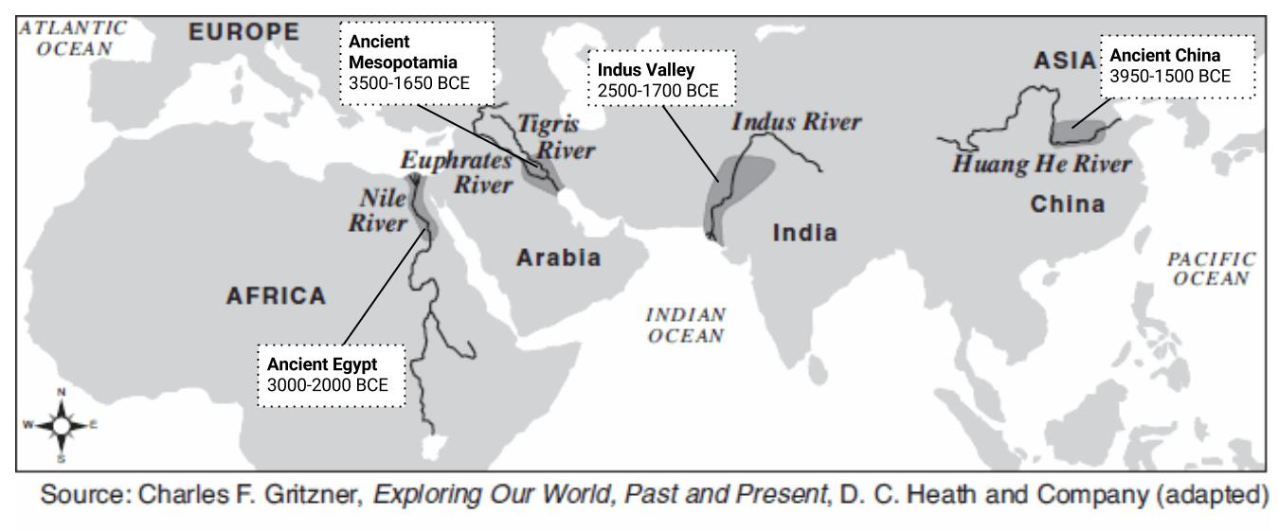
1. Based on the map above, what geographic feature did the early civilizations settle near? ________________________
________________________

2a. Which civilization is the furthest east? _____________
________________________

2b. Which civilization is the furthest west? _____________
________________________

3. Which river was the ancient Egyptian civilization located near? | 4. Which rivers were the ancient Mesopotamian civilization located near? | 5. Which river was the ancient Chinese civilization located near? | 6. Which river was the ancient Indus River Valley Civilization located near?
7. Which continent was the ancient Egyptian civilization located in? | 8. Which continent was the ancient Mesopotamian civilization located in? | 9. Which continent was the ancient Chinese civilization located in? | 10. Which continent was the ancient Indus Valley civilization located in?

DIRECTIONS: Actively read the documents below, list the advantages and disadvantages of settling near a river valley.

Document 1: Greetings, Oh Nile,…who comes in peace to give Egypt life; hidden god who guides the darkness,…irrigator of the meadows…to give all animals life; you feed the earth;…friend of bread and fruitfulness, benefactor of the grain. -Hymn to the Nile

Document 2: One such civilization was the Harappan civilization that developed in the Indus River Valley thousands of years ago. It was not until the 1920s that the world learned of the existence of this civilization. In 1922, a team of archaeologists uncovered one of the cities from the civilization. A vast region including present-day Pakistan and northern India made up the territory controlled by the Harappan civilization. Rich farmlands provided food for the people in over a hundred cities and towns. Goods were transported to and from the farms by means of a series of canals. Life was good in this civilization. The people had mastered reading, writing, and arithmetic. People in the cities enjoyed such modern conveniences as indoor plumbing, sewage systems, and heated public baths. -World History, Glencoe

Document 3: The early Chinese first settled along the Huang River-also called the Yellow River-about 5000 B.C. Hundreds of years later, farming villages were built there. By about 3000 B.C. Chinese farmers were growing grain in the valley’s rich soil. They were also raising cattle and sheep. Like the Egyptians along the Nile River, the people in the Huang valley learned how to build dikes to control floods. They also built ditches and canals to irrigate their fields. The Huang River was not as regular as the Nile in ancient Egypt. Some years the Huang did not flood. In other years the Huang’s flood broke through the dikes along its banks and destroyed crops as well as whole villages. For this reason the Chinese named the Huang the River of Sorrows. -Exploring World History. Globe Book Company
+ | 11a. List three ADVANTAGES of settling near a river valley. | - | 11b. List three DISADVANTAGES of settling near a river valley.
+ |  | -
+ |  | -
+ |  | -
When humans ADAPT to or MODIFY their environment, they change their behavior and change the world around them to meet their needs.

All civilizations need access to water. However, in some places there are not reliable water supplies. To meet the needs for reliable water access, early civilizations made modifications to their environment. The Neolithic Revolution was a major turning point in human history around 10,000 BCE. This was the point when humans began to cultivate crops and domesticate certain animals. People abandoned hunting and gathering and permanent settlements were established. Even though Rivers provided the means for early civilizations to survive and grow, there was a major problem that the environment presented to early humans. Not every person could live on or near the river. There were parts of the cities that were a few miles away from the river that made access to water unreliable. Mostly all the river valleys developed in very dry and desert like areas. Rainfall was also not reliable and some areas could go with little rainfall for many months

Why did humans need access to more water after experiencing the Neolithic Revolution?

______________________________________________________________________________________________________________________________________________________________________________________________________________________________________________________________________________________________________________________________________________________________________________________________________________________________________________________

DIRECTIONS: With a partner list THREE ways you think people of early civilizations adapted or modified their environment to solve their problem of unreliable access to water.

1.

2.

3.

