Judaism
I. Introduction
In the ancient civilizations of Mesopotamia and Egypt, there lived a group of ancient people called the Ancient Hebrews. Their religious beliefs and their traditions have been passed down for thousands of years and have many effects on our society. Today, the people who follow the religious beliefs and traditions of the Hebrews are called Jews and practice a religion called Judaism. Judaism began about 4000 years ago in the Middle East. Most of the people in the ancient world were polytheistic. This means that they believed in many gods. However, the Hebrews were monotheists. This means that they only pray to one god. The word monotheism comes from the Greek word “mono” which means “one” and “theism,” meaning “god.” The Hebrews said that they only have one god. In their eyes, God was all-powerful. Abraham, a Hebrew man, is considered the father of the Ancient Hebrews.

According to the holy books of the ancient Hebrews (called the Torah by Jews or the Old Testament by Christians), Abraham made a covenant, or promise, with God. Abraham and his wife Sarah were old and childless. They were told by God that they would have as many children as there are stars in the sky and that they would one day have their own land called Canaan. In exchange, Abraham and Sarah had to obey God’s laws. Prophets, such as Isaiah and Jeremiah warned that failure to obey God’s law would lead their people to disaster. The prophets preached a strong code of ethics, or moral standards of behavior. They called for rich and powerful people to protect the poor and weak. All people, the prophets said, were equal before God. This was unlike many other ancient societies, which the ruler was seen as god. Rather, the Jews saw their leader as fully human and must obey God’s law like everyone else.

DIRECTIONS: Actively read the following documents on Judaism and Buddhism. Explain the PURPOSE of these documents as well as COMPARE them.

Purpose: the reason the document was produced

DOCUMENT 1:
After "the LORD came down upon mount Sinai", Moses went up briefly and returned and prepared the people, and then in Exodus 20 "God spoke" to all the people the words of the covenant, that is, the "ten commandments" as it is written.
The Ten Commandments:
- You shall have no other gods before Me.
- You shall not make idols.
- You shall not take the name of the LORD your God in vain.
- Remember the Sabbath day, to keep it holy.
- Honor your father and your mother.
- You shall not murder.
- You shall not commit adultery (infidelity: unfaithful/disloyal to your wife/husband).
- You shall not steal.
- You shall not bear false witness against your neighbor.
- You shall not covet (want).

1. Based on this document, explain God’s purpose for writing the Ten Commandments? ________________________________________________________________________
______________________________________________________________________________________________________________________________________________________________________________________________________________________________________________________________________________________________________________________________________________________________________________________________________________________________________________________

Comparison: tell how something is alike or different from something else.
- Student will identify a similarity or a difference between the ideas presented in documents 1 and 2.
- Student will explain a similarly or a difference in the ideas presented in these documents. Student must use evidence from both documents 1 and 2 in their response.

DOCUMENT 1:
After "the LORD came down upon mount Sinai", Moses went up briefly and returned and prepared the people, and then in Exodus 20 "God spoke" to all the people the words of the covenant, that is, the "ten commandments" as it is written.
The Ten Commandments:
- You shall have no other gods before Me.
- You shall not make idols.
- You shall not take the name of the LORD your God in vain.
- Remember the Sabbath day, to keep it holy.
- Honor your father and your mother.
- You shall not murder.
- You shall not commit adultery (infidelity: unfaithful/disloyal to your wife/husband).
- You shall not steal.
- You shall not bear false witness against your neighbor.
- You shall not covet (want).

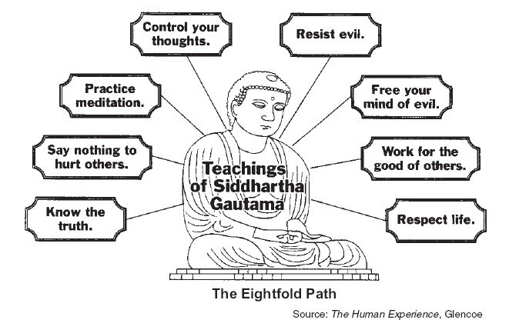

DOCUMENT 2:
Within the fourth noble truth is found the guide to the end of suffering: the noble eightfold path. The eight parts of the path to liberation [freedom from suffering] are grouped into three essential elements of Buddhist practice—moral conduct, mental discipline, and wisdom. The Buddha taught the eightfold path in nearly all his discourses [speeches].

2a. Using DOCUMENT 1 AND 2, identify a similarity or a difference regarding the ideas about how people should behave as expressed in documents 1 and 2. __________________________________
________________________________________________________________________________________________________________________________________________________________________________________________________________________________________________________________________________________________________________________________

SCORE OF 1: | SCORE OF 0:
Identified a similarity or a difference regarding the ideas about the treatment of people in society using both documents. | - Incorrect response (did not accurately identify a similarity or difference).  - No response.
2b. Explain a similarity or difference regarding ideas about how people should behave as expressed in documents 1 and 2. Be sure to evidence from both documents 1 and 2 in your response.
___ ___ ___ ___
___ ___ ___ ___ ___ ___
SCORE OF 1: | SCORE OF 0:
Explains a similarity or a difference regarding the ideas about the treatment of people in society using both documents. | - Only identified and does not explain.  - Did not use evidence relate to information in both documents.  - Provided incorrect information.  - Did not answer the question (no response).
___ ___

