CLUE 1: Houses

Vocabulary:
Erosion- the process by which the surface of the earth is worn away by the action of water, winds, etc.
Some Copan houses that were found near hillsides show debris from erosion. The probable cause of this erosion is that people were over farming the hillsides. The erosion seems to have begun in the mid 700’s A.D. and to have continued for a long time afterward. At some point, these houses were abandoned. Eventually, some houses were completely buried by erosion debris.

CLUE 2: Household items
The Mayan used obsidian, a glass like mineral, to make cutting blades. Obsidian blades were widely used in households in Copan, and many blades have been found. The dates of these blades reveal how populated the valley was. Obsidian blades found in Copan households show a range of dates from 500 to 1200 A.D. after this, the number of blades drops off.

CLUE 3: Bones

Vocabulary:
Anemia- condition marked by a lack of red blood cells or of hemoglobin in the blood, resulting in pallor (very white) and weariness.
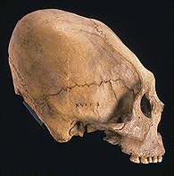
This skull shows evidence of severe anemia, which probably killed this Copan citizen. The spongy-looking areas at the back of the skull are caused by a lack of iron in the diet. This person suffered from malnutrition. Eighty percent of the skeletons found in Copan show evidence of anemia.
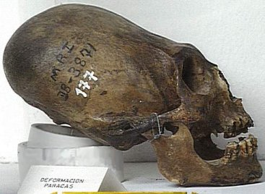
CLUE 4: Agriculture
This skull shows evidence that the head was wrapped during childhood to form it into a shape that was pleasing to the ancient Maya. The teeth have also been carved into a complex pattern, something that was done by Maya of the upper social classes. Spongy looking areas at the back of the skull show that this Maya noble had anemia.
Today, there are many people living in the Copan Valley. They grow corn, like the ancient Mayans did before them. There are about 25,000 people living in the Copan Valley, about the same number that lived there before the collapse of the Mayan empire. When you talk to a modern farmer who works in these fields, he reports that he is getting less and less corm from his fields. Each year, his crop is getting smaller. In order to feed the large population in the valley, farmers are growing crops on their land every year, leaving no resting period for the land.

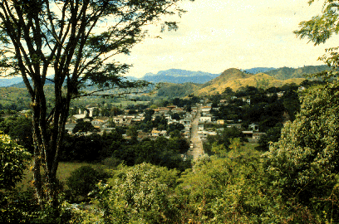

CLUE 5: Monuments
Mayan rulers carved elaborate monuments that told stories of their ascent to the throne and linage, important battles or other events. The Maya had a sophisticated and accurate calendar and a system of hieroglyphic writing. They dated many monuments and included the names of kings and when they ruled. There is one unfinished monument at Copan.

This stone monument, an altar, might have been carved for use as a throne platform for a Maya ruler. One side was completed, but the other sides were left unfinished. One of these unfinished sides, the Maya text shows a date, February 10, 822 A.D. The remaining text was never finished. There are no known monuments at Copan dated after 822 A.D.

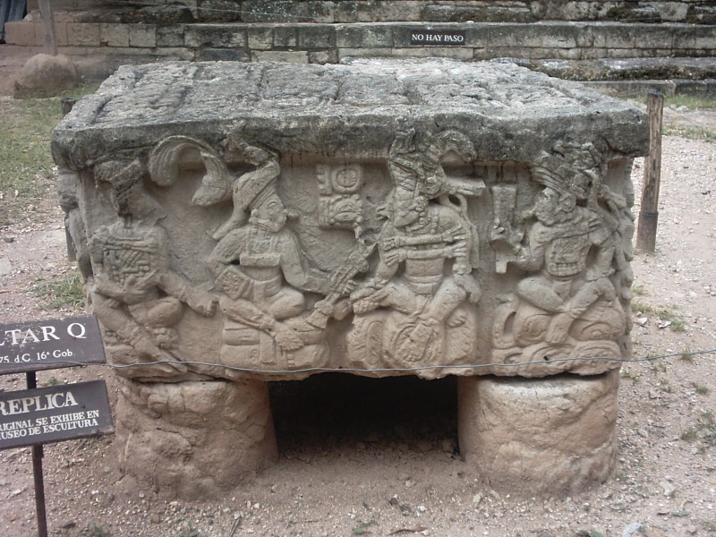

CLUE 6: Warfare
In Guatemala, in the Mayan ruins of the city of Tikal, there is evidence for a prolonged war and conflict. Late rulers embarked on campaigns of expansion. Major jade and obsidian routes were controlled by the Mayans. There is evidence that conquered people have eventually fought back against their conquerors around the year 761 A.D.
