The Neolithic Revolution
#6

NEXT YEAR: COMBINE DOC # 1 & 2 OR OPTION OF DOING 1 OR 2. OPTIONS FOR 3 AND 4 (if don’t understand doc 3 move to 4)

I. Introduction
The invention of tools, mastery of fire, and the development of language are some of the most impressive achievements in human history. Scientists believe these occurred during the prehistoric period known as the Stone Age. The Old Stone Age or Paleolithic Age lasted from 2.5 million to 8000 B.C.E The New Stone Age or Neolithic Age began in 8000 B.C.E and lasted to about 3000 B.C.E.

II. Paleolithic vs. Neolithic Living
DIRECTIONS: Using the documents below, analyze and compare and contrast the Paleolithic Age and Neolithic Age. Then using the evidence, evaluate which is more advanced and explain.

Document 1: Way of life

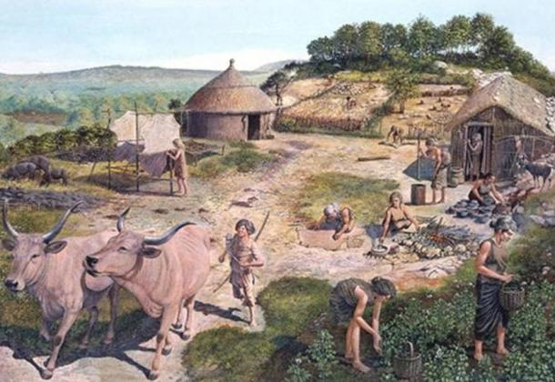
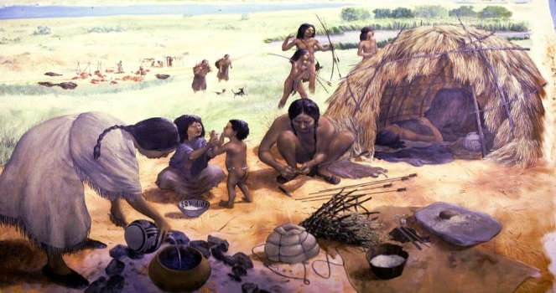
Paleolithic Age vs. Neolithic Age
The evidence from the document proves that the Paleolithic Age/Neolithic Age (circle one) is more advanced because __________________________________________________________________________
_______________________________________________________________________________________________________________________________________________________________________________________________________________________________________________________________________________________________________________________________________________________________________________________________________________________________________________________________________________________________________________________________________________________________________________________________________________________________________________________________________________________________________________________________________________________________________________________________________________________________.

Document 2: From Food Gathering To Food Producing
. . . Paleolithic men could not control their food supply. So long as they relied on foraging (scavenging), hunting, fishing, and trapping, they were dependent on the natural food supply in a given area to keep from starving. But while Paleolithic men continued their food-gathering pattern of existence in Europe, Africa, and Australia, groups of people in the Near East began to cultivate(grow) edible plants and to breed (raise and reproduce) animals. Often described as the “first economic revolution” in the history of man, this momentous change from a food-gathering to a food-producing economy initiated the Neolithic Age. Paleolithic man was a hunter; Neolithic man became a farmer and herdsman.

The evidence from the document proves that the Paleolithic Age/Neolithic Age (circle one) is more advanced because __________________________________________________________________________
_______________________________________________________________________________________________________________________________________________________________________________________________________________________________________________________________________________________________________________________________________________________________________________________________________________________________________________________________________________________________________________________________________________________________________________________________________________________________________________________________________________________________________________________________________________________________________________________________________________________________________________________________________________________________________________.
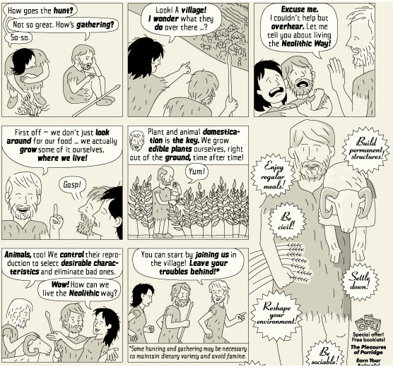
Document #3: Effects on Human Life

According to the diagram, what are two significant changes in human life that occurred as a result of the Neolithic Revolution? ___________________________________________________________
_______________________________________________________________________________________________________________________________________________________________________________________________________________________________________________________________________________________________________________________________.

Document #4: Effects on Human Life 2
Paleolithic Age |  | Neolithic Revolution |  | Food surplus |  | Population Increase  Population grows |  | Growth of Civilizations  and Cities
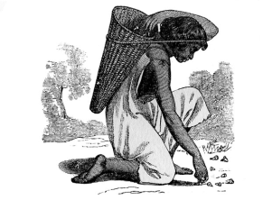 |  | 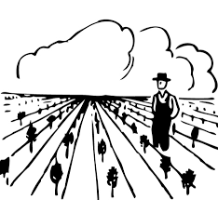

5. According to the flow chart, explain two ways how humans transitioned from the Paleolithic Era to the Neolithic Era? __________________________________________________________
________________________________________________________________________________
________________________________________________________________________________
________________________________________________________________________________
_______________________________________________________________________________.
*HOMEWORK*: Why is the Neolithic Revolution considered a turning point in history?
- Using your notes, your handout, and class activities, answer the question in 10 sentences or more on loose-leaf or typed.
- Include the following key terms you learned (Neolithic Revolution, domesticate, surplus, civilization ) and examples and evidence to explain your answer.

Directions: Examine the flowchart below. Using the text, images, and transitions below, write a series of sentences that explain how humans transitioned from the Paleolithic Era to developing the first civilizations.
Paleolithic Age Hunters and  Gatherers |  | Neolithic Revolution  Agriculture and Domestication |  | Food Surpluses  Extra Food |  | Population Increase  Population grows |  | Growth of Civilizations  and Cities

Transitions (You may use any of these transitions. You do not need to use all of them)
as a result | because | so | therefore | then, | initially, | next, | finally | eventually

In the space below, write a series of sentences that explain how humans transitioned from the Paleolithic Era to developing the first civilizations.

