The Neolithic Revolution
#6

I. Introduction
The invention of tools, mastery of fire, and the development of language are some of the most impressive achievements in human history. Scientists believe these occurred during the prehistoric period known as the Stone Age. The Old Stone Age or Paleolithic Age lasted from 2.5 million to 8000 B.C.E The New Stone Age or Neolithic Age began in 8000 B.C.E and lasted to about 3000 B.C.E.

II. Paleolithic vs. Neolithic Living
DIRECTIONS: Annotate the documents below. Then answer the questions that follow.

Comparison:
- Student will identify a similarity or a difference between the ideas presented in the documents.
- Student will explain a similarly or a difference in the ideas presented in these documents. Student must use evidence from both documents in their response.

Document: Way of Life
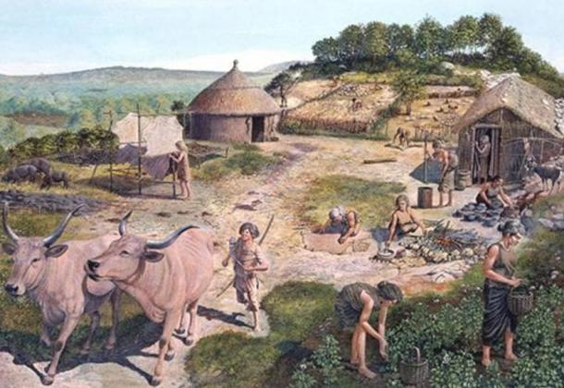
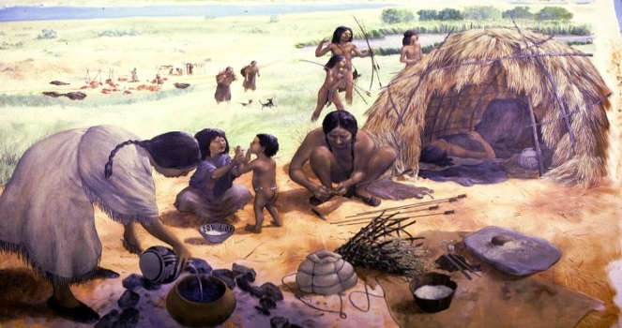
Paleolithic Age vs. Neolithic Age
. . . Paleolithic men could not control their food supply. So long as they relied on foraging (scavenging), hunting, fishing, and trapping, they were dependent on the natural food supply in a given area to keep from starving. But while Paleolithic men continued their food-gathering pattern of existence in Europe, Africa, and Australia, groups of people in the Near East began to cultivate(grow) edible plants and to breed (raise and reproduce) animals. Often described as the “first economic revolution” in the history of man, this momentous change from a food-gathering to a food-producing economy initiated the Neolithic Age. Paleolithic man was a hunter; Neolithic man became a farmer and herdsman.

1. Identify and explain a similarity or a difference regarding how people lived in the Paleolithic Age and Neolithic Age. Be sure to evidence from the documents in your response.

2. What is the biggest cause/change that occurred from the Paleolithic to the Neolithic Age?

Document: Effects of the Neolithic Revolution
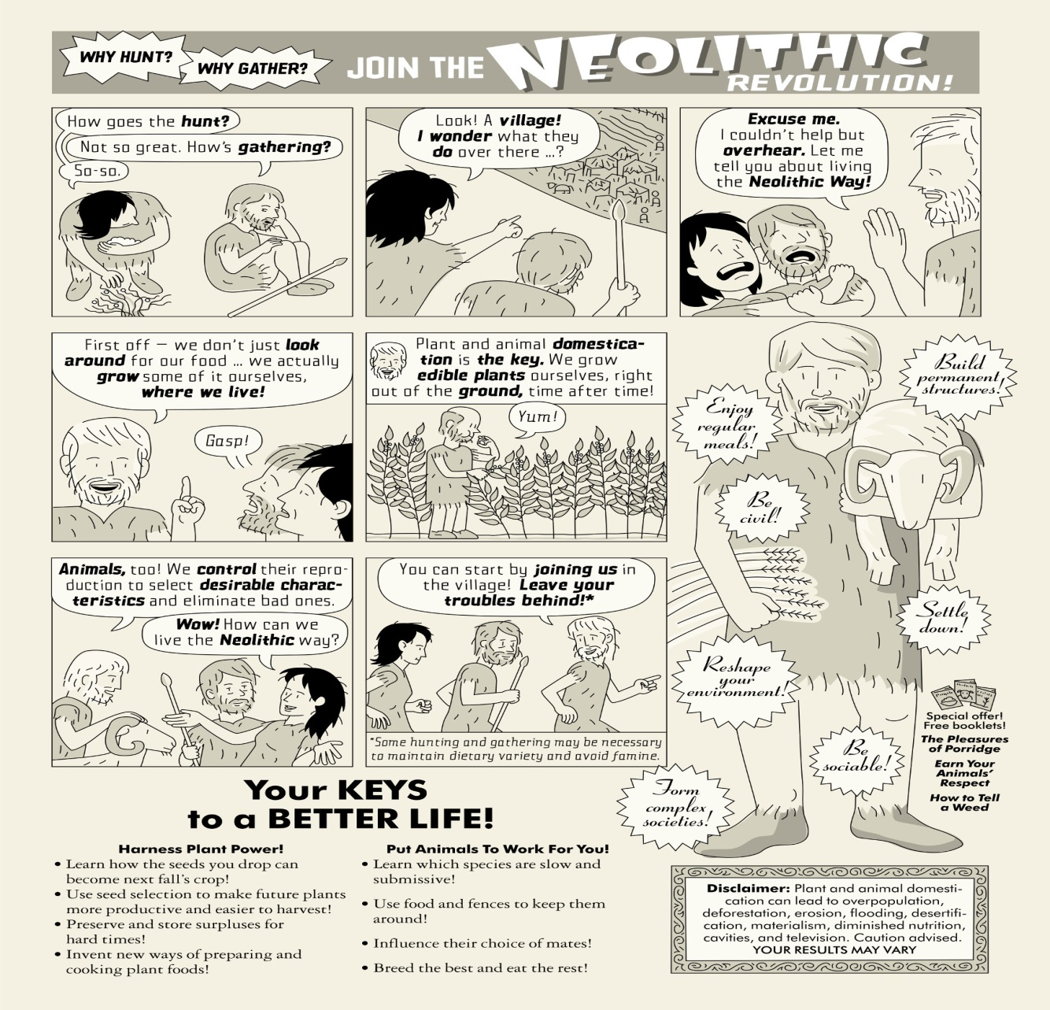

Using the document, identify TWO farming methods used by the Neolithic people.

Using the document, explain TWO effects the Neolithic Revolution had on people, places, and societies.

*HOMEWORK*
Using the document below, as well as your notes and handout, answer the question in 7-10 sentences on loose-leaf or typed, explain how the Neolithic Revolution was considered a turning point in history.
- Include the following key terms you learned (Neolithic Revolution, domesticate, surplus, civilization) and examples and evidence to explain your answer.

*TURNING POINT*-a significant event, idea, or historical event that brings about change; this change had a large impact on people, places, societies.

Paleolithic Age Hunters and  Gatherers |  | Neolithic Revolution  Agriculture and Domestication |  | Food Surpluses  Extra Food |  | Population Increase  Population grows |  | Growth of Civilizations  and Cities
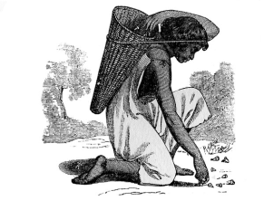 |  | 