\Resurgence (Rebirth) of European Trade and Cities

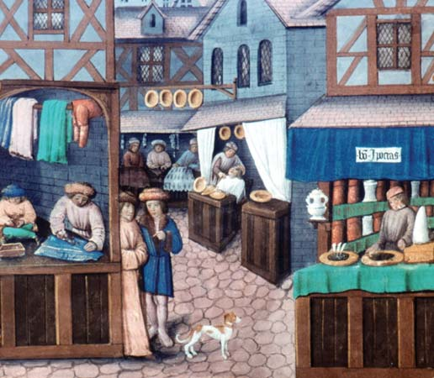I. Introduction
After the Crusades, things were beginning to look up for the people of Western Europe. Europeans were beginning to come out of the Middle Ages (also called the Dark Ages) and begin to interact with the rest of the world. Europeans became very interested in trade with the East. Improved ways of agriculture (farming) during the Middle Ages allowed the European population to grow, leading to an increase in trade. Also feudal warfare and foreign invasions declined. People felt safer and began to travel more. The crusaders brought luxury goods back to Europe from the Middle East. Wealthy nobles desired goods that could not be produced on manors. Peasants needed iron for farm tools. Traders began to crisscross Europe to meet the growing demand for goods.

DIRECTIONS: Read the following information and highlight or underline the effects the Crusades had on Europe. Also circle words that you do not understand. Then complete the essay template with the information that you have.

II. Trade Fairs and the Growth of Cities
Much trade with Europe went on at trade fairs. Trade fairs took place in towns where the trade routes met (usually on rivers). These fairs caused towns and cities in Europe to rise. Towns and cities have not been seen in Western Europe since the fall of the Roman Empire (1,000 years ago). Many traders came to settle in these areas, such as craft workers and merchants. The population of towns increased. In time, some towns developed into large cities populated by thousands of people.

To protect their interest, the traders who set up a new town asked the local lord, or the king himself, for a charter. This was a written document that set out the rights and privileges of the town. In return, traders paid the lord or the king a large sum of money, a yearly fee, or both. On the manors, there were no charters that gave a person rights. All rights and rules were given by the lord of the manor. Most charters also had a clause (special part in the document) that was popular with runaway serfs that declared that anyone who lived in the town for one year and one day was free. Meanwhile, as Europe’s population grew, manors became overcrowded and lords often allowed peasants to buy their freedom.

In towns the old social order of nobles, knights and serfs gradually changed. By the end of the Middle Ages, merchants (a person who buys and sells for profit) and skilled workers formed a new social class. In status, this class ranked between nobles, and serfs, so it was called the bourgeoisie, or middle class. Nobles hated the middle class, because they made enough money to take care of themselves that made them beyond nobles’ control. In medieval towns, the middle class gained economic and political power.

Medieval towns and cities were surrounded by high, protective walls to protect from invasions. As a city grew, space within the walls was overcrowded with a constant flow of newcomers. Because of overcrowding, city dwellers added second and third stories to their houses and shops. Therefore, a typical city was a jumble of narrow streets lined with tall houses. Upper floors extended outward over the streets below making the streets dim even in the daytime. Because mostly all buildings were made of wood and straw, fire was a constant threat. At night, the unlit streets were deserted (empty) and unsafe because there was no police to patrol them. Even a rich town had no garbage collection or sewer system. Residents simply threw their wastes into the street. During hot days, the smells coming from cities could be smelled for miles away.

NAME: ________________________________________ BAND: ______

THE RISE OF TOWNS AND CITIES IN EUROPE
DIRECTIONS: Using the information you just read, fill in the template below arguing whether towns and cities had a positive or a negative impact on European society. Give specific examples you learned and explain them to support your argument. Use the rubric below to help you earn an E.

One impact of the end of the Crusades was the revival (comeback) of trade. This led to the rise of towns and cities. The rise of towns and cities had a positive/negative (choose one) on the people of Europe.
There were a few reasons why the rise of towns and cities had positive/negative (choose one) effects on the people of Europe. The first reason was (name the reason) _____________________________________
_______________________________________________. This had a positive/negative effect because (explain the reason) ________________________________________________________________
____________________________________________________________________________________________________________________. Another reason was (name the reason) _____________
_____________________________________________________________________. This was positive/negative because (explain the reason) ___________________________________________ ________________________________________________________________________________
_________________________________________________________________. Even though the rise of cities and towns had positive/negative effect on the people of Europe, there still were some positive/negative (choose the opposite from your thesis) effects of cities and towns, such as (name the opposite effect) _______________________________________________________________________________. This was a positive/negative (choose opposite from thesis) because (explain the reason) __________
______________________________________________________________________________. However, this reason is still outweighed by the positive/negative (circle the one that matches your thesis) effects that town and cities bring such as (state two reasons) ____________________________________ _________________________________________________________ and ____________________ _______________________________________________________________________________.

EXCELLENT  - Argues a side accurately using relevant information in the written statement that demonstrates a clear and detailed understanding of the rise of Medieval towns and cities.  - Accurately and clearly uses details that connect to thesis.  - Uses key words accurately.  - Product is creative, accurate, and complete. | GOOD  - Argues a side using relevant information in the written statement that demonstrates an understanding the rise of Medieval towns and cities.  - Uses details that are accurate and connect to thesis.  - Uses key words in which most are accurately used.  - Product is complete and creative | SATISFACTORY  - Argues a side  - Uses supporting details that are relevant, but limited, general, or inconsistent in the written statement about the rise of Medieval towns and cities.  - Does not clearly and/or accurately gives information that connects to thesis and/or gives details, but does not align to thesis.  - Does not use key words and/or does not display a clear understanding of the definition.  - Product is complete. | UNSATISFACTORY  - Does not argue a side and or does not argue a side accurately.  - There are minimal details and/or details given are not accurate about the rise of Medieval towns and cities.  - Key words are not used or inaccurate.  - Product is incomplete

