Name: __________________________________________________ Band: __________

“All Roads Lead to Rome”
DIRECTIONS: Actively read about Roman roads, evaluate how the roads affected people, places, and societies, and how they changed over time. LABEL WHERE YOU SEE ANY ENDURING ISSUES. Answer the task that follows.

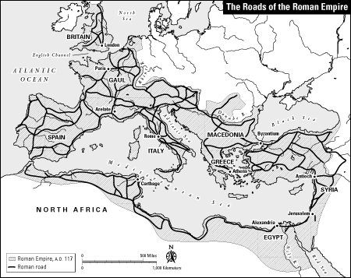
Rome was famous for their system of roads. Rome became an empire because of their powerful soldiers and the genius of their generals, but Rome remained an empire because of its roads. At this point in the Roman Empire, Rome had conquered many regions and there were more people that needed to be controlled and ruled over. Romans built over 53,000 miles of roads to connect every part of their empire. The roads were mostly built by the army and slaves. The roads were all done by hand and made out of stone. The roads were wide enough for large wagons to pass each other. The system of roads connected together every area of the empire. Roman emperors also used the road system to control their empire. For example, if there was a rebellion in one part of the empire, the emperor could send Roman armies from one part of the empire to another to maintain the peace. Roman emperors also used the road system to stay connected with the furthest territories of the empire by sending and receiving messages quickly over thousands of miles of roads. In addition, Romans could, when the need arose, but to speed the movements of tax collectors, administrators, and merchants, all the civilian travelers and traders who made the empire run smoothly. The Romans imported a whole variety of materials: beef, corn, glassware, iron, lead, leather, marble, olive oil, perfumes, purple dye, silk, silver, spices, timber, tin and wine. The main trading partners were in Spain, France, the Middle East and North Africa. Britain exported lead, woolen products and tin. In return, it imported from Rome wine, olive oil, pottery and papyrus. The Roman road network also encouraged a sort of “roadside” culture to develop and take advantage of the trade opportunities provided by the roads. Early hostels (hotels) sprung up to house travelers, and often expanded into large facilities. Tradesmen specific to road travel such as wheelwrights and veterinarians could set up shop and be guaranteed a steady supply of work. Eventually, entire towns sprung up along the roads, not only to utilize their trade potential, but tap directly in the jobs that could be created by the road network. Roman roads also encouraged the expansion of the Roman cultural presence separate from the government. Previously “barbaric” peoples had direct links to Rome through the roads, and over these routes, much of the less civilized parts of the continents could encounter the cultural practices that had existed on the Mediterranean shores. During the rise of Christianity, the road system allowed for the spread of the religion even when the government prohibited (did not allow) it, and contributed to the eventual adoption of Christianity by the Empire. The expansion of the empire through migration was also facilitated by the road network, and with this migration came the sharing of cultural practices not only from Rome, but the entire Mediterranean region. The proverb “all roads lead to Rome” emphasizes the centrality of the cultural that spread from Rome itself, and because all roads on the network did indeed lead to Rome, it was the Roman culture that eventually came to hold so much sway over such a large area. A person could start traveling on a Roman road in Northwest Africa, travel around the entire Mediterranean Sea and end up in Rome without ever leaving a Roman Road. Some of these roads are still used today. However, all Roman citizens were free to use the roads; there were some dangers to these roads. Travelers had to be aware of bandits, as people might simply “disappear” while riding on the Roman roads.
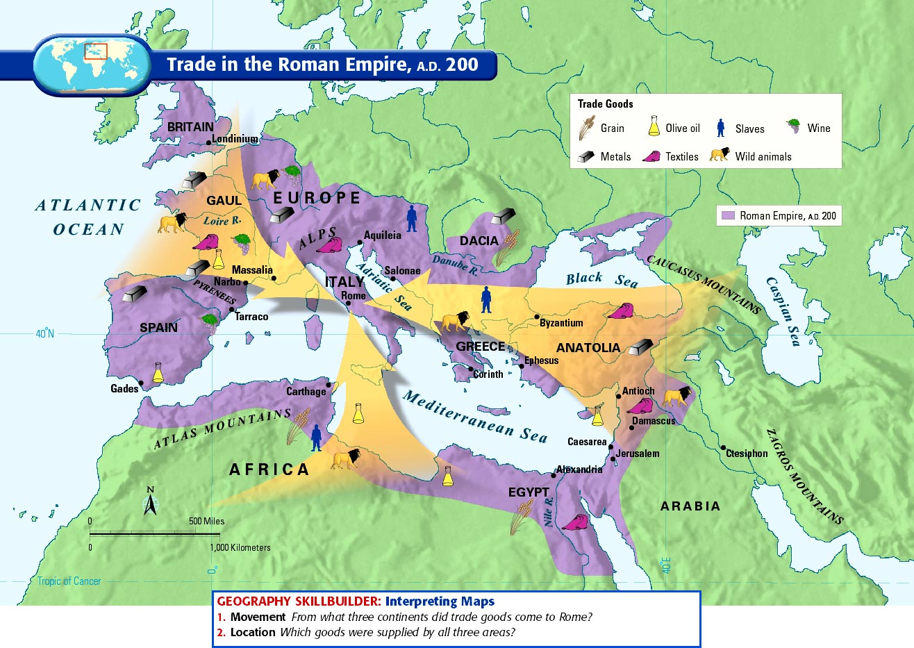

“All Roads Lead to Rome”

DIRECTIONS: According to the quote above, using the reading and the map, explain the purpose of Roman roads and it’s affect on people, places, and societes.

In your response be sure to provide the following:
- Topic sentence in the form of a thesis/claim (positive/negative impact)
- Provide evidence and examples (minimum of 3)
- Analysis (explain why the evidence and examples had a positive or negative impact)

Your response should be a minimum of 10 sentences.

Roads played a very important role in maintaining Rome’s power. Do roads still have a significant meaning to maintain a country’s power and control today? How?
_____
The enduring issue this best associates with is (check all that apply)

- CULTURAL DIFFUSION
- HUMAN RIGHTS (inequality/equality)
- IMPACT OF ENVIRONMENT ON HUMANS
- POWER
- SCARCITY
- TECHNOLOGY

