The Columbian Exchange
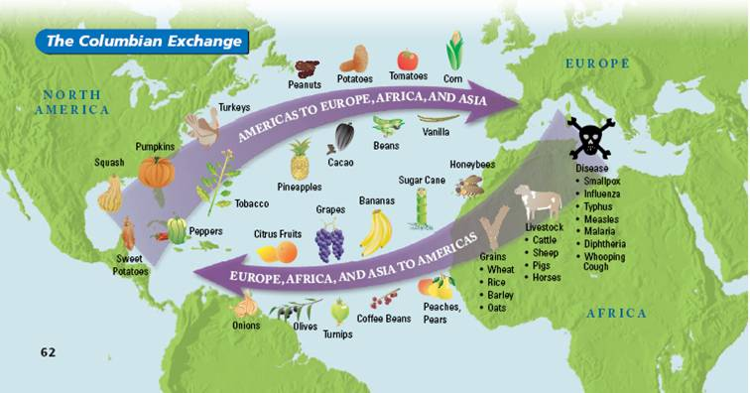
I. Introduction
In 1493, when Columbus returned to Spain after discovering the Americas, he brought with him “new” plants and animals that he had found. Later that year, Columbus returned to the Americas. With him were about 1,200 settlers and a collection of European animals and plants. In this way, Columbus began a vast global exchange that would greatly impact the world. In addition to people, plants, and animals, it included technology and even disease. Because of this global exchange began with Columbus, it is known as the Columbian Exchange.

Directions: Actively read the documents below and answer the questions that follow. Using the documents, explain why the historical developments and events associated with these documents are considered a turning point by explaining the impact it had globally. Be sure to use evidence from all the documents in your response.

Turning point – is a major event, idea, or historical development that brings about significant change. It can be local, regional, national, or global.

The turning point you will be discussing is the COLUMBIAN EXCHANGE. Use the documents below to explain why this is considered a turning point.

Source for the documents below: The Journal of Economic Perspectives, Vol. 24, No. 2 (Spring 2010), pp. 163-188
DOCUMENT | HOW DID THE COLUMBIAN EXCHANGE IMPACT PEOPLE, PLACES, AND SOCIEITIES – LOCALLY, REGIONALLY, NATIONALLY, AND/OR GLOBALLY?
DOCUMENT 1:
There are two channels through which the Columbian Exchange expanded the global supply of agricultural goods. First, it introduced previously unknown species to the Old World (EUROPE, AFRICA, & ASIA). Many of these species like potatoes, sweet potatoes, maize, and cassava (also known as manioc) resulted in caloric and nutritional improvements over previously existing staples. Other crops such as tomatoes, cacao, and chili peppers were not by themselves especially rich in calories, but complemented existing foods by increasing vitamin intake and improving taste. In many instances, the New World (The Americas) foods had an important effect on the evolution of local cuisines. Chili peppers gave rise to spicy curries in India, to paprika in Hungary, and to spicy kimchee in Korea. Tomatoes significantly altered the cuisine of Italy and other Mediterranean countries. Second, the discovery of the Americas provided the Old World with vast quantities of relatively unpopulated land well-suited for the cultivation of certain crops that were in high demand in Old World markets. Crops such as sugar, coffee, soybeans, oranges, and bananas were all introduced to the New World, and the Americas quickly became the main suppliers of these crops globally.

DOCUMENT 2: The list of infectious diseases that spread from the Old World to the New is long; the major killers include smallpox, measles, whooping cough, chicken pox, bubonic plague, typhus, and malaria. Because native populations had no previous contact with Old World diseases, they were immunologically defenseless. Dobyns writes that "before the invasion of peoples of the New World by pathogens that evolved among inhabitants of the Old World, Native Americans lived in a relatively disease-free environment… Before Europeans initiated the Columbian Exchange of germs and viruses, the peoples of the Americas suffered no smallpox, no measles, no chickenpox, no influenza, no typhus, no typhoid or parathyroid fever, no diphtheria, no cholera, no bubonic plague, no scarlet fever, no whooping cough, and no malaria." Although we may never know the exact magnitudes

DOCUMENT 3: Although we may never know the exact magnitudes of the depopulation, it is estimated that upwards of 80-95 percent of the Native American population was decimated within the first 100-150 years following 1492 (Newson, 2001). Within 50 years following contact with Columbus and his crew, the native Taino population of the island of Hispanola, which had an estimated population between 60,000 and 8 million, was virtually extinct (Cook, 1993). Central Mexico's population fell from just under 15 million in 1519 to approximately 1.5 million a century later. Historian and demographer Nobel David Cook estimates that, in the end, the regions least affected lost 80 percent of their populations; those most affected lost their full populations; and a typical society lost 90 percent of its population (Cook, 1998, p. 5).

DOCUMENT 4: Between the sixteenth to nineteenth centuries, over twelve million Africans were shipped to the Americas during the transatlantic slave trade, the largest involuntary migration in human history (Lovejoy, 2000; Manning, 1990; Nunn, 2008b). The trade was fueled by the high demand for labor in the Americas, which was driven, at least in part, by two aspects of the Columbian Exchange: The first was the spread of Old World diseases to Native Americans, which resulted in extremely low population densities in the New World. The second was the cultivation of highly prized Old World crops, such as sugar and coffee, which were particularly well suited to New World soils and climates. The forced movement of African slaves to the Americas reached its height.
Name:____________________________________ Band: ____________

TURNING POINTS – COLUMBIAN EXCHANGE

DIRECTIONS: Using the documents from class and your knowledge of Social Studies, explain how the Columbian Exchange was considered a turning point in history.

Turning point – is a major event, idea, or historical development that brings about significant change. It can be local, regional, national, or global.

The Columbian Exchange was (provide a definition)_____________________________________
_____________________________________________________________________________________________________________________________________________________________________. This took place between the Old World, which covers the continents of ______________________,
______________________________, and ___________________________ and the New World, which is the area known as ________________________________. The Columbian Exchange is considered a turning point because (state & explain reason 1—use the documents to provide evidence) ___________
_______________________________________________________________________________________________________________________________________________________________________________________________________________________________________________________________________________________________________________________________________________________________________________________________________________. This impacted (state the people/places/societies) ______________________________________ in a positive/negative way because ______________________________________________________
________________________________________________________________________________
_______________________________________________________________________________________________________________________________________________________________________________________________________________________________________________________________________________________________________________________________________________________________________________________________________________. Another reason the Columbian Exchange is considered a turning point because (state & explain reason 2—use the documents to provide evidence) ___________________________________________________
___________________________________________________________________________________________________________________________________________________________________________________________________________________________________________________________________________________________________________________________________________________________________________________________________________________________________________. This impacted (state the people/places/societies) ______________
_________________________________ in a positive/negative way because _________________
________________________________________________________________________________
________________________________________________________________________________
_______________________________________________________________________________________________________________________________________________________________________________________________________________________________________________________________________________________________________________________________________________________________________________________________________________.

Excellent (5)  - Clearly identifies and accurately defines the turning point.  - Develops a thoughtful and in-depth argument about it impacts people or how they have been affected.  - Is more analytical or descriptive | GOOD (4)  - Identifies and accurately defines the turning point.  - Develops a thoughtful argument in some depth about how the turning point affected people, places, societies, etc.  - Provides some analysis. | SATISFACTORY (3-1)  - Identifies and accurately defines a turning point; may include minor inaccuracies  - Argument is not clearly explained on in depth about how the turning point affected people, places, societies, etc.  - Lacks analysis; provides only description. | UNSATISFACTORY (0)  - Fails to develop the task or may only refer to the turning point in a general way; OR includes no relevant facts, examples, or details; OR includes only evidence copies from the documents; OR includes only entire documents copied; OR is illegible; OR is a blank paper.

