DIRECTIONS: Using the Venn Diagram below, outline the similarities and differences between what a plebian and patrician in Roman society. Remember, where the two circles overlap is where you put the things that are the same. The outside, where the two circles do not meet, are the differences.

Similarities
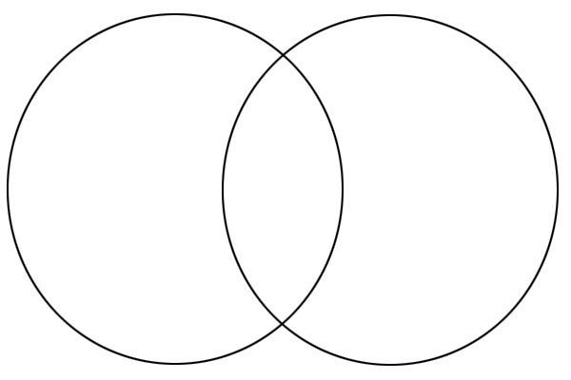
Patrician
Plebian

